Short Scientific CV

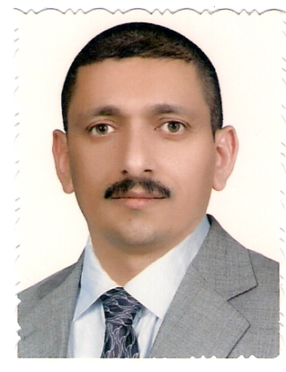
Name: ( Hassan Rashed Yassein )
M.Sc. ( at 2001) in ( Country Iraq )
PhD ( at 2017) in ( Country Iraq)
The scientific title: Prof.
Affiliation: University of Al-Qadisiyah
Dept.: Mathematics
College: Education
Mobile:- +964- 7723819290
Email: hassanr_06@yahoo.com
hassan.yaseen@qu.edu.iq

Specialization:- Mathematics \ cryptography and Algebra
Your Research Interests:
- Security
- Information security
- Ring , Group , Modules

Scopus id:
https://www.scopus.com/authid/detail.uri?authorId=57190947507
Google Site: Google scholar :
https://scholar.google.com/citations?user=oERTdYcAAAAJ&hl=en
Research gate : https://www.researchgate.net/profile/Hassan_Yassein
Academia.edu: https://qadis-eng.academia.edu/HassanYassein

EADS ID: 1466431

