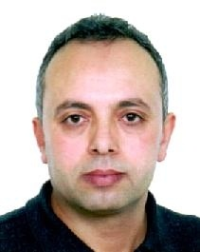
Curriculum Vitae

Personal file
- Name: Jaleleddine
- Surname: Kraiem
- Date and place of Birth: 10-01-1972 Kairouan
- Nationality: Tunisian
- Address: B. P. 606 Tunis Carthage Cedex 1080
- Telephone: 0021697362425
- E-mail : jalel.eddinekraiem@gmail.com
- Civil Status: Married
- Date of driving license: Year 2000
Education and Diplomes
- The Baccalaureate
- Technician Certificate in Informatics and Management.
- Certificate in the relationship between the citizen and the. administration.
Professional experiences:
- From a year 1999-2021 to date (22 years’ experience
in the administrative field in a government institution « SNIT ».
- The career plan: as a head of department
- Rank: First Administrative Officer
- From 1999 to 2002 in the Department of Informatics
- From 2003 to 2006 in the management recovery department
- From 2007 to 2010 in the commercial
- From 2011 to 2014 in the Human Resource Management
- From 2015 to 2021 General Administration « in charge of the Central Control Office »
Academic Qualifications
- Oracle
- Pascal
- Access
- Adobe Photoshop Flash MX
- Word
- Excel « Levels 1 & 2 »
- Power point
Languages
- Arabic: Excellent
- French: Good
- English: Average
Memberships
- Member of the Qatar Green Building Council
- Member of the International Federation for the Arabic Language
- Member of the platform /Arab Researcher ID ARID / Malaysia
- Member of the Arab Forum for Human Resources Development
- President of the charity association in Tunisia “5 years”
- Member of the Network Islamweb.net / Qatar
- Member of the Mosque Building Authority in Tunisia

