Zana Salahaddin Najmaddin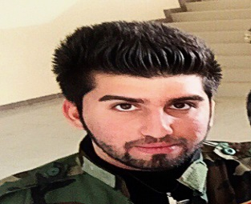
Baghdad road , Kirkuk , Iraq
Tel : 009647702314185
e-mail : zananajm71@yahoo.com
PERSONAL INFORMATION :
Date of Birth : 11-11-1995
Gender : Male
Marital Status : Single
Nationality : Iraqi
EDUCATION :
KIRKUK UNIVERSITY , KIRKUK , IRAQ , COLLEGE OF ENGINEERRING ,
Petroleum Engineering Student , 2nd Stage .
JOB EXPERIENCE :
Worked as a Mini Market Manager at a Tourism Village in Erbil ( GULAN TOURISM VILLAGE ) .

SKILLS :
LANGUAGE : Fluent in Kurdish , Arabic , English and Turkish ( Turkmen accent )
Computer Knowledge : Windows , M.s Office ,
Matlab , Quick Basic & Fortran .
Working Hard .
Leadership Personal .
OTHER INFORMATION :
- Vice President Of SPE ( Society of Petroleum Engineers International ) @ Kirkuk University , student chapter ( 2014-2015 ) .
- I was the fifth in arrangement of succeeded students in first stage .
- I was the first in arrangement of succeeded students in second stage .

REFERENCES :
- Ass. Prof. Dr. Maki H. Zedan , University of Tikrit .
- Dr. ‘Izzet Niyazi , University of Kirkuk .

