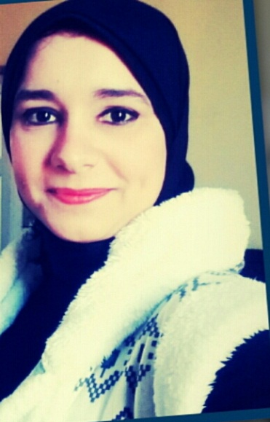
PERSONAL INFORMATION:
- NAME: Eman Soubhi Othman Mohamed.
- GENDER: Female.
- Nationality: Egyptian.
- Religion: Muslim.
- Marital Status: Single.
- Date Of Birth: 4/11/1991
- Address: 1St Abdul Wahab Yusuf– El Kabary – Alexandria
- Telephone: 01226685971
- Email Adress:EmanSoubhi18@yahoo.com.
Education:
- Higher Institute Of Social Work In Alexandria
- Bachelor Degree In Social Work 2013
- Pre – Master Now
Training Courses:
- Training In the Field of Human Development
- ICDL
Language Skills:
- English in general
Employment History:
- Name Of Employer:Tele-sells.
- Employee Of Receptionist In Al Amal Hospital.
- Office management services and health treatment.
- Accountant in Center College of Commerce English courses.
Personal Skills:
- Team Work
- Availability Of Work Under Pressure
- Good Communication Skills
- Fast Response To Changes In Work Environment

References:
- Available Up On Request

