**My profile**

ه

و

**Hager Sami Ahmed Amer**

**01225350314 _01116966954**

**Hagersami659@gmail.com**

**Alexanderia**

**_**

**Al Agami**

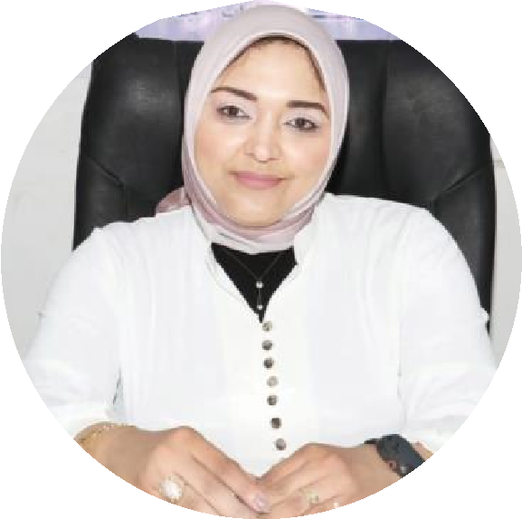

A social worker with extensive experience in psychological support and providing advice on dealing with problems.

Specialized in finding solutions to societal issues and people with special needs.

Work experiences

* Officer for protection and psychological and social support at UNICEF in Egypt and Caritas for Syrian refugees in Egypt
* Lecturer at Falcon Institute for Strategic Studies
* Teaching assistant and training supervisor at the King Mariout Institute for Literary Studies from 2008 to 2011.
* Practical training at Al-Ajami Model School in Alexandria on the role of a social worker in 2003.
* Supervising practical ( social ) field training for students of the Sociology Department, the four teams, the Sociology Division, Higher Institute for Literary Studies.
* Dealing with the computer, using it in research, and word processing, writing and producing. A training course from the International Center for Journalists, 2005.

education

* Doctorate in Arts, Department of Sociology

From the Faculty of Arts, Damanhour University, credit hour system.

Under the title “Electronic games and their impact on the socialization of children.”

* Pre-Master’s degree from Alexandria University, Damanhour Branch 2007.
* Master of Arts, Department of Sociology, Faculty of Arts, Damanhour University.

Under the title “The Impact of the Use of Communications and Information Technology and the Internet on Prisoner Cohesion.”

Excellence Award for the year 2017.

* Bachelor of Arts, Department of Sociology, Higher Institute for Literary Studies, King Mariout.

With a very good grade for the year 2006.

Compositions

Author of the book Letters to You.

Author of the book My Defeat is You.

Author of the book Family Problems and Marital Silence.

Author of the book Coffee D 19: What is it, where does it come from, and how to deal with it.

Author of the book The Impact of Information and Communications Technology on Family Cohesion.

# Skills Computer skills t

|  |  |  |
| --- | --- | --- |
| A | Ms word  Excel  PowerPoint | Communicate with others  cooperation  Scientific research |

Problem solving

Languages make decisions

Arabic language: the mother tongue of organization

English: Good spoken and written

Time management

## Certificates

Certificate of specialization in English from the IBI Center Sh

Certificate of passing the Arabic language skills development course for postgraduate studies from the Faculty of Arts, Alexandria University

Certificate of passing scientific research methods from the Faculty Development Center - Alexandria University

Certificate of passing the International Center for Journalists in Washington for the year 2005 (ICFJ). Sh

Certificate of passing the Effective Presentation and Effective Communication course – Faculty Development Center

Damanhour University

Certificate of passing scientific research methods

Certificate of passing scientific research ethics

Certificate of participation in a scientific lecture in the name of our major cultural issues: Towards a scientific methodological comparison

Certificate of participation in a scientific lecture in the name of scientific methodologies between tradition and innovation, statistics as an example

Certificate of participation in the training workshop tagged - building a scientific research plan

Certificate of participation in a scientific lecture tagged _ Operation of the mind and the mechanism of thinking in scientific research and life

Certificate of participation in a scientific lecture tagged _ research gap

And scientific additions

Certificate of participation for a scientific lecture tagged _The Art of Entertaining Public Speaking

Certificate of participation for a scientific lecture tagged _searching for aspects of cooperation using S Scopus

Certificate of Participation, “I Have Rights” Initiative, “The Role of the Family in Children’s Use of Social Media Sites,” Monitoring, Participation

Certificate of participation in the mental health and social service course

Certificate of participation in the virtual forum on innovation in scientific research

Certificate of participation in the scientific lecture tagged _The Digital Divide and ways of Digital Transformation

Certificate of participation in the international virtual conference on continuing education in light of the repercussions of pandemics - entitled The impact of information and communications technology on education in light of the Corona pandemic - Suleiman International University in Turkey

Certificate of participation for an evening entitled _Psychological Adaptation

Diploma Certificate in Statistical Data Analysis

Certificate of attendance at a training course - leadership and teamwork

Certificate of participation in the scientific lecture tagged _skills of writing and publishing scientific articles

Certificate of attendance in the program “The Art of Priorities and Crisis Management in the Family.”

Certificate of participation in the scientific lecture entitled “Quality in Education”.

Certificate of attendance at a workshop - family relations and the art of communication

Certificate of passing a diploma in digital transformation techniques in learning

Certificate of participation for a scientific lecture tagged _quality in education: a field vision

Certificate of participation in the scientific lecture entitled _ Researcher’s Digital Tools in Publishing and Scientific Research

Certificate of attendance at a training course entitled _Foundations of Scientific Writing

Certificate of attendance at the course “Skills for Dealing with Behavioral Disorders.”

Certificate of attendance for an introductory evening - change management

Certificate of participation in the scientific lecture - teaching and training skills and strategies

Certificate of participation in the scientific lecture - The human personality from childhood to maturity

Certificate of attendance for a course entitled _Essentials of emotional intelligence towards enhancing mental health

Certificate of participation in a scientific lecture tagged - The art of reading as a starting point for scientific research and a path to knowledge

Certificate of participation in a scientific symposium - The role of scientific institutions in supporting scientific research

Certificate of participation in the International Scientific Publishing Diploma

Certificate of completion of the International Scientific Publishing Diploma

Certificate of passing educational content, awareness program on sustainable development goals

Certificate of participation for a scientific lecture tagged _ digital tools for the scientific researcher

Certificate of participation in the scientific lecture tagged _Analytical thinking in scientific research

Certificate of participation in the applied diploma - preparation of scientific research

Certificate of passing the applied diploma_preparation of scientific research

Certificate of attendance at the training program - Marital Happiness Capsules

Certificate of participation in the fourteenth annual and third international conference

Media and management of local and international crises, Faculty of Information, University of

Baghdad - Republic of Baghdad - Arid platform

Certificate of participation in a training course entitled “Managing Family Stress.”

Certificate of participation in the lecture entitled _Schools, curricula and scientific concepts

Certificate of participation in the scientific lecture - Our children and electronic addiction

Certificate of attendance at a training course - Effective communication with adolescents

Certificate of participation in a lecture - stations in the integrated awareness industry

Certificate of attendance at the human rights symposium - the most prominent human rights violations in the world, especially the Arab world

Certificate for a course entitled _Internet of Things

Certificate of participation in the international conference - The impact of new media sites on the culture of dialogue for young people