Curriculum Vitae
Full Name: - Duraid Hani yuonus AL Nooh
Place of birth: - Iraq / Baghdad
Nationality: - Iraqi
Gender: - Male
Marital Status: - Single
E-mail Address: - duradeh@yahoo.com
Ordinary Address 2014: - Republic of Iraq / Ministry of Higher Education & Scientific Research / University of Baghdad / College of Education for Pure Science / Ibn AL-Haytham / Physics Department
Mobile No Iraq: - 00 964 7901991431
Scientific Title: - Assistant lecturer
Address in Australia: - Unt 3/16 Bunderra Close Karawara
Mobile No Australia:- 0434919493
Academic Qualifications:-

- First University Degree: - Bachelor of Sciences (BSc)
Date of Degree awarded: - 30-6-2004
Department: - Physics Department
College: - College of Education for Pure Science / Ibn AL-Haitham
Name& location of the university: - University of Baghdad / Iraq
- Second University Degree: - Master of Sciences in physics (MSc)
Date of Degree awarded: - 25-1-2010
Department: - Physics Department
College: - College of Education for Pure Science / Ibn AL-Haitham
Name& location of the university: - University of Baghdad / Iraq
Field of Interest: - Theoretical Physics / Plasma

Experience:-

- The date of my first appointment was in 1996 at the Technical Institute.
- In 2004 I was appointed by the physics Department College of Education for Pure Science / Ibn AL-Haitham / University of Baghdad.

Publications:-

- Duraid .H. yuonus , R.H.Majeed "Study Of The Dynamical Behavior For Deuterons In Dense Plasma Focus", University of Baghdad, Ibn AL-Haitham Journal.2009.V(22).N(4). P (133-143).
- H.J.M AL-Agealy, D. H. Yuonus, E. A. Jawad and M. A. Haitham "Charge transport in magnetized plasma" University of Baghdad, Ibn AL-Haitham Journal.2012.V (25). N (1). P (211-221).
- S. H. Leabi, D. H. Yuonus "The Study Of Wear Effect On The unsaturated Resin Reinforced By Rice Husk" University of Baghdad, Ibn AL-Haitham Journal.2012.V (25). N (3). P (162-168).
- A. K. Saadon, M. M. Ali, K. A. Jasim and D. H. Yuonus "Study the physics and Dielectric Properties of Ferrite-Sis Composite" University of Baghdad, Diyala Journal for Science Accepted. N (71). D (24-2-2013).
- R. H. Majeed, D. H. Yuonus "Theoretical study for Analyzing the Neutron/Alpha Particles Emission Mechanisms from Thermonuclear
Fusion Plasmas". University of AL-Mustansirya,Journal of the College of Education .N(72F).D(15-4-2013) .
- K. A. Jasim, M. Abdul-Nebi and D. H. Yuonus "Study the Superconducting Properties of Bi₂Sr₂Ca_{1. 8}La_{0.2}Cu₃O_{10-δ} Gamma Irradiation", University of AL-Mustansirya, Journal of the College of Education. N (100F). D (15-4-2013).

- Durade .H. yuonus "Theatrical Calculations For Sputtering Yield of Nickel surface Hitted By Xenon Plasma Ions", University of Baghdad, Ibn AL-Haitham Journal.2013.V(26).N(2).P(158-165).

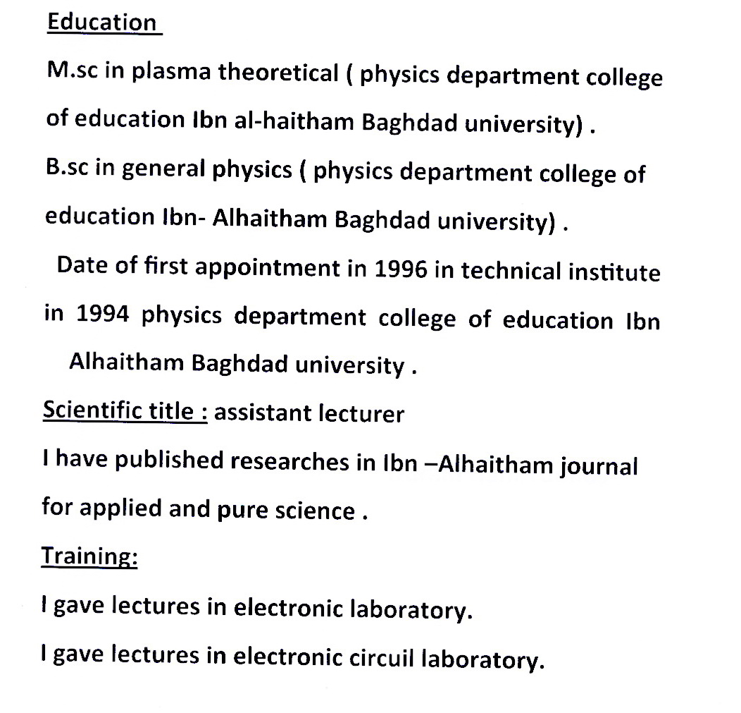
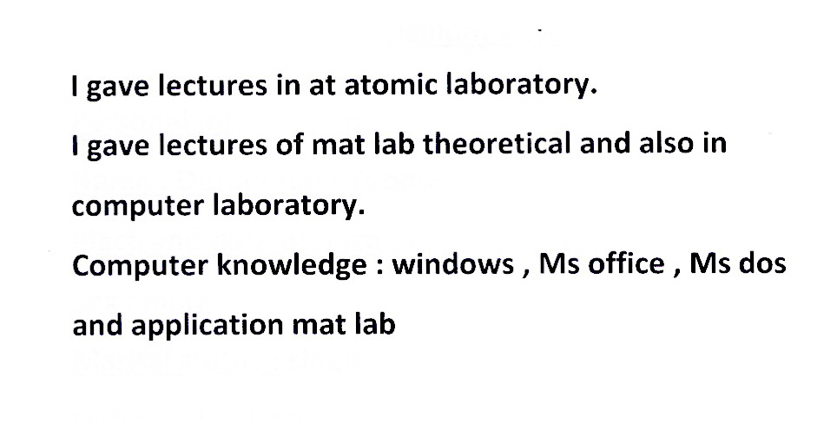
Referees:-
- PR. Dr. Khalid Hadi Mahdi
Department of physics
College of Education for Pure Science / Ibn AL-Haitham / University of Baghdad.
E-mail: - khalidsama@yahoo.com
Mobile phone: - 00 964 7901781471

- Ass. Prof. Hadi Jabber AL-Agealy
Department of physics
College of Education for Pure Science / Ibn AL-Haitham / University of Baghdad.
E-mail: - hadi_alagealy@yahoo.com
Mobile phone: - 00 964 7801915909

Republic of Iraq
Ministry of Higher Education
And Scientific Research
University of Baghdad

Study of the Dynamical Behavior for Deuterons in Dense Plasma Focus

Thesis Submitted to Collage of Education Ibn AL - Haitham, University of Baghdad In Part Fulfillment of the Requirement for Degree Master of Physics

By
Duraid Hani younus

Supervisor

Dr . Abd – Al – Rahman Mahmoud Dr . Raad Hameed Majeed

Proof Assist. Proof

1430 2008

Abstract

The motion of fast deuterons in most dense plasma focus devices ( DPF ) , may be characterized such that it have a complex nature in their paths and this phenomena can be by described by a gyrating motion with arbitrary changes in magnitude and direction .

In this research we focus on the understanding the theoretical concepts which deeply depend on the experimentally results to explain the deuteron motions in the pinch region. Then we use the fundamentals physical formulas that related to the explanation of this motion to prepare a suitable model to calculate the vertical and radial components for deuteron velocity by employing Rung – Kutta Method.

Duraid Hani younus

