CV
Personal information
Name:
Seba aziz sahy yaseen
Date of birth :- 3-5-1969
Nationality: Iraq
Gender:Famel
Marital status: mirage
Driver license :

CONTACT
Address:
Iraq-Baghdad- al- Qadissih
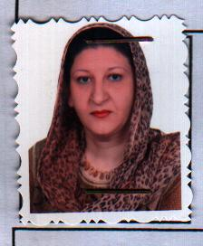
Phone:
0096407901617914
E-mail:
sebaaziz96@yahoo.com
Seba.aziz77@gmail.com
Google Scholar:
Seba.aziz77@gmail.com
Research gate
Saba.aziz@mtu.edu.iq

LANGUAGES:
Arabic
English
WORK EXPERINCE
EDUCATION:-
- Bachelor Degree Department of computer science from Ministry of Higher
Education & scientific Research- University of Technology – Baghdad
- Master degree of computer Science, from Ministry of Higher Education & scientific Research –Iraqi Commission for Computers & Informatics – Informatics Institute for Postgraduate Studies.

ADDITIONAL SKILLS:-
Network security, computer networking, software Agent, Artificial Intelligence

Certifications:-

RESEARCH/ PUBLICATION

- Traffic Management with Deployment of Li-Fi Technology
- Image Feature Extraction using Quantum-PSO and Chaotic Map
- Reconstruction Torn Image Pieces
- Investigation Framework of Online Analytical Processing in Academic Information Systems to Support Decision Making
- Graph Oriented Databases for Internet of Things
7-Evaluate the efficiency of video transmission using anew circular search
Algorithm based on the motion estimation for a single

