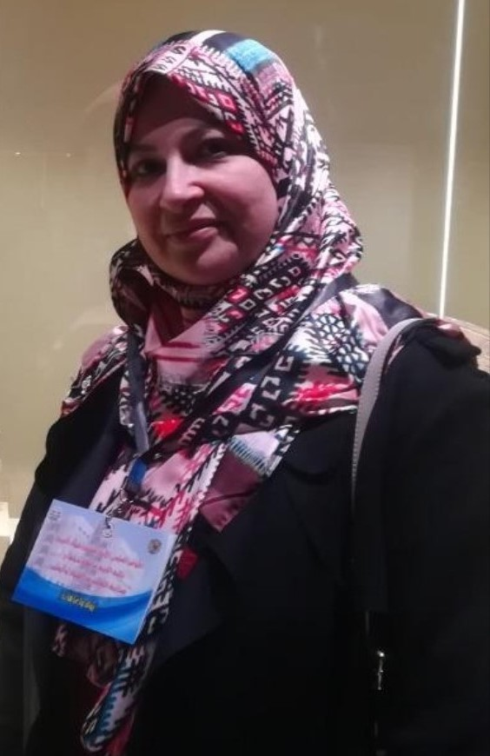 |  | Dr. Eman Abdelrahman Mohamed Abdalah  Lecturer, Foundations of Education Department, Faculty of Education, Sohag University, Egypt
INTRODUCTION  Contact Data  Cell phone:  00201010419974  LinkedIn Profile:  https://www.linkedin.com/in/eman-abdelrahman-mohamed-b10902128?utm_source=share&utm_campaign=share_via&utm_content=profile&utm_medium=android_app  Research Gate:  https://www.researchgate.net/profile/Eman-Abdalah  E-mail:  Eman_abdalah@edu.sohag.edu.eg  Hobbies:  - Leadership and team management skills  - Reading and scientific research  - Training with a focus on human development  - Using computer software, e.g., MS Word and PowerPoint  - Internet search skills  - Studying English |  | Education  - PhD (Doctor of Philosophy in Education) (Major: Foundations of Education), 2008  MA in Foundations of Education, 2002  Special Diploma in Education, 1999  Bachelor in Education and Science (Major: Biology), 1997  Work Experience:  Lecturer, Foundations of Education Department, Sohag University  31/8/2007 to date  University Activities:  - Joining the Organizational Committee of Science Day at the University on December 21, 2022  Faculty- Relevant Activities:  - Member of Faculty Council 2022, Student Affairs 2009, Post-Graduate Studies 2014, and Community Service and Environment Development 2013  - Member of quality teams (students’ standard and faculty members’ standard)  - Deputy Director of the Quality Unit from 2022 to date  - Member or personal interview committees for undergraduate and post-graduate students from 2009 to date  - Member or personal interview committees for post-graduate students from 2009 to date  - Participant in testing and electronic scoring from 2009 to date  - Member of conference organization committee at the faculty  Positions:  - Deputy Director of the Quality Unit to 2022 and from 2023 to date  Department- Relevant Activities:  - Member of the Department Council from 2009 to 2011, 2012, 2014, 2018, and 2024  - Member of the seminar sessions  - Participant in the description and teaching of 15 undergraduate courses in the department  - Participant in the description and teaching of 12 post-graduate courses in the department  - Reviewing many questionnaires and field study tools for researchers inside and outside the department at Egyptian, Kuwaiti, and Saudi universities  - Organizing, attending, and presenting research papers at the department’s forums in 2020, 2022, and 2023  - Participation in preparing the department’s guide for master’s theses and doctoral dissertations from 2016 to 2022  - Member of the department committees, including timetables preparation in 2022 and 2023  - Member of the supervision committees for 14 master’s theses and doctoral dissertations, most of which were awarded from 2009 to date  - Receiving training and participating in (15) online and offline workshops and training courses in all fields of research, quality, crisis management and human development, e-learning, and preparing electronic tests  Conferences:  - Attending (17) local and international online and offline conferences in many educational, social, and research fields in Egypt  Publications:  Requirements for effective school leadership from the perspective of two generations of teachers  Problems hindering the educational preparation of general diploma students according to national quality standards  Educational research paths to free education and its issues in Egypt from 1987 to 2017: An analytical study  [From] – [To]  [It's okay to brag about your GPA and the awards and certificates you've obtained. Feel free to summarize academic courses as well.]  Work Experience:  Assistant Lecturer, Foundations of Education Department, Sohag University  12/ 2/ 2007-31/ 7/ 2008  Demonstrator, Foundations of Education Department, Faculty of Education in Qena, South Valley University (16/4/1998)  Skills  اللالالاالالال

