Curriculum Vitae
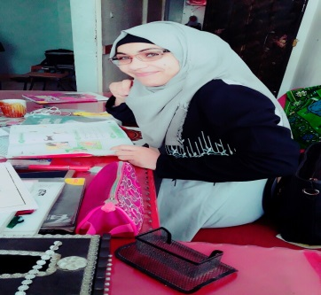

Personal data:
Name : Basma Ismail Shehda El- Kurd.
Address: Rafah – Gaza- Palestine.
Mobile number : 009720592625683
Email address : bassma.ismail1991@gmail.com.
Date of birth: 30/3/1991
Material status: divorced.
Place of birth : KhanYounis
Nationality : Palestinian.
Education :
A certificate of art from high school with a very good average.
PA from the university in methods of teaching English .
Experience :
2-7 years of teaching English.
A year in international translation.
Work experience:
Teacher at a governmental school.
Teacher at educational center
Manger at an educational center.
Marketing
Secretary at educational center
Work expertise :
Cultural
Social .
Education.
Business and IT.
Computer Literacy:
- Working professionally with Microsoft operating systems.
- Excellent search skills over the Web.
- Excellent knowledge in most of popular software applications needed for any work environment, e.g. MS Office, A
- Excellent ability to learn quickly any new tool, online or offline.
Good manner in using network's program( Skype – Gmail- hotmail- Yahoo)
Interests :
Swimming
Reading poetry.
Reading novels.
Write short memoir and story.
Languages :
Arabic ( native ) Excellent ( writing – reading – speaking).
English: very good ( writing- reading- speaking).

Work Qualifications:
- Excellent ability to act as Project Manager with highly professional communication, negotiation and organizational skills.
- Excellent ability to work under pressure with outstanding flexibility.
- Meeting given deadlines on time without compromising output quality.
- Obeying to organizational roles and regulations with elevated behavior.
- Focusing on exceeding respective higher-level supervisor expectations.
- Dealing politely with work colleagues and aiming at achieving team success.

Please feel free to contact me for any questions or comments you may have.
References and samples are under request.

