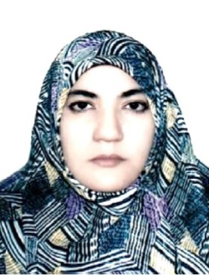
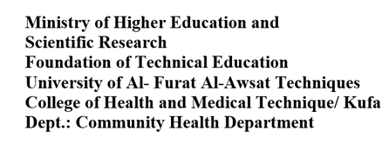
Curriculum Vitea
 | Miaad K. Alkhudhairy | Name | 1
 | 3 /6 /1970 | Date of Birth | 2
Medical Technical Institute/ community health department / Qadissiyah/ Graduation Year/ 1992 | 1- Diploma in Community Health | Educational Attainment | 3
Babylon University/ College of Science/ Graduation Year/1996 | 2- Bachelor: Biology
Kufa University/ College of Education for Girls/ Graduation Year/ 2008 | 3- Master: Biology/ Medical Bacteria
Bacteriological and Genetic Study of Methicillin Resistant Staphylococcus aureus Isolated from Hospitals in Najaf City. | Thesis:
Qadisiyah University/ College of Education / Research stage/ 2016 | 4- PhD: Biology / Molecular Bacteriology
Molecular Characterization of Hospital Associated Methicillin Resistant Staphylococcus aureus (HA-MRSA) Isolated from Hospitals in Al-Najaf | Thesis:
 | Scientific Research Division/ Department of Scientific Affairs/ Al-Furat Al-Awsat Technical University/ Kufa | Work Place | 4
 | 1997 | Date of Appointment | 5
 | Assist. Prof. | Scientific Title | 6
 | Najaf / Kufa / Kufa Technical Institute | Home Address | 7
 | miaadalkudairy@gmail.com | E. Mail | 8
 | 07808397263 | Mobile no. | 9
Computer Center University of Kerbala/ 2010 | 1-TOEFL ITP test | Scientific Training Courses | 10
Kufa University-Information Center for Research and Rehabilitation- Postgraduate/ 2010 | 2- Certificate of Proficiency in computer (IC3 tests)
Kufa University/ College of Medicine/ 2007 | 3- Polymerase Chain Reaction (PCR) Technology
Kufa Medical Technical Institute/ community health departement -2010 | 4- (PCR) Technology in the fields of medical and criminal investigations
Kufa University/ College of Medicine/ 2009 | 5- New in Molecular Biology
Kufa University/ College of Medicine/ 2013 | 6- Real Time PCR Technology
Head of Health Community Techniques department/ College of Health and Medical Techniques, Al-Furat Al-Awsat Technical University  (from 1/ 9/ 2015 to 23/ 1/ 2019). |  | Administrative positions | 11
 |  | Publications | 12
Characterization of methicillin-resistant Staphylococcus aureus (CA-MRSA) isolated from Al-Najaf city, First conference, Scientific College 2008. |  | 1)
Community-acquired methicillin-resistant Staphylococcus aureus (CA-MRSA) carrying mecA and Panton-Valentine leukocidin pvl genes isolated from the holy shrine in Najaf, Iraq. J. Bacteriol. Res., 4(2): 15-23 year 2012. |  | 2)
Comparison of a Seven Conventional Phenotypic Methods with Polymerase Chain Reaction for Detection of Methicillin-Resistant Staphylococcus aureus. Al-Qadisiyha Journal for Science Vol. 21 No. 1 Year 2016. |  | 3)
Detection of Escherichia coli isolated from patients in Al-Sader hospital, first conference, College of Humanities, 19-20/4/2016. |  | 4)
Assessment of toxoplasmosis among aborted women in Al-Najaf Al-Ashraf province. International Journal of Chem. Tech Research 10 (1), 383-390 year 2017. |  | 5)
Detection of β-lactamases producing Methicillin-Resistant Staphylococcus aureus (MRSA (. Al-Qadisiyha Journal for Science Vol. 23 No. 2 Year 2018. |  | 6)
Integron frequency of Escherichia coli strains from patients with urinary tract infection in Southwest of Iran. J Acute Dis 2019; 8(3): 113-117. |  | 7)
Comparison of adhesin genes expression among Klebsiella oxytoca ESBL-non-producers in planktonic and biofilm mode of growth, and imipenem sublethal exposure. |  | 8)
Prevalence of Metallo β-lactamase Producing Pseudomonas aeruginosa Isolated from Diabetic Foot Ulcers infection in Al-Najaf Governorate |  | 9)
First preliminary survey of extended-spectrum β-lactamases (ESBLs) in nosocomial uropathogen Klebsiella pneumonia in north central Iran. |  | 10)

