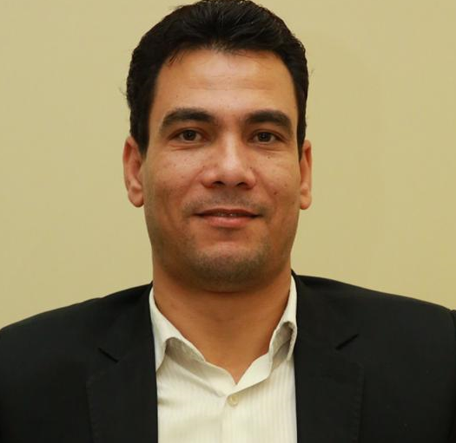

Date of Birth: 6 Jul 1981
Nationality: Egyptian
Address: Smaanoud-Al-Gharbiya-Egypt
Mobile: +20 1062399144 +201025060624
E-mail: H2mdy.H2mdy@Gmail.com

Current Job
Assistant Lecturer of Records and Libraries
Faculty of Arabic Language In Menoufia
Al-Azhar University– Egypt

Personal Summary
- Records Lecturer and Libraries Assistant، Al-Azhar University– Egypt
- I am an individual excited who has experience and information awareness in the field of documents, libraries and archives.
- Lecturer and expert in libraries, documents, archives, and transformation of digital systems
- . I am very professional with a focus on detail, organizational skills, coordination and excellent reporting.

Certifications
- F Phd:in the management and archiving of electronic documents in the Sheikh of Al-Azhar Al-Sharif - an Analytical Study Evlauation 2018.
- Master Degree: in Digital Information Services 2017 Appreciation: Excellent with university course and exchange between universities
- Pre-Masters from the Faculty of Humanities / Al-Azhar University with a good grade in 2014
- BSc. Department of documents and libraries 2004, very good with honors
- Diploma of Education from Al - Azhar University with a good grade for the year 2010
- Diploma of Education - Tanta University with a good grade for the year 2011

Career Objective

To join a progressive organization and be part of its success using my strong analytical, coordination and decision making skills and commitment to perform quality work.
To learn, excel and grow, chasing all opportunities to diversify my areas of expertise for broad-ranging experience and versatility.

Work Experience
- Assistant Lecturer, Department Of Documentation And InformatFaculty Of Arabic Language Al-Azhar University Branch Shbeen El Koom, Menoufia 03/2019 – Current
- Expert in Archiv
- Teaching Assistant e and developer in Ras-Alkhaimh Palace Archive.
- Assistant Lecturer, Department Of Documentation And InformatFaculty Of Arabic Language
- Attend conferences in the field of documents and libraries.
- Participation in the program of digital transformation – In the College of Graduate Studies - Al-Azhar University
- Worked as a library specialist at Al-Azhar Institute in the period from 2006 to 2012

Trainings
- ICDL
- Computer Course in Tanta University.
- The technical aspects of the library's information vessels in the administration of educational training in the Azhar institutes sector in the period from 4/3/2007 until 17/3/2007 at Mansoura Institute.
- Electronic archiving course from ZAD electronic archiving
- Intelligent electronic paging management from the International Library and Information Center
- Course of Analysis of Records and Manuscripts, 2019, Institut français d’archéologie orientale IFAO
- Indexing and classification of libraries - Center of Professor Dr. Said Dawood 2017
- Course in o subject analysis and Microfilm t2017
- Workshop Mitadata (CDs – DVDs) ، Global Access Training 2019.
- Quality and Accreditation Courses at the National Organization for Quality Assurance and Accreditation of Institutions Higher Education in Cairo: Strategic Planning , Description of programs and decisions and evaluation of learning outcomes - colleges and institutes of higher education , Self-assessment and quality assurance - higher education institutions

Languages
- Fluent in oral and written Arabic (Native Language)
- Fluent in oral and written English
Computer Skills
- Familiar with most Microsoft applications with advanced level in MS Windows OS, MS Word, MS Excel, MS Outlook, MS Project, MS PowerPoint.
- Fluent in dealing with automated systems in libraries
- Fluent in Analysis of archives and dealing with archival software and applications
Personal Attributes

- Attention to details
- Strong analytical, research and problem solving skills
- Strong drive and initiative
- Strong Communication and team work skills

- Collaborative approach
- Quality & task oriented
- Well organized and precise
- Fast learner
- Hard worker & Committed

Refrances:
Professor. Dr. ashraf abdalmohsen Professor. Dr.reda alngar
Professor. Information Science Professor. Ibrary& Information
Faculty of Arts Faculty of Arabic language
beni suef university.Egy AL-Azhar university. Egy
Mob.+01272121003 Mob.+01009441959
E- mail. dr.ashraf2000@yahoo.com . E- mail. dr.red20@yahoo.com

Professor. Dr. omnia sadek
Professor. Ibrary& Information
Faculty of Arts. Menoufia university. Egy
Mob.+01001556801
E- mail. osadek@idsc.net.eg

All Certificates can be sent upuon request

