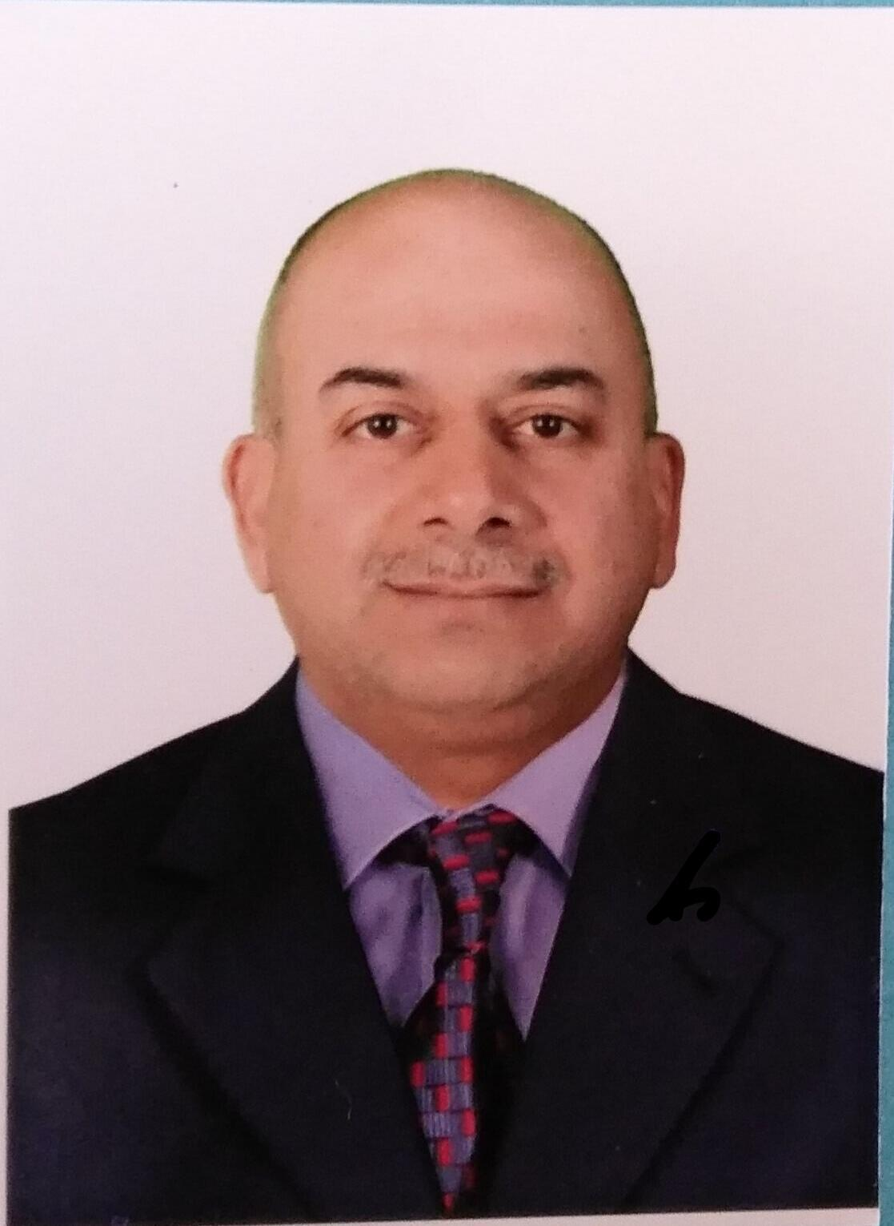 Curriculum Vitae
Full name (first, second, third, fourth) | Ahmed Salman Hammood Hamad
Job position | University of technology
Academic position | Assistant Lecturer
Official Email | 10702@uotechnology.edu.iq)

Profile
Education:
Technical Diploma in Mechanical Techniques - Iraq
B. Eng. Mechanical Engineering - Iraq, M.Sc. Aircraft Production Technologies - Ukraine.
3- Academic experience:
University of Technology, Assistant Lecturer, 2004- until now, full time.
4- Non- Academic experience
Non
current membership in professional organizations:
Member of the Iraqi Engineers Association

Important links
Google scholar | https://scholar.google.com/citations?authuser=1&user=IJQiF_sAAAAJ
Research gate profile | https://www.researchgate.net/profile/Ahmed_Salman
Publons Profile | researcher/2971661/ahmed-salman/
ORCID ID | https://orcid.org/0000-0001-6432-1901

Research Interest
Aircraft Design _ Composite Materials _ Program-CAD-CAM

Publications
1- Optimization of Machining Parameters for MRR and Surface Roughness for 7024 AL-alloy in Pocket Milling Process.

2- Improving the Properties of Acrylic by Creating Crack Using Laser Beam. IOP Conference Series: iopscience.org - Materials Science and Engineering . Vol . 579 , No.1. IOP Publishing , 2019. P. 012042.
3- Synthesis of Polymers by a Solar Photocatalytic Microreactor System. Global Journal of Researches in Engineering: C Chemical Engineering Volume 17 Issue 2 Version 1.0 Year 2017.
Teaching
Scientific Supervisor / in the training center and laboratories / lathe and CNC machining CAD - CAM
- Teaching aircraft maintenance material/ mechanical engineering department / aircraft branch/ fourth stage

Honors and Awards
Honors and Awards:
*Letter of thanks from the Minister of Higher Education and Scientific Research (3)
*Letters of thanks from the President of the University of Technology.(12)

