CURRICULUM VITAE

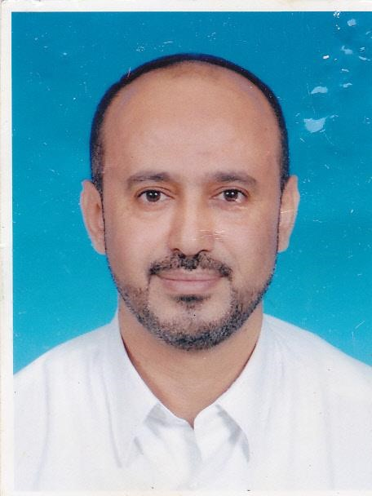
Personal Information:
Surname: Al-mohamadi
Given Name: Salah Mohammed Abdulhabeb
Address: 01-13-01 pinang hights
Jalan Pinang Raja 18/2 section 18
40200 Shah Alam, Selangor Malaysia
Hp.No: 0142209690
E-mail: smm.edu@gmail.com
Date of Birth: September, 11, 1969
Place of Birth: Taiz
Nationality: Yemen
Marital Status: Married with two daughters
Objective: To secure a rewarding assignment to lead the educational
Work to its next level through skilful management and by motivating,
training and supporting the team to achieve higher standards of
performance.
Key Skills: Education background, motivation, training, head of admin and leadership
Experience:
September 2015 –present: vice principal of Al Baseerah
Intenational School ShahAlam.
Sep 2014-sep 2015:Head of Administration of Al-Baseerah International school
May .2013 – 9/2014 : Head of boy section Al-Baseerah International School Malaysia.
Sep 2011-May 2013: Discipline master of Al-Baseerah International school
/92008 to /92009: Vice Director of the Office of activity and Al-Dawah
Al-Forqaan School in the State of Qatar, Doha.
We got first place in the activity and advocacy through our work at the
school with honors through innovation and excellence in performance.
performance. Appreciated 87%.
September.2007 – September.2008: vice principal of Geel Al- Amjad private school YEMEN
Where the school is located more than forty classrooms, 60 teachers and
more than 1,200 students.
September.2006 to. September 2007: Director of the School of Yemen in Djibouti
September.2003 to. September 2006: A teacher of science and biological material for secondary
School of Yemen in Djibouti.
September.1994 to. September 2003: A teacher of science for secondary school students , Geel Al-
Amjad private school Yemen.
During these years, got certificates of appreciation and an excellent
degree in education from the Ministry of Education
Vocational Training:

25 – 27february 2013 : 3 days Towards Professionalism in Teaching, Seminar
Organized by Baseerah International School Malaysia
25Jun-3 July 2011: 7 days(60 hours) Administrative Development Skills
By GOLF BOARD FOR HUMAN DEVELOPMENT
27Junuary -6 February 2009: Period of training in Charitable Activities work.
By SHEIKH EID CHARIYT ASSOCIATION In Al-Doha Qatar.
22 May 2007 to 28 May 2007 : Training course in the field of school administration By The Ministry of
National Education and Higher Education in Djibouti.
12 July 2006 to24 August 2006: Training course in medical laboratories –( routine testing)
By National University in Yemen.
Education:
23/May 2014-15Feb2016: Master of Business Administration from Lincoln university Malaysia
The field of human resources.
September 1988 to October 1992: Bachelor's degree in Education in biological
From the University of Taiz - Yemen .
27february 2013 : Diploma of Administrative Development Skills
By GOLF BOARD FOR HUMAN DEVELOPMENT.
Languages: English: Very good written and oral skills.
Arabic: Excellent written and oral skills.

Reference: Dr.Mohamed Mahmoud El-Sayed Nasef
Professor
Faculty of Chemical and Natural Resources Engineering
Universiti Teeknologi Malaysia
Tel. No.006-07-5535561 Fax.006-07-5581436
E-mail: mahmoudeithar@fkkksa.utm.my

Dr.Mohammed Abdu Khalid Mahdy
Assistant professor
Department of Parasitology
Faculty of Medicine
Sana,a University Yemen
Tel.no.00967-4-215702
E-mail: alsharaby9@yahoo.com

