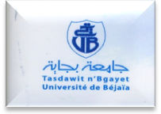
جامعة بجاية
Université de Bejaia
Faculté des Lettres et Langues.

Aboudaou
Tél :
Tél. : Tél : 34/22/15/42
Fax : Fax : 34 /22/15/47
كلية الآداب و اللغات- أبو داو
الهاتف: 034/22/15/42
الفاكس: 034/22/15/47

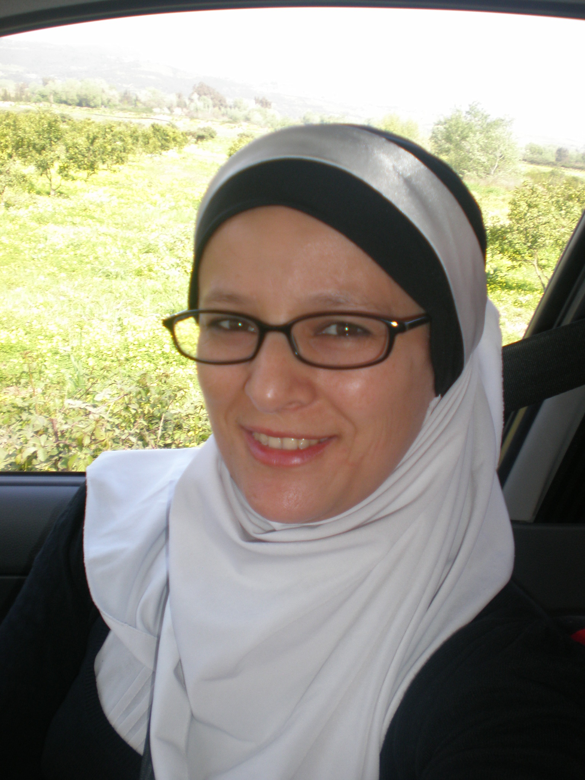

Curriculum Vitae

- Personal Information
- Full Name : Nadia Idri د. نادية ايدري
- Date of Birth (M/D/Y) : 08/03/1979
- Professional address: Department of English, Faculty of Arts and Languages, University of Bejaia
- Cellular Phone : ++213 774 90 77 30/669 39 95 46
- E- mails : nadia.idri@univ-bejaia.dz, nadiaidri@gmail.com n_idri@yahoo.co.uk
- ORCID/ ID : http://orcid.org/0000-0001-6245-1884
- https://scholar.google.com/citations?user=JRJ_zGgAAAAJ&hl=fr
- Degrees, Trainings, contributions and Professional Development:

- Participation in the Setif Innovation Hub online training organized by MBI Algeria Campus dans les formations suivantes:
- ''Planning Learning : what should every teacher know and do" by Lounis Tamrabet, 20 May 2020.
- Build a marketing Plan by Mohamed Ketfi, 1 june 2020
- Evaluate the necessary resources and organisations, 2 June, 2020
- Creating value with values, 3 June 2020
- The challenge to convince your future partners by Mohammed Yahyaoui, 5 June 2020
- Evaluate with Design Thinking, 13 June 2020
- 18 to 20 May, 2020: participation in the symposium webinar about “internationalization of higher education during the COVID-19 crisis” organized by Tehran University of medical sciences education development centre.
- May 2020 until now; Syllabus designer at Owlypia INC., UK
- March 2020 until now: Ambassador at Owlypia competitions and an organizer of the all its online rounds and at MASSA School (www.owlypia.org)
- November 2019 until now: Cactus Foundation advisor and collaborator: https://cactusglobal.com/mental-health-survey/
- 2018 until now: Director of the private school: MASSA School in Bejaia and a trainer of teachers in the professional development series in the school.
- September, 2017: An Evaluator of newly recruited teachers at Bejaia University.
- From 07 to 18 May, 2017: An evaluator of Bejaia university’s structures as part of the sub-committee of the University’s relation with the socio-economic world
- March, 20th, 2017: Participation in the correction of exam copies of the national contest “councours d’admission pour l’obtention de bourse de formation à l’étranger” at saad dahlab university, Blida, 1
- March, 5th, 2017: Participation in the elaboration of the exams of the national contest “councours d’admission pour l’obtention de bourse de formation à l’étranger” at saad dahlab university, Blida, 1
- Mobility Scholarship in Erasmus Mendus, Mobile+ in the University of Porto, Portugal from December, 12th to December, 17th, 2016.
- May, 28th, 2016: University of Mouloud Mammeri, Tizi Ouzou: Accredited to supervise research (habilitation en langue et literature anglaise, HDR)
- May, 29th, 2016: Participation in the second edition of training teachers on how to write a research paper for publication at Mohamed Lamine Debaghine, Setif 2 University (Trainer of teachers).
- 2015-2016: Designing the linguistics’ master for the “harmonization” purpose required by the Ministry of Higher education and scientific research at a national level.
- November, 7th, 2015. A trainer and an organizer of teachers in the first Algerian English Teachers’ Training (AELTT) workshop (the Alumni Engagement Innovation Fund Winning Project, sponsored by the US embassy). https://alumni.state.gov/aeif-2015-winners with a one hour workshop entitled: Classroom Management: Rule the Class with your Leaners.
- June, 9th, 2015: Participation in training teachers on how to write a research paper for publication at Mohamed Lamine Debaghine, Setif 2 University (Trainer of teachers).
- June, 1st and 2nd, 2015: Training at the Department of English at Bejaia University of Statistics in Scientific Research.
- May, 21st, 2015: One day training on “Personal and Professional Development” in Oracle Language School.
- April, 2nd, 2015: One hour online webinar organized by NILE (UK) on: Feedback and Assessment in Content and Language Integrated Learning.
- June, 25th & 26th, 2014: Participation in the teachers’ training workshop on how to design a language course on integrating notions of civic education organized by Babel Language School in partnership with the Middle-East Partner Initiative (MEPI” de US Embassy on: “Critical Thinking, Decision-making techniques, Democracy and Participation, and Citizenship.
- PhD in Didactics of English: Fear of Negative Evaluation as a Variety of Anxiety in Foreign Language Learning: the Case of First Year LMD Students of English in Abderrahmane-Mira University- Bejaia at ‘University Constantine 1. http://bu.umc.edu.dz/theses/anglais/IDR1360.pdf
- May, 14th & 15th 2014: Participation in the First Teachers’ Training Workshop on Teaching Civic Education through Language Training organized by Babel Language School in partnership with the Middle-East Partner Initiative (MEPI” de US Embassy on: “Critical Thinking, Decision-making techniques, Democracy and Participation, and Citizenship.
- June, 2012: Zotero training; levels 1 and 2 ; a bibliographic research software (University of Grenoble, France).
- Professional development trainings in French universities: Paris X, Grenoble, Montpellier, Aix en Provence, Marseille.
- 2009: Attended the “Teaching ESP Workshop” organized by Syken College and Oxford University.
- June 2006: A first post-graduate degree in educational psychology and teaching foreign languages (Magister), University Ferhat Abbas, Setif.
- June, 2003: A Bachelor of Arts in English, University Ferhat Abbas, Setif.
- July, 1998: Baccalaureate in Arts and Social Sciences, Setif.
- Scientific Productions (Papers, book reviews, chapter of books)
Author | Title | Journal or House/ Publication | Volume/Issue | Month/Year | p.p. | Indexation/URL
Dr.  Nadia Idri | محمد هاني عبود & ونادية ايدري  العالقة بين االلتزام الديني وقوة األنا لدى عينة من طلبة الجامعة الهاشمية | مجلة الدراسات النفسية و التربوية- جامعة السلطان قابوس | 14.3 | جوان 2020 | 398-416 | http://dx.doi.org/10.24200/jeps.vol14iss3pp398-416
Dr.  Nadia Idri | Exploring the Effectiveness of Teacher Education Programmes to Enhance Teacher-Students Relationship: The Case of Secondary School Teachers at Ain Beida – Oum El Bouaghi  (co-author: Nour El Houda Khiari) | Academic Review of social and human studies, Section (C) Literature and Philosophy | Vol 12 N° 01 | 2020 | pp : 232 - 244 | EISSN: 2437-0320  Facteur d'impact ASJP: 0.0402  https://www.asjp.cerist.dz/en/article/109326
Dr.  Nadia Idri | a need-based evaluation of an oral presentation course at Bejaia University: perspectives and considerations (Co-author: Amina Kimouche) | Journal of studies in Language, Culture and Society (JSLCS) | 2/2 | Dec/2019 | 30-41 | E-ISSN:1750-2676  http://univ-bejaia.dz/jslcs/images/doc/JSLCS-issue-Vol%202-03-December-2019.pdf
Dr.  Nadia Idri | Intergration of Learners with Special Needs: A Socio-cultural Clue to Debate  In L’enseignement inclusif pour l’intégration sociale en Algérie :  Réalité et perspectives à la lumière  des expériences aguerries | Université de Bejaia/CASAM | / | May, 2019 | 109-118 | ISBN: 978-9931-9563-0-3
Dr.  Nadia Idri | The Effect that Fear of Negative Evaluation has on EFL Learners’ Oral Performance ‘co-author, Akkar, S) In In Alexandra M. Columbus (ed.). Advances in Psychology Research | Advances in Psychology Research | 133 | March, 2018 | 115-140 | https://novapublishers.com/shop/advances-in-psychology-research-volume-133/
  ISBN: 978-1-53613-270-0
Dr.  Nadia Idri | A Study of the Frequency of Language Learning Strategy Use: The Case of Master I Students In, Nadia Idri (ed.). English Language studies: voices from novice researchers. (co-author: Kedjar, L.) | Mauritius: Editions Universitaire Européenes | / | Jan, 2018 | 06-20 | ISBN : 978-620-2-27581-1
Dr.  Nadia Idri | La violence verbale et comportementale dans les établissements primaires : constats et témoignages | Actes du colloque national: Figures de la violence en Algérie: aspects psychologiques et sociologiques (coordonné par Pr. BOUATTA Cherifa). |  | Décembre 2017. | 106-114 | ISBN : 978-9931-9141-4-3
Dr.  Nadia Idri | Spelling errors of the language transfer and cultural origins Among Beginner Algerian EFL Learners in Writing | Revue Almostalah, Université de Tlemcen | N° 14 | Décembre, 2017 | Pp 15-32 | ISSN : 1112-3923
Dr.  Nadia Idri | The Effect of Group Counseling Based on the Modification of Negative Self-Statements on Reducing Gender-Biased Foreign Language Anxiety among Ajloun National University Students (co-author: Mohammed H. Abood) | Journal of Educational and Psychological Studies - Sultan Qaboos University (JEPS) | Vol.11 Issue 4, | Oct, 2017 | 730-735 | https://journals.squ.edu.om/index.php/jeps/issue/view/173  ISSN: 2218-6506  E-ISSN  2521-7046
Dr.  Nadia Idri | Writing Business Letters across Languages: A Guide to Writing Clear and Concise Business Letters for Translation Purposes | Arab World English Journal (AWEJ). | 7/4 | Dec/2016 |  | www.awej.org  ISSN: 2229-9327
Dr.  Nadia Idri | Les enjeux de la  Didactique de la Traduction au sein de l’Université algérienne: «hier,  aujourd’hui et demain » (With Hichem Benmokhtari) | Cahiers de Linguistique et Didactique | 16 | December, 2016 | 80-91 | ISSN : 2335-1780,  https://www.asjp.cerist.dz/en/article/6903
Dr.  Nadia Idri | Review of the book Sampling and Choosing Cases in Qualitative Research: A Realistic Approach, by N. Emmel | The Journal of Language Teaching and Learning, | 6/2 | 30 June, 2016 | 88-89 | ISSN: 2146-1732,  www.jltl.org
Dr.  Nadia Idri | Chapter 4: Professional Teaching Dispositions: Perspectives from North Africa  In: Dispositions in Teacher Education : A Global Perspective, Edited by Anita G. Welch and Shaljan Areepattamannil  https://link.springer.com/chapter/10.1007/978-94-6300-552-4_4  DOI. 10.1007/978-94-6300-552-4_4 | Sense Publishers, The Netherlands | / | June, 2016 | 79-102 | ISBN: 978-94-6300-550-0 (paperback)  ISBN: 978-94-6300-551-7 (hardback)  ISBN: 978-94-6300-552-4 (e-book)
Dr.  Nadia Idri | The Relationship between Personality Styles and Academic Self-Efficacy among Jordanian EFL Learners  (co-author Dr. Mohammed Hani Abood) | Emirates Researh Publishing Limited (editors: Pr. Michel Plaisent & Dr. Lili Zheng) | / | May, 24th, 2016 | 24-28 | ISBN 978-93-84468-54-5
Dr.  Nadia Idri | Focusing Teacher’s Practices, Learners’ Attitudes and Study Skills Through Action Research | Arab World English Journal (AWEJ). | Vol 6. N° 4 | December, 2015 | 261 - 274 | www.awej.org  ISSN: 2229-9327
Dr.  Nadia Idri | Research Design, Creating Robust Approaches for the Social Sciences | Arab World English Journal (AWEJ). | Vol 6, N° 3 | September, 2015 | 424-426 | www.awej.org  ISSN: 2229-9327
Dr.  Nadia Idri | Suggesting a Support Centre for Dissertation Writing in EFL at Bejaia University | Arab World English Journal (AWEJ). | Proceedings | August, 2015 | 42-53 | www.awej.org  ISSN: 2229-9327
Dr.  Nadia Idri | Book Review : Social Network Analysis | Arab World English Journal (AWEJ). | Special Issue on CALL, N 2 | July, 2015 | 226 – 229 | www.awej.org  ISSN: 2229-9327
Dr.  Nadia Idri | Zotero Software: A Means of Bibliographic Research and Data Organisation; Teaching Bibliographic Research | Arab World English Journal (AWEJ). | Special Issue on CALL, N 2 | July, 2015 | 124-133 | www.awej.org  ISSN: 2229-9327
Dr.  Nadia Idri | Book Review: Social Science Research: From Field to Desk | Arab World English Journal (AWEJ). | Vol.6, N° 1. | March, 2015 | 420-422 | www.awej.org  ISSN: 2229-9327
Dr.  Nadia Idri | Foreign Language Learning and the Creation of Anxiety in Students: the Case of First Year Students of English in the University of Bejaia; LMD System Group | Al Athar | 20 | June, 2014 | 23-36 | ISSN 1112-3672  Dépôt légal N 392/2002  SJIF 2012 = 3.572
Dr.  Nadia Idri | Algerian University Students’ Pragmatic Failure when Speaking EFL: Teachers’ Views and Strategies | The European Procedia of Social and Behavioural Sciences (EpSBS) | Vol 01 | 2014 | 229-236 | 2301-2811
Dr.  Nadia Idri | Nick EMMEL (2013). Sampling and Choosing Cases in Qualitative Research: A Realistic Approach. Book Review for SAGE | Methodspace, online |  | Janvier, 2014 |  | http://www.methodspace.com/group/bookreviews/forum/topics/nick-emmel-2013-sampling-and-choosing-cases-in-qualitative?xg_source=activity
Dr.  Nadia Idri | Investigating Social Anxiety among First Year LMD Students of English at Bejaia University and Coping Strategies  https://platform.almanhal.com/GoogleScholar/Details/?ID=2-55644 | Revue des Science Sociales et Humaines, Ouargla | 13 | Décembre 2013 | 21-35 | ISSN 1121-2170
Dr.  Nadia Idri | A Child’s school Diary from the Lens of a Professional Educator: Case of Chouhadaa Hamoum Public School, Bejaia | European Journal of Social and behavioral Science (EJSBS) | Vol 8(5) | Octobre, 2013 | 1264-1275 | ISSN 2301-2218
Dr.  Nadia Idri | Investigating the Potential Sources of Fear of Negative Evaluation among Eleven Algerian University EFL Learners: A Qualitative Analysis In Psychology of Fear: New Developments | Editeur: Marta N. Purcella Nova Publishers, Inc ; New York | Livre  collectif | Octobre, 2013 | 53-68 | ISBN : 978-1-62808-888-5
Dr.  Nadia Idri | Book review: Borgatti, S. P., Everett, M. G. & Johnson, J. C. (2013). Analyzing Social Networks. London: SAGE. | Methodspace, online |  | Juillet, 2013 |  | http://www.methodspace.com/group/bookreviews/forum/topics/book-review-borgatti-s-p-everett-m-g-johnson-j-c-2013-analyzing-1?xg_source=activity
Dr.  Nadia Idri | Le retour sur la prise de bougie 1833 | Actes du colloque dirigé par Dr Settar OUATMANI: Bejaïa, Ville d’Histoire et de Civilisation | Livre collectif | Juin, 2013 | 181-192 | ISBN : 978-9931-9141-0-5  Dépôt légal : 2491-2013
Dr.  Nadia Idri | Using Multimedia Labs in Enhancing EFL Students’ Research Methods Skills | Multilinguales | 01 | Juin  2 013 | 80-93 | ISSN: 2335-1535
Dr.  Nadia Idri | Book Review; Research Design, Creating Robust Approaches for the Social Sciences, Stephen Gorard (2013 |  | Methodspace, online | Mai, 2013 |  | http://www.methodspace.com/group/bookreviews/forum/topics/book-review-research-design-creating-robust-approaches-for-the?xg_source=activity
Dr.  Nadia Idri | Education and Reform to Reach Autonomous Learners: Between Reality and Myth | Procedia - Social and Behavioral Sciences | 69 | 2012 | 2174 – 2183 | ISSN : 18770428
Dr.  Nadia Idri | Foreign language anxiety among Algerian EFL students: The case of first year students of English at the university of Abderahmane Mira-Bejaia; LMD (Licence/Master/Doctorat) system group | Universal Journal of Education and General Studies (UJEGS) | Vol 1(3) | Mars 2012 | 055-064 | ISSN: 2277-0984
 | “Sources of FNE among First Year LMD1 Students of Abderrahmane Mira University” | Procedia - Social and Behavioral Sciences | 29 | 2011 | 1932-1941 | http://ac.els-cdn.com/S1877042811029107/1-s2.0-S1877042811029107-main.pdf?_tid=56783ada-56b1-11e5-89d2-00000aab0f6c&acdnat=1441775716_5673eb0f3817770a8e248d747c0b1e39
 | Foreign Language Learning, Classroom Interaction and Lack of Motivation: the Case of First Year Students of English in the University of Béjaia; LMD System Group | Le Forum de l’enseignant, ENS Constantine, | N° 8, | Juin, 2011 | pp 204-221 | ISSN. 1112-5101
 | Algeria and Educational Development; the LMD System as an Algerian Step towards Globalisation in Higher Education | The Future of Education | / | March, 10th, 2010 | Online blog | http://www.futureofeducation.com/profiles/blogs/algeria-and-educational
 | La Psychologie de l’Enfant Africain et le Droit de l’Education | The Future of Education | / | March, 10th, 2010 | Online blog | http://www.futureofeducation.com/profiles/blogs/la-psychologie-de-lenfant
 | The LMD System Experience as a Struggle between the Educational Development and Reform: An Analytical Study of the Endeavour of the Academic Year 2004/2005 in Bejaia University with Suggested Solutions | Education Resource center (ERIC) |  | 2005 | ERIC Number: ED504547 | http://files.eric.ed.gov/fulltext/ED504547.pdf
 | Fourth International Anthology on Paradoxism (author: Florenin Smarandache) | Editura ELMAROM, Râmnicu Vâlcea | / | 2004 | 10-11 | ISBN 973-8467-19-5
- Conference, Workshop & Study Days Presentations
Author | Title of the Presentation | Place | Dates | Year | observation
 | “Ethics in Higher education: Legislations, Perceptions and Practices”  (co-author: Ahmed Chaouki Hoadjli) | Mohamed-Cherif Messaadia University, Souk Ahras, Algeria  http://www.univ-soukahras.dz/fr/wp-content/uploads/2020/03/conference-leaflet-converti.pdf  http://www.univ-soukahras.dz/fr/wp-content/uploads/2020/03/national-conference-march-11-12.pdf | March 11th – 12th, | 2020 | National Conference:  The Algerian EFL Student and University Work
 | Une génération accro aux écrans: la cyberdépendance; sorte d’héroïne numérique (co-author : Zahir Ahouari) | University of Bejaia  http://univ-bejaia.dz/Fac_Sciences_Humaines_Sociales/images/PGR/Relations_ext/Colloques/Argumentaire%20L%20addiction%20au%20virtuel.pdf | 2 March | 2020 | l’addiction au virtuel de l’usage à la dépendance, une problématique émergente en Algérie ?
 | L’éducation pour tous: favoriser l’alphabétisation à travers le développement de la formation, stratégies d’enseignement et la compétence scripturale; cas de Bejaia (co-authors : Dalila Bensalem & Samiha Akkar) | University of Bejaia  http://193.194.94.3/Fac_Lettres_Langues/fr/548-alphabetisation-en-langues-nationales-et-etrangeres  http://193.194.94.3/Fac_Lettres_Langues/images/prog%20bon.pdf  http://193.194.94.3/Fac_Lettres_Langues/images/colloque240.png | 24-02 | 2020 | L'alphabétisation en langues nationales et étrangères: pratiques actuelles et perspectives d'avenir
 | Présentation du processus de publication dans the Journal of studies in Language, Culture and Society (JSLCS) | Université de Bejaia  http://univ-bejaia.dz/Fac_Lettres_Langues/images/programme%20jrn.pdf  https://www.facebook.com/Webtv.universite.de.Bejaia/videos/146416882994551/ | 5-6 et 9-10 février | 2020 | Les journées portes ouvertes sur la bibliothèque : Patrimoine documentaire enrichi par les productions scientifiques et littéraires des enseignants de la Faculté des Lettres et des Langues.
 | Table ronde : Recherches didactiques et créativité littéraire dans les départements des langues étrangères | Université de Bejaia  http://univ-bejaia.dz/Fac_Lettres_Langues/images/programme%20jrn.pdf  https://www.facebook.com/Webtv.universite.de.Bejaia/videos/146416882994551/ | 5-6 et 9-10 février | 2020 | Les journées portes ouvertes sur la bibliothèque : Patrimoine documentaire enrichi par les productions scientifiques et littéraires des enseignants de la Faculté des Lettres et des Langues.
 | Moral issues and Professional Competence: Towards  an Ethical Generation of Researchers | La Doctoriale, Université de Bejaia | 15 et 16 Janvier | 2020 | Research Themes’ Choice, Reasoning,  and Development to measure  Undertakings Competencies in EFL,  Higher Education and Scientific Research  Field
 | Different Discourse, Different Linguistic and Social Behaviours: A Conversation Analysis in Context among Bejaia Community | Université de Bejaia | 8-9 janvier | 2020 | الندوات العلمية التكويتية لفائدة طلبة الدكتوراه
 | Le rapport entre l’éducation inclusive et les pratiques dans l’enseignement supérieur. Entre attitude, culture universitaire et réalités | Université de Bejaia  http://www.univ-bejaia.dz/Fac_Lettres_Langues/documents/LUniversite%20algerienne%20et%20les%20pratiques%20inclusives%20Projet%20Journee%20Thematique.pdf | 28janvier | 2019 | la conférence internationale qui porte sur L’Université algérienne et les pratiques inclusives. De la réalité aux perspectives.
 | French Linguistic and Cultural Hegemony in a Multilingual Context: Case of the Department of English, Bejaia University | Université de Bejaia  http://univ-bejaia.dz/Fac_Lettres_Langues/images/pdf/Actes%20colloque%20Bejaia%202015.pdf | Le plurilinguisme et le pluriculturalisme : Problématiques sociolinguistiques, littéraires et didactiques | 2018 | Le plurilinguisme et le pluriculturalisme : Problématiques sociolinguistiques, littéraires et didactiques
 | Tips to write a successful academic essay | The fourth creative local library, Bejaia | October, 15th, | 2018 | writing and academic writing competitions in Algeria (CWAWC 2018),
 | Reading to Write an Academic Research Paper | University of Bejaia  http://univ-bejaia.dz/Fac_Lettres_Langues/images/second%20metodology%20seminar%20oct%202017.pdf | 16 october | 2017 | The EMICOB's Second Methodology Seminar for Master and Doctorate Students:  The Day’s Theme: “Basics in Research Methodology”
 | Strengthening cultural identity through reinforcing multilingual education in primary schools | University of Batna 1 | 15-16 May | 2017 | Speaker and coordinator in the national conference about “the mother tongue and its relation to Foreign languages” in collaboration between University of Batna 1, University of batna 2 and Students’ national Solidarity (SNE)
 | Investigating the ICT Sources Perception and usage by the Algerian EFL Teachers | University of Bejaia | May, 8th | 2017 | Best paper Award Prize of the Second academic writing competition with Rima Outmoune
 | Autonomy and Professional Development | University of Bejaia | May, 8th | 2017 | Workshop presenter, founder and chair of the academic writing and creative writing competetions
 | Relating Shakespeare’s language to Emotionality: A Humanistic Aspect | University of Bejaia  http://univ-bejaia.dz/Fac_Lettres_Langues/images/poster.pdf | May, 8th | 2017 | Speaker, chair of the national study day entitled: the Study Day on “The 400 Anniversary of William Shakespeare’s Death: A Year Later to Not Forget” held on May 08th, 2017 at the Faculty of Arts & Languages, University of Bejaia, Algeria.
 | Social Apprehension: the Learner and the Other, a Source of reluctance to Speak in EFL Classes” | University of Bejaia | April, 25th | 2017 | Speaker at the conference organized in collaboration between the department of English and the students’ scientific club BEST entitled: Students’ Reluctance and Unwillingness to communicate”
 | Designing and carrying out a research project: from Vague ideas to a narrowed down topic | LESMS Research Lab, University of Bejaia  http://webtv.univ-bejaia.dz/index.php/tag/the-emicobs-first-methodology-seminar-for-master-doctorate-students/ | February, 27th | 2017 | Speaker, chair and session chair of the “EMICOB’s First Methodology seminar for Master and doctoral Students”
 | Languages for travel and tourism at Bejaia | University of Bejaia  http://univ-bejaia.dz/Fac_Lettres_Langues/images/1er%20Workshop%20sur%20Les%20langues.pdf | 17 january | 2017 | Speaker at the “premier workshop sur les langues dans l’économie algérienne”
 | Les langues d’entreprises maritimes à Bejaia: étude des cas d’un consignataire | University of Bejaia | 17 january | 2017 | Speaker at the “premier workshop sur les langues dans l’économie algérienne”
 | “Integration of learners with special needs: A socio-cultural clue to debate” | University of Bejaia  http://www.univ-bejaia.dz/inclusif/Argumentaire%20du%20Seminairec.pdf | 3-4 december | 2016 | Actes du séminaire national organisé  les 03 et 04 décembre 2016  L’enseignement inclusif pour l’intégration  sociale en Algérie :  Réalité et perspectives à la lumière  des expériences aguerries  Speaker and reporter,
 | Train the EFL student’s mind to think critically through leadership principles: | University of Bejaia  http://univ-bejaia.dz/Fac_Lettres_Langues/images/fll/Colloque%20national%20Anglais.pdf | 22-23 november, | 2016 | National Conference on  Teaching and Learning Civic Education through EFL in Higher Education:  Case Studies  22nd and 23rd November, 2016  Speaker, session chair, scientific and organizing committee member
 | Language and Culture in Algerian EFL Classes: The Syllabus Revisited (With Houria Halil) | University of Batna 2 | 16-17 november | 2016 | 1'st international seminar entitled: foreign  language teaching and intercultural awareness, organized by the English department at  batna2 university on November 16tn , 17th 20.16'  Speaker (co-author: Houria Halil)
 | “Let’s Share my First English Workshop” | ABP El Djazzeir School, Bejaia | Academic year 2016-2017 |  | Chair of the series of the workshops for kids (age 4 to 6 and 7 to 14), lessons’ designer
 | From First Step Manuscript Writing to Publication; the Process | Sétif 2 University. | 28 may | 2016 | trainer
 | The Relationship between Personality Styles and Academic Self-Efficacy among Jordanian EFL Learners | La Rochelle business school, University of Quebec | 24-25 May | 2016 | The international conference on Studies in Humanities and social sciences (SHSS). Presentation, session-chair and best presented paper of the session
 | La violence verbale et comportementale dans les établissements primaires : Constats et témoignage | University of Bejaia, Laboratoire Interdisciplinaire Santé et Population  http://univ-bejaia.dz/Fac_Sciences_Humaines_Sociales/images/PGR/Recherche_Scientifique/Actes%20Colloque%20_%20Figures%20de%20la%20Violence%20en%20Algerie.pdf | 10 et 11 mai | 2016 | Colloque National: Figures de la violence en Algérie: Aspects psychologiques et Sociologiques
 | Les enjeux de la Didactique de la Traduction au sein de l’Université algérienne : Hier, aujourd’hui et demain | Université d’Oran 2, Laboratoire de la linguistique, Dynamique du Langage et Didactique (LDLD)  http://tesniere.univ-fcomte.fr/ressources/AffichageTRADETTAl2201fv.pdf | 7 et 8 mai | 2016 | 7ème colloque International en Traductologie et TAL (TRADETAL), co-auteur : Hichem BENMOKHTARI
 | The Effect of Fear of Negative Evaluation on EFL Learners’ Oral Performance | Maison de la Culture, Bejaia | 16 april | 2016 | Third position Best paper Award Prize of the Second academic writing competition with Samiha Akkar
 | Organisation of the play “The Matter of Educaion” performed by 7 to 13 years old. | Maison de la Culture, Bejaia | 16 april | 2016 | The First academic writing and the second creative writing competitions
 | The publish or Perish Principle for Writers | Maison de la Culture, Bejaia | 16 april | 2016 | The First academic writing and the second creative writing competitions : Speaker, event chair and founder
Dr. Nadia Idri | Classroom Management: Rule the Class with your Leaners. | Bejaia | 7 November | 2015 | first Algerian English Teachers’ Training (AELTT) workshop: Trainer and Organizer
Dr. Nadia Idri | The Role of Facebook Groups in Shaping Self-regulated Learning | University, 8 Mai, 1945,Guelma  http://www.univ-guelma.dz/fr/national-conference-intercultural-communication-digital-age-november-3%E2%80%904-2015 | 3-4 november | 2015 | National Conference: Intercultural Communication in the Digital Age: Scientific committee member and a participant
Dr. Nadia Idri | Coping with Students’ Writing Procrastination through Self-regulated Learning | Foreign Languages Policy in Algeria and Teacher Professionalism” (FLPATP)  Tlemcen university  http://asels.org/wp-content/uploads/2014/01/University-of-Tlemcen.pdf | 20-21 October | 2015 | International Conference: Applied Linguistics and Foreign Languages Teaching: Participant
Dr. Nadia Idri | The Aspect of Fear and Ethnic Profiling in Zighen Aym’s Tale: “Still Moments” | Department of English and the Laboratoire d’Étude des Langues et Cultures Étrangères, Université de Tizi Ouzou | October, 1st | 2015 | Study Day in English Postgraduate Research on: The Applicability of Academic Theories to Cultural Studies and Linguistic Topics and Corpuses
Dr. Nadia Idri | Methodological Issues to Consider in Academic Writing and scientific Publication: Case of Social and Human Sciences | Sétif 2 | 9 June | 2015 | Trainer: Workshop Training Sessions on Writing an Academic paper for Teachers
Dr. Nadia Idri | Whisper to the World to Change or Shout at the Word to Change | Bejaia | 19, 20 May | 2015 | The Best Creative Writing Days Workshops
Dr. Nadia Idri | Tips to Write a Research paper | Bejaia | 19, 20 May | 2015 | The Best Creative Writing Days Workshops
Dr. Nadia Idri | Writing a Thesis: A Challenge for Language Teachers and Learners; Towards Suggesting a Writing Support Centre | Bejaia, | 21st, April, | 2015 | International Conference: Innovation in Teaching and Learning English: New Approaches and Methods (Plenary Session) (Conference Chair)
Dr. Nadia Idri | Focus on Professional Teaching Dispositions:  Cases from Higher Education ELT Practices | Bejaia, http://univ-bejaia.dz/Fac_Lettres_Langues/documents/International%20Conference%20April%2021-22.pdf | 21st, April, | 2015 | International Conference: Innovation in Teaching and Learning English: New Approaches and Methods (Workshop) (Conference Chair)
Dr. Nadia Idri | Questioning Academic Writing Performance among Masters Students: English for Academic Purposes Perspectives  Case of Bejaia University | Online : video conference (the Oxford University Press/University of Sheffield) | 15-16th Jan 2015 | 2015 | OUP/ELTC Online EAP Conference: The Cultures of EAP,
Dr. Nadia Idri | The Reality of Using Technological Tools as a Means of Data Collection in Higher Education. Cases of Dropbox, SurveyMonkeys, emails, Zotero and Googlegroup | Bejaia | 18 et 19 November 2014 | 2014 | La Révolution Numérique: Enjeux et Perspectives dans l’Apprentissage et l’Enseignement des Langues (Plenary Session)
Dr. Nadia Idri | Zotero Software : A means of Bibliographic Research and Data Organisation for Masters | Bejaia  http://univ-bejaia.dz/Fac_Lettres_Langues/fr/recherche-scientifique/manifestations-scientifiques | 18 et 19 November 2014 | 2014 | La Révolution Numérique: Enjeux et Perspectives dans l’Apprentissage et l’Enseignement des Langues (Workshop)
Dr. Nadia Idri | Algerian University Students’ Pragmatic Failure when Speaking EFL: Teachers’ Views and Strategies (oral presentation + Poster online at:  http://www.c-crcs.com/files/menu_items/other/24c.pdf  http://www.c-crcs.com/files/menu_items/other/24d.pdf | Mersin, Turkey | 14-17 May | 2014 | The Annual International Conference on Cognitive - Social, and Behavioural Sciences
Dr. Nadia Idri | Longitudinal Study on LMD System; Teaching, Learning and Administrative Practices: Between theory and Practice; Case of the Department of English, Bejaia University. | Bejaia, Algeria  http://univ-bejaia.dz/documents/Study-day-The%20LMD-System-in-the-Algerian-University.pdf | 13 May | 2014 | Study Day : « The LMD System : Realities, Experience an Expectations » Chair of the event (Plenary Session)
Dr. Nadia Idri | A Child’s school Diary from the Lens of a Professional Educator: Case of Chouhadaa Hamoum Public School, Bejaia | Antalya, Turkey | 02 – 05 October | 2013 | International Conference on Educational and Educational Psychology (ICEEPSY)
Dr. Nadia Idri | Le retour sur la prise de bougie 1833 | Bejaia, Algeria | 30-31 October | 2012 | International Conference : Bejaia : Ville d’Histoire et de Civilisation (Workshop)
Dr. Nadia Idri | Education and Reform to Reach Autonomous Learners: Between Reality and Myth | Istanbul, Turkey. | 10-13 October | 2012 | International Conference on Educational and Educational Psychology (ICEEPSY)
Dr. Nadia Idri | Using Multimedia Labs as a Facilitator in Enhancing EFL Students’ Research Methods Skills: Case of First Year Students of English at Bejaia University, Research Methodology Teaching | Bejaia, Algeria | 1-2 July | 2012 | Towards a Technology-based ELT in Higher Education (Conference chair)
Dr. Nadia Idri | Introducing Social Networking and Virtual Classrooms to Promote the Algerian EFL Instruction and Out of Class Language Learning
Dr. Nadia Idri | Présentation du système LMD : composantes, évaluation et Développement | Bejaia, Algeria | 16 April | 2012 | Study Day: Le système LMD dans Tous Ses Etats
Dr. Nadia Idri | Interculturality: A Study of Language Transfer, French Influence and the Common Errors in Spelling Among Beginner Algerian EFL Learners | Université de Skikda. | 16-17 janvier | 2012 | Colloque national : L’interculturalité dans tous ses états
Dr. Nadia Idri | Sources of FNE among First Year LMD Students of Abderrahmane Mira University | Istanbul, Turkey | 19-22 October | 2011 | International Conference on Educational and Educational Psychology (ICEEPSY)
Dr. Nadia Idri | The Role of Continuous Evaluation and Tutoring in Achieving Learners’ Autonomy within the LMD System  The Case of A-Mira University (2004-2008) | Setif, Algérie | 11-12 April | 2011 | National Conference: PROMISES AND CHALLENGES OF THE ALGERIAN UNIVERSITY AFTER THE FIVE YEAR REFORM (Workshop)
Dr. Nadia Idri | Foreign Language Learning, Classroom Interaction and Lack of Motivation: the Case of First Year Students of English in the University of Bejaia; LMD System Group | ENS Constantine, Algeria | 11-12 January | 2010 | National conference: Learning Strategies and pedagogical  Implications (Plenary Session)
Dr. Nadia Idri | The LMD System Experience as a Struggle between the Educational Development and  Reform: An Analytical Study of the Endeavour of the Academic Year 2004/2005 in Bejaia University with Suggested Solutions | Bejaia, Algérie | 4-5 December | 2005 | International Conference : Le dispositif LMD : Problèmes et perspectives

- Published Books

Author | Title of the book | House of Publication | Date | Year | ISBN
Dr. Nadia Idri | English Language Studies; Voices from Novice Researchers, (ed) | Editions universitaires européene | janvier | 2018 | 978-620-2-27581-1
Dr. Nadia Idri | Fear of Negative Evaluation in an EFL Setting: An Algerian Case study | Editions universitaires européene | november | 2016 | 978-3-639-832-31-0

- Supervision
- BA students

Année | Nom et Prénom | Intitulé | Régime
2003-2004 | Karim Medjkoun | The Effect of Lack of Motivation on Learning English as a Foreign Language : the case of first year LMD students in the University of Bejaia | Ancien système
2006-2007 | Lamia Ait Saidi et Mourad Temine | Errors Caused by the French Interference on English Words’ Selling : Case of First Year LD English Students ; G 1 and G2 | LMD
2006-2007 | Lyna Sebbah | The Effect of Teachers’ Style on the Foreign Language Students’ Learning Process. | LMD
2006-2007 | Nassima Meridj | The Effect of Risk-taking on Foreign Language Students’ Motivation in Speaking English in Oral Sessions : The Case of Third Year LMD Students ; Language Sciences and Didactics | LMD
2006-2007 | Farida Allaouat | the Contributing Factors to Errors in Writing with a Reference to Error Analysis | LMD

- Master students

Année | Nom et Prénom | Intitulé
2008-2009 | Farida Allaouat | Investigating how Classroom Incivilities Affect High School Teachers’ Self-esteem: The Case of High School EFL Teachers of Literary Stream at Lycee Hafsa – Akbou
2008-2009 | Meriem Manseur | Searching for Reasons of EFL Students’ Pragmatic Failure during Classroom Oral Communications. The Case of Oral Expression Teachers of Third Year L.M.D Students of English
2008-2009 | Karima Radjoukh | The Effect of Oral Corrective Feedback of EFL Learners’ Oral Errors on their Communicative Competence. Case study: First Year LMD Students, Studying English as a Foreign Language at Bejaia University
2009-2010 | Nassim Chabane | Investigating Potential Sources of Fear of Negative Evaluation Among First Year LMD Students of English at Bejaia University
2009-2010 | Nessrine Mouyet | Investigation of the Communication Apprehension Producing Factors among EFL Learners : The Case Study of First Year LMD Students of English at Bejaia University
2010-2011 | Latifa Kedjar | Study of Language Learning Strategy Use and its Effect on earners’ Perception of Autonomy: The Case of First Year Master I Students of English at Bejaia University
2010-2011 | Rahima Ouadi | The sources of FNE experienced by pupils at the Lycee of Adakar, and the Strategies that both students and teachers use to cope with these sources.
2011-2012 | Hanifa Rabhi | Foreign Language Anxiety as a Consequence of EFL Students’ Negative Beliefs on the Instructors’ Evaluation
2012-2013 | Amina Benkhellouf | Learners' Perception towards Using Cooperative Learning in Oral Sessions: The Case Study of third year LMD Students of English at Béjaia University
2012-2013 | Fatiha Boudjrida | The Effect of Teacher’s Negative Feedback on the Instructor-Learners Interaction. Case Study: Second Year LMD Students of English at Béjaia University
2012-2013 | Fatma Zahra Aissou | - Enhancing and Facilitating Students’ Research Methods Skills through the Integration of Multimedia Labs: Case of First Year LMD Students of English at Abderrahmane Mira University of Béjaia, Subject: Research Methodology Teaching.
2012-2013 | Sabiha Bouti | - Investigating Teachers’ and Learners’ Beliefs towards Learner Autonomy: Between Beliefs Elicited Regarding Theory and practice. The case study: third year LMD students of English at Bejaia University  (co-supervisor : Linda Khenoune)
2013-2014 | Nawel Kadri | The Effect of Self-regulated Strategies on Students’ Procrastination in the Writing Process. Case Study: Third year LMD, LSD Students at the Department of English at the University of Bejaia
2014-2015 | Samiha Akkar | The Effect of Fear of Negative Evaluation on EFL Learners Oral Performance: Case of Third year LSD Students, University of Bejaia
2014-2015 | Linda Tighzer | Exploring the Link between Code Switching and ESL Learner‘s Oral Performance: Case study: Intermediate ESL Students at C.I.L.A, University of Napoli) (co-supervisor : Dr. Judit Papp, University of Napoli)
2014-2015 | Aziz Brahmi | The Effect of Vocabulary Gap on Third Year Students’ Academic Writing. Case of Essay Writing in English.
2015-2016 | Mouhoub Ait Atmane | Investigating the Role of Oral Presentation Projects in Enhancing EFL Learners’ Oral Proficiency.
2015-2016 | Rima Outmoune | Investigating the ICT Sources Perception and Usage by Algerian Teachers
2016-2017 | Dounya Graini | Raising English Foreign Language Learners’ Communicative Competence through Culture Based Content.  Case Study: Third Year LMD Students of English at the Department of letters and English Language, University of 8 Mai 1945-Guelma. Co-supervision with Mrs. Lassoued Sabrina from the University of Guelma
2016-2017 | Baya Belouassa & Katia Touloum | The Effect of Communicative Listening Activities on Developing Learners’ Communicative Competence  Case Study: First Year Students of English at Bejaia University
2017-2018 | Sara ZOUAOUI | Using Short Stories to Teach Culture  Third Year LMD Students as a Case Study
2018/2019 | BELKACEMI Nabila & ABDELLI Meriem | Language Conflicts; an LPP Outcome: Case of Tamazight Officialisation ; LPP in The Light of the Recent Arab-Berber Movements
2018/2019 | Hareb Sabrina Berkouki Siham | Language Conflicts; an LPP Outcome: Case of Tamazight Officialisation ; LPP in The Light of the Recent Arab-Berber Movements

- Doctoral Students

N° | NOM /PRENOM | Title | Year
1 | Djihane MELLIT | : Raising EFL learners’ Motivation to Read Literary Texts through Using Literary Works – Based Films. The Case of Second Year LMD Students of English at Setif Univerity | 2016
2 | Mouad LAHMER | A Diagnosis of Students’ Reading Difficulties through the Use of the IELTS General Training Reading Test : The Case of Students of English at the University Abderrahmane Mira, Bejaia | 2016
3 | Houda KHIARI Nor El | Developing Social Skills as an Emotional Intelligence Competence to Enhance EFL Teacher – Student Relationship : The Case of First Year Secondary School EFL Students and Teachers in Ain Beida – Oum El Bouaghi | 2016
4 | Mimouna DJOUAD | The Effects of Integrating Teaching Simulation as a Pre – Training Programme on Pre – Service Teachers’ Anxiety Case of third Year LMD Students in the Department of English Language and Literature at Mohamed Lamine Debaghine , Setif 2 University | 2016
5 | Bilal DRIBI | Algerian Arabic and French as a Mixed – Code among University students : The Case of Jijel University Students | 2016
6 | Amina KIMOUCHE | Exploring EFL Master Students’ difficulties in Academic Oral presentation through Action Research : towards Designing a Curriculum at the department of English at Bejaia University | 2016
7 | Dalila BENSALEM | Promote EFL Learners Self-regulation in Writing through Neuro-linguistic Programming. The Case of First Year Pupils at Fatma Nsoumer Secondary School | 2018
8 | Samiha AKKAR | Developing an ESP Curriculum for HSE Students : The case of INSFP students  of Bejaia, Algeria | 2018

- Taught Subjects

Post-graduate levels:
English for sociology magister students, English for doctoral Students of Tamazight, Document-based research, educational psychology and ELT for doctoral student of English.
Graduate and undergraduate levels: Linguistic schools and concepts, general linguistics, soliolinguistics/ethnolinguistics, , didactics, TEFL, writing, speaking, grammar, research methodology, study skills, methodology of the university work, bibliographic research, evaluation in EFL, writing up a research paper, portfolio/didactics of the pedagogic project, theory of scientific research, error, learning and evaluation ; research methods in language learning, content and form consideration of the thesis (APA style).
Detailed Teaching and Pedogogical Tasks :
- 2016-2017: Teaching doctoral students of Tamazight, Teaching educational psychology and document-based research for doctoral students (1st year)
- 2015-2016: Research Methods in Language Learning, Content and Form Consideration of the Thesis, Writing a Research Paper and Didactics of the Pedagogic project (Master I and II: Applied Linguistics and ELT)
- 2014-2015: Teacher of methodology of the university work (first year students), Teacher of Error, Evaluation and Learning (Master II: Applied Linguistics and ELT), teacher of the didactics of the Pedagogic Project/Portfolio (Master II: Applied Linguistics and ELT), Teacher of Research Methods in Language Learning and a teacher of Methodology of Writing a Research Paper (Master I: Applied Linguistics and ELT), Teacher of Teacher of Content and Form Consideration (Master II: Applied Linguistics and ELT),
- 2013-2014: Teacher of Evaluation (Master II: Didactics), teacher of methodology of the university work (first year students), Teacher of Bibliographic Research (Master I: Applied Linguistics and ELT), teacher of the Didactics of the Pedagogic Project/Portfolio (Master II: Applied Linguistics and ELT).
- 2012-2013: Teacher of Research Methodology (3rd year Language Science and Didactics), teacher of evaluation (Master II students; Didactics), teacher and coordinator of methodology of the university work (first year students), teacher of bibliographic research (Master I: Didactics), Teacher of Writing a Research paper (Master I: Didactics).
- 2011-2012: Teacher in charge of research methodology, TEFL and evaluation; a coordinator of the sociolinguistics’ subject and the responsible of Master II level. Teacher of post-graduate students of sociology.
- 2010-2011: Teacher in charge of research methodology and evaluation; a coordinator of the sociolinguistics’ subject.
- 2009-2010 : Teacher in charge of sociolinguistics/ethno-linguistics, research methodology, Evaluation in EFL. I am also coaching two master students, responsible of Master I: Didactics level, Master II (Didactics and ESP), coordinator and responsible of the Research Methdodology Unit.
- 2008_2009: Teacher in charge of general linguistics, sociolinguistics/ethnolinguistics, research methodology, T.E.F.L. and evaluation (master I and master II). Responsible of Master II (Research and ESP), Coordinator of the Methodology of Scientific Research subject.
- 2007-2008: Teacher in charge of general linguistics, sociolinguistics/ethnolinguistics, applied linguistics, methodology of research and the Didactic one of foreign languages (Master I: Didactics).
- 2006-2007: Teacher of research methodology (1^{era} year LMD) and of didactics of foreign languages (3rd year).
- 2006-until now: supervising research projects of end of cycle in linguistics and didactic of languages. (4 in BA and 3 in Master II) and member of jury in several vivas.
- 2006-2007: Designing a syllabus of the master, option: Didactic of English and option: Business English.
- 2005-2006: Teacher of linguistic concepts and schools and research methodology (1st year, LMD).
- 2004-2005: teaching linguistic concepts and schools at the Department of English at the university of Béjaia (1st year).
- 2003-2004: teaching grammar, oral expression and written expression at the Department of English at the university of Sétif (2nd and 3rd years) and of linguistics at the Department of English at the university of Béjaia (3rd year students). I also taught English at the institute of chemistry, University of Setif.
- September - December 2003: teaching of English at Merabti Ali middle school, Tizi El Oued Souk El Tenine Béjaia.

- Reviewing, Editing Experience

- Reviewer at: European Journal of Social and Behavioral Science (EJSBS) , Arab World English Journal (AWEJ), Educational Research Journal, Herald Journal of Education and Language Teaching and Learning.
- Reviewer at the Journal of Social Sciences, Sétif 2, Algeria.
- Member of many scientific committees in national and international conferences :
- Intercultural Communication in the Digital Age, November, 3 & 4 2015 ; University of Guelma
- International Conference on Education & Distance Learning (24th - 25th July 2015, Sri Lanka : Co-chair : http://conference.serendivus.com
- Annual International Conference. Cognitive-Social and behavioural Sciences :
- International Conference on Education and Educational Psychology (ICEEPSY) since 2012 : http://www.c-crcs.com
- April, 21 & 22, 2015: International Conference: Innovation in Teaching and Learning English: New Approaches and Methods. University of Bejaia.
- November, 18 & 19, 2014 : La Révolution Numérique: Enjeux et Perspectives dans l’Apprentissage et l’Enseignement des Langues, University of Bejaia.
- May, 13, 2014 : The LMD System : Realities, Experience and Expectations : a Study Day. University of Bejaia.
- July, 1 & 2, 2012: Towards a Technology-based ELT in Higher Education. University of Bejaia.
- Member of the scientific committee in various scientific journals and organisms :
- Future Academy, Cognitive-crcs (http://www.c-crcs.com/Content.aspx?code=14&description=Editorial Board ICEEPSY)
- European Journal of Social and behavioral Science (EJSBS) (http://www.futureacademy.org.uk/ContentConference.aspx?code=196&conference_code=160&description=Editorial%20Board )
- Arab World English Journal (AWEJ), (https://www.awej.org/index.php/advisory-board )
- Journal of Language Teaching and Learning (http://www.jltl.org/html/reviewers.html)
- European Journal of Social and Behavioral Science (EJSBS)
- International Journal of English and literature (editor and reviewer) ISSN: 2141-2626
- : https://academicjournals.org/journal/IJEL/editors
- International Journal of English and Literature, SSN: 1996-0840
DOI: 10.5897/AJFS, http://www.academicjournals.org/IJEL

- Chairing Scientific and Academic Events :

- Chair of the one-day conference on: L’Université algérienne et les pratiques inclusives. De la réalité aux perspectives to be held on January, 28th, 2019 at Bejaia university
- 12-02-2017 to 16-04-2017: Organisation of a Training Course course of weblog writing held at the University of Bejaia to support English Language learning presented by Miss Nawel Mansouri (Researcher at the University of the West of Scotland, UK)
- 09/02/2017 to 06/04/2017: Organisation of a Training Course course of Interactive Theatre held at the University of Bejaia to support English Language learning presented by Miss Souad Smaili (Researcher at Northampton University, UK).
- May, 8th, 2017: Chair of the national study day entitled: the Study Day on “The 400 Anniversary of William Shakespeare’s Death: A Year Later to Not Forget” held on May 08th, 2017 at the Faculty of Arts & Languages, University of Bejaia, Algeria.
- May, 8th, 2017: Chair and founder of The Third Edition of the Academic Writing and Creative Writing Competitions,
- April, 16th, 2016: The First academic writing and the second creative writing competetions : Speaker, event chair and founder
- Co-chair of the International Conference on Education & Distance Learning (24th - 25th July 2015, Sri Lanka : Co-chair : http://conference.serendivus.com/index.php/main/loadEducationAndDistanceLearning
- May, 19-20, 2015 : The Founder and the chair of the Creative Writing Days (Competetion of students’ creative writings and organized teachers’ workshops).
- April, 21-22, 2015 : Chair of the International conference : Innovation in Teaching and Learning English : New Methods and Approaches, Bejaia.
- 13, May, 2014 : Study day : The LMD System in the Algerian University : Realities, Experiences and expectations, Bejaia
- July, 1 & 2, 2012 : Chairing the National Conference : Towards a Technology-Based ELT in Higher Education Bejaia.
- Administrative, Pedagogic and Scientific Functions and Participation

- January, 2020: An advisor and collaborator at CACTUS Foundation on the Mental Health Survey: https://cactusglobal.com/mental-health-survey/
- Editor in chief of the Journal of studies in Language, Culture and society (JSLCS), University of Bejaia (http://univ-bejaia.dz/jslcs)
- Associate editor of the Journal of Traduction et Langues” of the University of Oran.
- A member of the team in charge of the “Moodle” platform and an evaluator of the productions of newly recruited university teachers issued from the training: “ICT and Pedagogical Practices” (August 2017 to September 2017).
- A selected member of the partnership between the University of Bejaia and the university of Guelma in supervising mobility master students from Batna during the academic year 2016/2017.
- A volunteer member of the “Cellule d’accompagnement, de sensibilisation, d’appui et de médiation (CASAM) of the University of Bejaia since december 2016.

- A member of the “Quality Assurance Cell” in charge of the internal evaluation of the university since November, 2016.
- Responsible of the master: Applied Linguistics and English Language Teaching from 2013 until now. The master will change its name and content into “Linguistics” starting from 2016/2017 until December 2019.
- In charge of the mobility Project (hosting master students) between the university of Mostaganem and the University of Bejaia in April, 2015.
- Coaching BA and MA research projects, examiner and board of reviewers’ chair in many master defense days.
- Member in the faculty’s scientific committee since 2006.
- Member of the recruitment committee of the faculty since 2011.
- Elected as the chair of the scientific committee of the Department of English since 2011 (two turns)
- 03/11/2014: Part of the recruitment committee at the “Agence Thématique de recherché en science de la Nature et de la Vie, Bejaia”.
- Designer of the syllabus of the Applied Linguistics and ELT in 2012-2013.
- A member of the editing committee of the journal MULTILINGUALES of the Faculty of Arts and Languages and the LAILEMM Lab at Bejaia University.
- Member of the scientific committee and sessions’ chair in the: International Conference on Education and Educational Psychology (ICEEPSY 2012, Istanbul, ICEEPSY, 2012, Antalya, Turkey and ICEEPSY 2014, Cyprus, Turkey). www.iceepsy.org
- Responsible of (Master I didactics, Master I ESP and Master II didactics).
- Scientific committee member: and sessions’ chair : “Towards a Technology-based ELT in Higher Education, Bejaia”, July 2012.
- Designer of the syllabus of the Master : Didactics of English in 2007.
- Designer of the syllabus of the Master : English for Specific Purposes in 2007.
- Designer of the syllabus of the third year specialty BA: Language Science and didactics in 2006.
- Designer of the academic Master: Applied Linguistics and ELT, University of Bejaia.
- Other Achievements

- 8 May, 2017: First award of the third academic Writing competition (with the student under my supervision: Rima Outmoune
- 16 April, 2016: Third place award of the second academic writing competition (for the student under my supervision: Miss samiha Akkar)
- September, 2015: Publication of a post word to the book: Souvenir de Constantine published by Guy Ruffino, Paris: Muller Editions.
- May, 19, 2015: Presenting a poem in the creative writing event at Bejaia entitled: Whisper to the World to Change or Shout at the World to change.
- November, 2014: Person in charge of sponsoring in the international conference: La Révolution Numérique: Enjeux et Perspectives dans l’Apprentissage et l’Enseignement des Langues.
- October 2014 : A member of the organizing committee oof the international study day of thedepartment of Arabic, Bejaia : Evaluation of Training in the LMD System in the Classes of Arabic Language and Literature, October, 20th, 2014.
- 2013-2014: Founder and Designer of the academic Master: Applied Linguistics and ELT, University of Bejaia.
- 13 March, 2011 until now : President of the Scientific Committee of the Department of English.
- October, 2006- March, 2011: A volunteer Representative of teachers of the Department of English in the Faculty’s Scientific Committee.
- December, 2006 until now: A member of the Faculty’s scientific committee of the faculty.
- 2011-2012: Responsible of Master II: Didactics
- 2010-2012: Coordinator of the Sociolinguistics Subject.
- 2009-2010: Responsible of Master I: Didactics, Responsible of Master II: Didactics, Responsible of Master II: ESP
- 2009-2010: Coordinator of the Research Methodology Subject (First Year Level)
- 2009: Founder member of the scientific club of the Department of English: the BEST (Best English Students’ Team) to help learners be active at a university setting.
- 2008-2009: Master II: Didactics, Responsible of Master II: ESP
- 2008-2009: Coordinator of the Research Methodology Subject (First Year Level)
- 2006-2007: Designing a syllabus of the masters, option: Didactic of foreign languages and option: business English.
- August,2006: Voluntary training and work at : Consulting, Textile Representations and Achievements (TexEuros: Filiale Algeria) : Translator, in charge of mailing, processing of professionals in the Algerian market.
- A member of the Algerian English Language Teachers’ Training Project (AELTT) ; a finalist project in the Alumni Engagement Innovation Fund (AEUF), 2015 organized by the US embassy (organizer). (https://www.facebook.com/pages/AELTT-Project/1696248990596276?sk=info&tab=page_info).
- October 21 – 11 November, 2004: Alumnus to represent Algeria in the US Exchange Programme: International Visitors: “Youth Leadership I”.
In Perspective :
- Preparing a project (with national and/or international partners for inclusive education in Bejaia University in CASAM cell.
- The Third edition of the Methodology Seminar for October, 2020.
- Project to launch various trainings offered to the socio-economic world at Bejaia via LESMS research lab, Bejaia for 2020.
- Four articles for publication
- Edited book about the Algerian Hirak
- Edited book about “ESP” in the Algerian context
- Textbook: Introduction to Linguistics
- Textbook (co-authored) about: Research Methodology Companion
- Organisation of a fifth edition of the competitions: Creative writing Contest and the Academic writing Contest for students of English, October, 2020.
APPENDIXES
My journalshelp
Here you will find all the journals where you are part of.
- 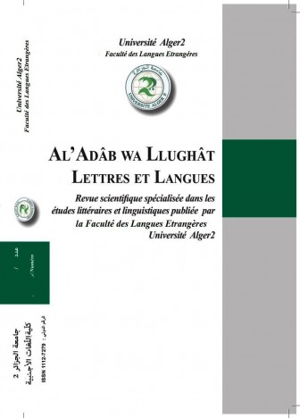
الآداب و اللغات
Sign in as: | - Editor in chief  - Associate Editor  - Reviewer  - Secretary  Withdraw
- 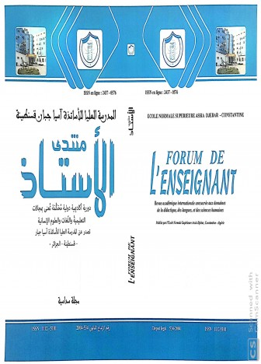
FORUM DE L' ENSEIGNANT منتدى الأستاذ (منتدى الأستاذ)
Sign in as: | - Editor in chief  - Associate Editor  - Reviewer  - Secretary  Withdraw
- 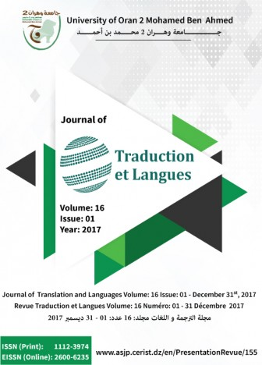
Traduction et Langues (TANSLANG)
Sign in as: | - Editor in chief  - Associate Editor  - Reviewer  - Secretary  Withdraw
- 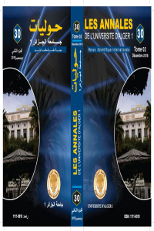
Annales de l’université d’Alger
Sign in as: | - Editor in chief  - Associate Editor  - Reviewer  - Secretary  Withdraw
- 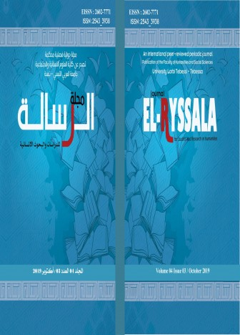
مجلة الر سالة للدراسات والبحوث الإنسانية (JESRH)
Sign in as: | - Editor in chief  - Associate Editor  - Reviewer  - Secretary  Withdraw
- 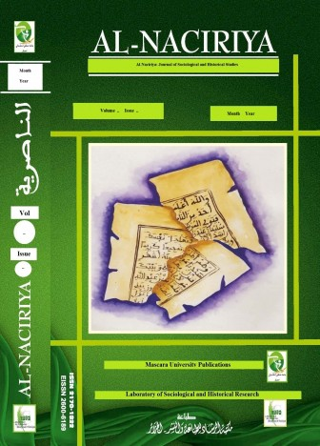
الناصرية (Al Naciriya)
Sign in as: | - Editor in chief  - Associate Editor  - Reviewer  - Secretary  Withdraw
- 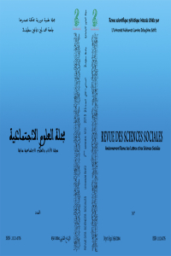
مجلة الآداب و العلوم الإجتماعية (R.S.S)
Sign in as: | - Editor in chief  - Associate Editor  - Reviewer  - Secretary  Withdraw
- 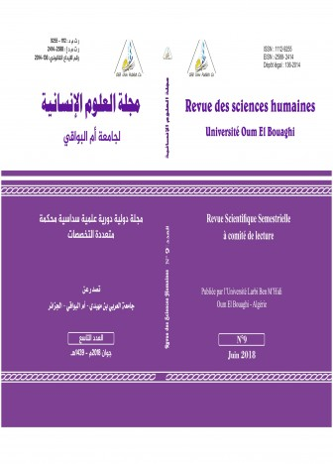
مجلة العلوم الانسانية لجامعة أم البواقي (RSHUOEB)
Sign in as: | - Editor in chief  - Associate Editor  - Reviewer  - Secretary  Withdraw
- 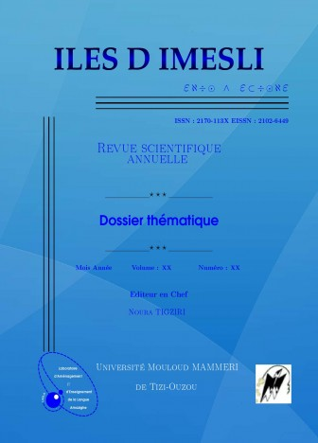
Iles d Imesli
Sign in as: | - Editor in chief  - Associate Editor  - Reviewer  - Secretary  Withdraw
- 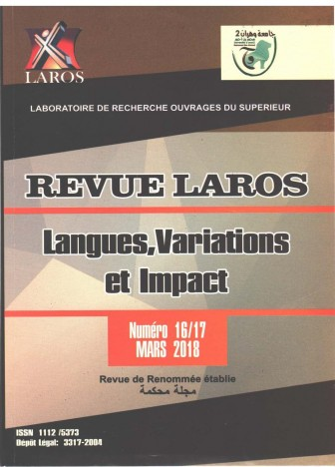
Revue LAROS
Sign in as: | - Editor in chief  - Associate Editor  - Reviewer  - Secretary  Withdraw
- 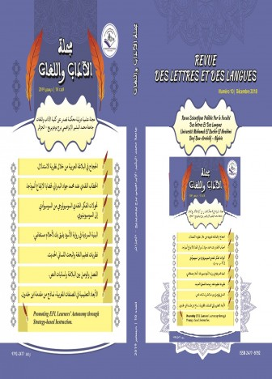
مجلة كلية الآداب واللغات (م آ ل RLL)
Sign in as: | - Editor in chief  - Associate Editor  - Reviewer  - Secretary  Withdraw
- 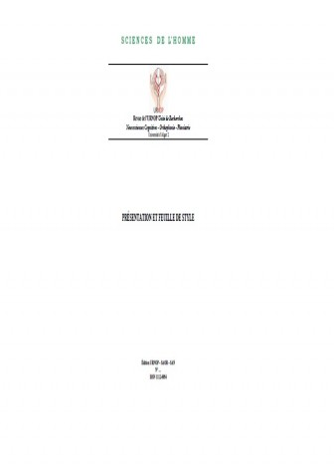
SCIENCES DE L’HOMME (RSH)
Sign in as: | - Editor in chief  - Associate Editor  - Reviewer  - Secretary  Withdraw
- 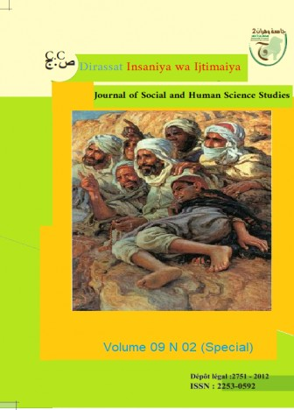
دراسات إنسانية واجتماعية (DHS)
Sign in as: | - Editor in chief  - Associate Editor  - Reviewer  - Secretary  Withdraw
- 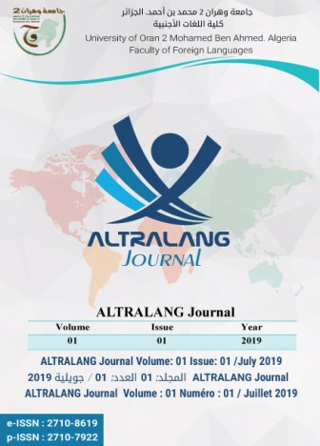
ALTRALANG Journal (Altralang J.)
Sign in as: | - Editor in chief  - Associate Editor  - Reviewer  - Secretary  Withdraw

