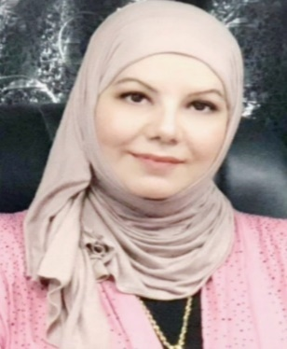
Lecturer. Doctor. Sabreen Sami Abed
Date of birth: oct./6th /1977
Residency: Baghdad / Iraq
Marital status: single
Place of work: Ashur College
Email: sabrinsami2015@gmail.com
Mobile number : 07712288005
Education
- Ph.D. Degree in Oral Histology, Baghdad University/ College of Dentistry, Baghdad Iraq, 2016 – 2018.
- M.Sc. Degree in Oral Histology, Baghdad University/ College of Dentistry, Baghdad Iraq, 2014 – 2015.
- Higher Diploma in Oral Diagnosis, Baghdad University/ College of Dentistry, Baghdad Iraq, 2009 – 2009.
- Bachelor Degree in dentistry, Baghdad University /College of Dentistry, Baghdad Iraq, 1996 – 2000.

Professional Appointments
- Peer reviewer in Publons Academy
- Lecturer , Ashur College / Department of Dentistry 2020.
- Head Department and Lecturer of Dentistry, Al-Turath University, 2018-2019.
- Specialist Dentist, Ministry of Health, 2009-2012.
- G.P. Dentist, Ministry of Health , 2005-2008.
- Residency Dentist, Ministry of health, Baghdad Iraq 2001 – 2005

Publications
- Sabreen S. Abed et. al. 2019. The Epidermal Growth Factor Receptor Expression in Leptin-Treated Traumatic Oral Ulcer in Rats. Journal of Global Pharma Technology 2 019. Vol. 11. Issue 03 (Suppl.) 138-146.
- Sabrin S. Abd et al. 2018. Localization of Decorin in Leptin –Treated Traumatic Oral Ulcer in Rats J. Pharm. Sci. & Res. Vol. 10(8), 2018, 1929-1933.
- Sabreen S. Abed et al. 2019. The Biological Effects of Leptin as Topical Treatment for Traumatic Oral Ulcer in Rats. Annals of Tropical Medicine & Public Health. June 2019 Vol. 20.
- Sabrin S. Abed et al. 2016. Expression of Syndecan 1 on Periodontium treated with Topical Application of Aloe-Vera. Journal of Baghdad college of dentistry. Volume: 28. Issue: 3 Pages: 82-86 .

Awards and Honors
- 4 letters of thanks and appreciation form dean of Al-turath university /2019.
- 1 letters of thanks and appreciation from head of Baghdad university/ 2018.

