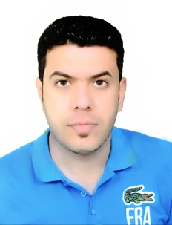
السيرة الذاتية

Name: Anwar Abdul Rahim Ajel Sfaih.
Nascent: 1985
Last Name: Qaraghouli.
Housing: hand Nasr- spend Rifai - Dhi Qar province
Mobile: 07808396797
Academic achievement: Bachelor of management and economy.
Specialization: Economy.
Email: sosoamal77@gmail.com.
Skills: work on the computer, Excel program, Alaakssz, PowerPoint, Word, Photoshop, formic And windows.,
My hobbies:
I love reading books, sports, travel, and reading
My career school:
He studied primary school in Qadisiyah boys' school, and completed and medium-sized Jaafar Taiarellbennin School, and completed a study Prep victory in the junior high boys, and completed university studies in Wasit University College of Business and Economics.

Anwar Abdul Rahim Ajel Sfaih.
Mobile: 07808396797

