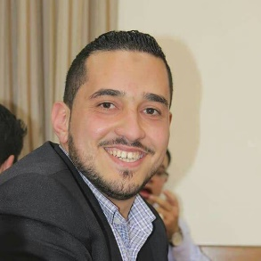
Mohammad Fozat Al-Taani

Irbid, Jordan – Mob. +962 790067608 – E-mail: mft_91@yahoo.com
Personal Information
- Marital status: Married
- Dependants: 3
- Nationality: Jordanian
- DOB: Mar 19th, 1991

Education and Qualifications
- Jordan University (2017-2020)
MA in Educational Psychology /Measurement and evaluation
- Ãl-Albayt University (2009 – 2013)
BA in Physics Studies
- Irbid Secondary School, Jordan (2008 – 2009)
General Secondary Education Certificate
Work Experiences
From To Institution, Location, Work details
01/11 08/13 Computer Maintenance Shop, Irbid (Jordan)
(Repairing computer hardware and software)
08/13 until now Ministry of Education, Amman (Jordan)
(Science and physics teacher 9th -10th grade from 2013-until now)
(Coordinator of Science for grades 9th -10th -11th – 12th from 2014-until now)

Achievements
- Science Network, with QRTA (5/2017- 5/2019), 160 hours
- Coordinator teacher workshop, with QRTA (2018) 18 Hours
- GAP UNESCO Environment Education for Sustainability, with QRTA (9/2016-4/2018),160 hours
- Participated at (Haqiq Initiative) 2016
- A member of the Youth Center, Bayt Ras (2006–2012)
- Self-Engineering Workshop, Injaz (2012)
- Leadership Workshop, Injaz (2011)
- Multiple Intelligence Workshop, Injaz (2011)
- MAHARAT Course, Business Development Center (2010)
- English Conversation Workshop, Ãl-Albayt University (2010)

Skills
- Excellent simulation programs for science (crocodiles clip , phet , yenka , esay plot)
- Excellent in SPSS Program and statistical analysis
- structuring and development test classroom
- Excellent in research method
- Excellent in scale construction and development
- Excellent communication skills with all ages.
- Excellent leadership skills.
- Excellent presentation skills.
- Time management skills.
- Reliable, hardworking, faithful and loyal.
- Excellent computer skills especially in Microsoft Office (word ,excel ,power point ,front page ,one note ,publisher ,acces).
- Ability to work with others and under pressure.
- Ability to work individually and as an effective team member.
- Ability to face problems.
- Punctual.

Knowledge
- Excellent background knowledge in Arabic language
- Good background knowledge in English language

References
Available upon request

