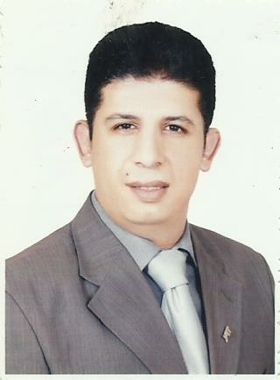
Curriculum Vitae

Ahmed Hafez Elaraby

+201282828050

CAREER OBJECTIVE

Seeking a suitable position in a growth – oriented company, known for its professionalism and integrity. Secure a challenging position in the hospitality business that offers variety of tasks with an opportunity to utilize solid practical work experience combined with strong business geared education, skills and knowledge.

PERSONAL PROFILE

∙Hardworking and result – oriented.
∙Able to work under pressure.
∙Good interpersonal skills and great adaptability.
∙Confident, optimistic and team leader skilled.
∙Able to rationally organize own work.

WORK EXPERIENCE
Learning center coordinator may 2010 - present
YAT EDUCATION CETERS
∙follow up lcmis system for all customers .
∙Delivery customers all the books with lcmis
∙Help customers solve all their problems
∙Coordination with technical support and customer service as well as for all courses.
∙Create and modify sessions on the system
∙Fair work place for all sessions and inform the Director and management in case of problems for customers

Accounts System coordinator January 2008-may2010
Jebel Ali Golf Resort & Spa; Dubai Heritage Vision LLC; Bateaux Dubai LLC

- Check and confirm all tasks about Axapta.
- Review all operations of all sections accounts with the system record
- Design and create all the files with excel .
- Preparing city ledger deductions for payroll accountant.
- Finalize monthly collection reports / fund flow / monitoring payables and receivables.
- Preparing reports including weekly, monthly and Yearly Credit reports and journals vouchers.
- Reporting directly to Account Manager.

Manager of Maintenance
Ela lamia company for computer(ucc) May 2001-December 2004
- Solve all the problems related maintenance
- Follow-up maintenance companies
- Reporting daily maintenance as well as at the end of each month

Technical Support Specialist December 2004-December 2007
YAT EDUCATION CENTERS (Port Said Branch)
1) Diagnose hardware and software problems, and replace defective components.
2) Perform data backups and disaster recovery operations.
3) Maintain and administer computer networks and related computing environments, including computer hardware, systems software, applications software, and all configurations.
4) Plan, coordinate, and implement network security measures in order to protect data, software, and hardware.
5) Operate master consoles in order to monitor the performance of computer systems and networks, and to coordinate computer network access and use.
6) Perform routine network start up and shutdown procedures, and maintain control records.

Test Centre Administrator December 2004-December 2010
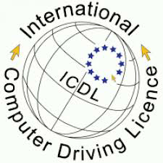
Person Vue & Prometric & ICDL On Yat Learning Solutions

- Reporting head office manager.
- Handling all operation from Maintenance.
- Opening all servers testing ( prometric and vue ).
- Upload and download all result for test centers .
- Print daily scheduling
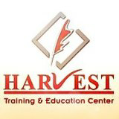

Harvest Training College (Port Said Branch)
International Language & Computer Center – ILC
- Instruct IT courses
- Instruct Computerized Accounting
- Instruct Graphics Design Diplomas
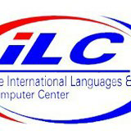
- Make work shop on Programming Projects

QUALIFICATIONS
∙Bachelor of quality controller
Bachelor of Arts and Education

LANGUAGES

∙ Arabic – native
∙ English – excellent
∙ French – fair

IT Information

Microsoft Business Solutions Axapta, ( 4.0 , 2009 )
OS Platforms (Microsoft Windows XP, Vista , seven ,win8.1, server (2003, 2008-2012)
Office applications ( office 2000 , 2003 , 2007 , 2010-2013-2016 )
Isa server (2006 ,2004 ) + TMG
Auto cad ( 2009 -2012 )

Certificates Information

- Computer Driving Licence (ICDL) v4.0
- Windows Server® 2008 Network Infrastructure, Configuration
- Windows Server® 2008 Applications Infrastructure, Configuration
- Pro: Windows Server 2008, Enterprise Administrator
- Deploying and Maintaining Windows Vista Client and 2007 Microsoft Office System Desktops
- MCITP Enterprise administrator on windows server 2008
- Microsoft Technology Associate (Networking Fundamentals -Database Fundamentals )
- Microsoft Office Master Specialist (Microsoft Office 2010 Master Specialist )
- Microsoft Office Expert (Microsoft Excel 2010 Expert - Microsoft Word 2010 Expert)
- Microsoft Office Specialist (Microsoft Access 2010 - Microsoft PowerPoint 2010 )

PERSONAL DETAILS

∙ Place/Date of birth: Port Said, 28th September 1980
∙ Nationality: Egyptian
∙ Religion: Moslem
∙ Marital Status: married
∙ Permanent Address: El-zhor elabor building 1 18 flat
∙ Present Address: portsaid El-zhor elabor building 1 18 flat

∙ Contact No
+201270071661
+201143414404

∙ E-mail: mr.ahmedhafez@hotmail.com
ahmedhafez315@gmail.com
ahmedhafez315@yahoo.com

*Reference available upon request

