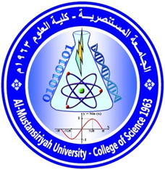
Photo

Name :Dr.Khetam Habeeb Rasool
Specialization: Microbiology /Immunology
Email:khetamhabeeb112@yahoo.com
Phone No.:07904414418
Academic degree: Doctorah
M.Sc. thesis :
Study of Crude Pyocynine and Alginate Extracted from Pseudomonas aeruginosa bacteria On Mouse Immune Response./Biology Department/College of science/AL-Mustansiryah University

PHD thesis:
Bacteriological and biochemical study of oral cancer in Iraqi patients . / Biology Department/College of science/AL-Mustansiryah University
: current field of Interest:
Medical bacteriology
Immunology
Biotechnology
Publications for the last 5 years:

1)THE BACTERIAL PROFILE AND C-REACTIVE PROTEIN OF SUSPECTED SEPTIC NEONATES ADMITTED TO THE AL-KADYEMIA TEACHING HOSPITAL.( 2013 ) International Journal of Recent Scientific Research
Vol. 4, Issue, 6, pp.969 – 971.

2) THE POSSIBLE ROLE OF IL-17 IN PATHOGENESIS OF PERIODONTAL DISEASE.(2013). International Journal of Recent Scientific Research
Vol. 4, Issue, 11, pp.1723-1727.

3)Effects of Coriandrum sativum, Thymus vulgaris, Borago officinalis and
Pimpinella anisum on biofilm Escherichia coli (2014)Journal of Genetic and Environmental Resources Conservation,2(2):219-230.

ترسل الاستمارة الى الاميلات التالية:
Esraa_biotechnology@hotmail.com
Sabask7@yahoo.com

