Curriculum Vitae (CV) Hamzah Al-Shukri
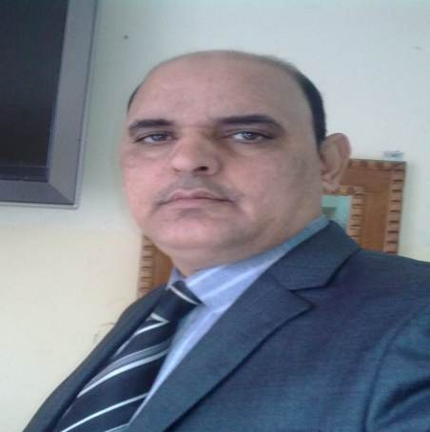

Hamzah Hashem Kzar
Full name: Hamzah Hashem Kzar Lawi Al-Shukri
Place of birth: Al-Qasim, Babylon, Iraq
Date of birth:22 Oct 1972
Nationality: Iraqi
Language : Arabic and English
Place of work: physiology, chemistry, and pharmaceutics department, veterinary college, Al- Qasim Green University
Mobile: +9647823112420
E-mail: hamzahashem16@yahoo.com, hamzahashemqqaa@gmail.com

Academic Scientific Rank
- lecturer (clinical biochemistry) at 4/2/2016
-demonstrator (chemistry) at 1/10/2007

Qualification
- Ph.D.(Clinical biochemistry), Collage of medicine, Babylon University, Iraq (2020).
- M.Sc.(Clinical biochemistry), college of medicine, Babylon university, Iraq (2015).
- B.Sc. (Chemistry), College of science, Babylon university, Iraq(1994).

Title of M.Sc. Thesis
Biochemical and Genetic Study on Patients with Sporadic Colorectal Cancer in Babylon Province.
Department of biochemistry, college of medicine, university of Babylon

Title of PhD Thesis

Study the gene expression of hypoxia inducible factor-1 mRNA alpha and estrogen receptor index in women and cells with breast cancer

Title of B.Sc. project

Study of the optical activity of different monosaccharide that extracted from Citrus peels

Courses taught

undergraduate
-Biochemistry
-Practical Clinical biochemistry
-Chemistry of diseases
-Enzymology

Publications

1-Evaluating the Superoxide Dismutase-1 status in Wild Type and Mutant at codons 12 and 13 of KRAS gene Spectrum for the Patients with Sporadic Colorectal Cancer.

2-Assessment of antioxidant status in different genotypes/phenotypes at codon 72 of TP53 gene for patients with sporadic colorectal cancer in Babylon province.
3-Assessment of Antioxidant Status and Ceruloplasmin in Early and Advanced Stages of Sporadic Colorectal Cancer Patients whom Receiving Adjuvant Chemotherapy.

4-Study the Ascorbic Acid Levels, Lipoprotein Ratio and Hypocholesterolemia Action of Dry Okra Extract on Experimental Model of Locally Male Rabbits.

5-Evaluation of Oxidative Stress Status: Total Antioxidant Ratio in Serum of Patients with Metastasis and Non-metastasis Lung Cancer in Babylon Province.

6-Hypoglycemic effect of boiling aqueous extract of palm heart on alloxan- induced diabetic model of locally rabbits.

7-Study Some of the Risk Factors on Total Antioxidant Capacity in Iraqi Patients with Sporadic Colorectal Cancer

8-Effects of grape seed oil (Vitis vinifera) on fertility of male local rabbits

9-Biochemical and Genetic Study on Patients with Sporadic Colorectal Cancer in Babylon Province.

10-Study the Ascorbic Acid Levels, Lipoprotein Ratio and Hypocholesterolemia Action of Dry Okra Extract on Experimental Model of Locally Male Rabbits.

11. Study the cytochrome P450 gene expression changes in Iraqi patients with chronic liver disease.

12. Spectrum of Human Growth Hormone Receptor Gene Polymorphisms in Physiological Obese Subjects in Babylon province, Iraq.
-------------------------------------------------------------------------------------

Conferences

1- 5th symposium for the role of biochemistry in medicine, 2015, college of medicine, Babylon university
2- Chemical security program CSP ,2016, Babylon university

