CURRICULUM VITAE  DR sahar abdul-rasool  NATIONALITY: IRAQI/SOUTH AFRICAN (dual)  sabdul-rasool@uwc.ac.za  +27735399770  +27216962955  za.linkedin.com  sahar abdul-rasool  Blog :http://sahar-allaboutteaching.blogspot.com  AN ANATOMIST,CLINICIAN, AND RESEARCHER  WHO WORKS TOWARDS BETTERMENT OF HUMANITY  Skills  Science  Molecular Biology  Clinical Research  Research Design  Academic Writing  Anatomy  Embryology  Higher Education  Curriculum Design  Curriculum Development  E-Learning  What sets me a part from other colleagues is my clear vision, persistence ad perseverance to achieve goals and my interpersonal skills which contribute to my success. |  | Experience  May 2008 – Date  Senior Lecturer/ Assistant professor and Head of the Anatomy Cluster at the Department of Medical Biosciences, Faculty of Natural Sciences, University of Western Cape (www.uwc.ac.za)  2007- 2008  Lecturer, Department of Medical Biosciences. Faculty of Natural Sciences, University of Western Cape (www.uwc.ac.za)  2002-2006  University of Cape Town (South Africa):  Part-time employment (Academic rank) involved in teaching Gross Anatomy, Neuroanatomy and Embryology to first and second year medicine and occupational therapy.  Education  MB ChB (1987)  University of Baghdad  MSc(1995)  in Anatomical Sciences  Al-Nahrain University- Baghdad  PhD (2006)  University of Cape town  A fellow of the royal college of physician (london) 2021- date  LEADERSHIP  Developed curriculum, teaching and examination materials in the capacity of a Anatomy Cluster/Module Chair for the first and second- year modules of Dentistry. These courses have been implemented in 2014 till date and have passed the Health Profession Council of South Africa evaluation.  Oversaw and improved the Anatomy curricula in the department of Medical Biosciences.  Developed curriculum, teaching and examination materials in the capacity of a Anatomy Cluster/Module Chair for the first-year Medical Biosciences core Anatomy course (MBS111)  GRANTS  _______________________________________________  2011-2014: A research grant from the Cancer Association of  South Africa (CANSA).  2022: Senate Research Fund grant for 2022

PUBLICATIONS

2022
Taher T, Saadi R, Oraibi R, et al. (May 13, 2022) E-Learning Satisfaction and Barriers in Unprepared and Resource-Limited Systems During the COVID-19 Pandemic. Cureus 14(5): e24969. doi:10.7759/cureus.24969

“COVID-19 Variants of concern”: A multi-faceted approach is needed to enhance the readiness for future variants.
Authors
S Abdul-Rasool, G Hughes
Publication date
2022/5
Journal
Academia Letters

2021
IOSR Journal of Dental and Medical Sciences (IOSR-JDMS)
Volume 20, Issue 8 Ser.6 (August. 2021), PP 38-41 www.iosrjournals.org
Estimation of body height based on the length of tibia in different stature groups
Reshma Fatteh, Jeyaseelan N, Pooja Shree Godaba, Narne Gayathri, P.S Sarath Kumar Miranda Simone Roman, Reece Ranaldo De Buys, Lebogang Moatshe, Sahar Abdul-Rasool

2020
The Synergistic and Neuroprotective Effects of Alcohol‐Antioxidant Treatment on Blood‐Brain Barrier Endothelial Cells
D Fisher, KA Thomas, S Abdul-Rasool
Alcoholism: Clinical and experimental research
Cited by:1

2019
The effect of hyperglycinemic treatment in captive-bred Vervet monkeys (Chlorocebus aethiops)
ZE Magwebu, M Mazinu, S Abdul-Rasool, CG Chauke
Metabolic brain disease 34 (5), 1467-1472

2018
Patterns of copy number alterations in primary breast tumors of South African patients and their impact on functional cellular pathways
K Lupicki, S Elifio-Esposito, AS Fonseca, SH Weber, B Sugita, BC Langa, ...
International Journal of Oncology 53 (6), 2745-2757
Cited by: 3

Autosomal recessive congenital cataract in captive‐bred vervet monkeys (Chlorocebus aethiops)
ZE Magwebu, S Abdul‐Rasool, JV Seier, CG Chauke
Journal of Medical Primatology 47 (2), 93-100
Cited by: 3

2017
Abstract A14: Copy number profiling in South African breast cancer patients
K Lupicki, S Elifio-Esposito, AS Fonseca, A Mahajan, SR Pereira, B Langa, ...
Cancer Research 77 (22 Supplement), A14-A14

2015
Effect of valproate, sodium benzoate and dextromethorphan in hyperglycinemic captive bred Vervet monkeys: 4.1.
Z MAGWEBU, S ABDUL-RASOOL, J SEIER, C CHAUKE
Journal of Veterinary Pharmacology and Therapeutics 38

2015
Top of Form
Copy number analysis of the DLX4 and ERBB2 genes in South African breast cancer patients
BC Langa, MMC Oliveira, SRF Pereira, K Lupicki, C Marian, D Govender, ...
Cytogenetic and genome research 146 (3), 195-203
Cited by :5

2010
Understanding human coronavirus HCoV-NL63
S Abdul-Rasool, BC Fielding
The open virology journal 4, 76
Cited by: 101

2006
An evaluation of molecular markers for improved detection of breast cancer metastases in sentinel nodes
S Abdul-Rasool, SH Kidson, E Panieri, D Dent, K Pillay, GS Hanekom
Journal of clinical pathology 59 (3), 289-297
Cited by:46
___________________________________________________________________

Bottom of Form

POSTGRADUATE STUDENTS SUPERVISION
3.5.4.2. Master Degree:
Graduates:
2011-2012: Ms Zandiswe Emilia Magwebu (Cum Laude)
Thesis title: Molecular Genetics: Strategies to identify congenital cataract genes in captive-bred monkeys.
2009-2013: Ms Bridget Langa (Cum Laude)
Thesis title: Loss of heterozygosity at the interferon regulatory factor-1 gene in South African breast cancer patients.
2009-2013: Mr Beynon Abrahams (Co-supervision)
Thesis title: The effects of various combinations of different classes of anticancer drugs and tyrosine kinase inhibitors on the human MCF-7 breast carcinoma cell line.
2016-2019: Mr Hasan Sharef Geeth Ghanaim
The potential therapeutic role of palm oil on prostate cancer
2016-2020 Ms Sameerah Slahuddin:
Project tile: The anti-cancerous properties of red palm oil. To be submitted in November 2020

Doctoral Degree:
Graduates:
2013-2017: Dr Zandiswe Magwebu
Project title: Hyperglycinemia in captive-bred Vervet monkeys with cataract: genetic dynamics and associations.
2012-2014: Dr Emhemmed Bu Katala (co-supervision)
Project title: Ursolic acid and Oleanolic acid as novel therapeutic targets in breast cancer.

2016-2021 Dr Robin Alvin Booysen (Co-supervision)
Project title: The effects of green tea, green rooibos and their major flavonoids (EGCG and aspalathin) on testicular cell health in vitro

professional SOCIETIES
A life member of the Anatomical Society of Southern Africa.

2021- DATE A fellow of the royal College of physicians LONDON

WORK ON MEDICAL EDUCATION IN IRAQ
October 2021

- Presented three lectures as part of the Medical Education Course that was organized by Royal College of Physicians (RCP) London- Iraq Network. The course was chaired by Prof Hilal Al Saffar, the international advisor of RCP Global in Iraq.

- Presented a lecture on “Literature Review and Proposal Writing” as part of the Medical Research Course that was organized by RCP London- Iraq Network

- Member of the Editorial Board of Al- Anbar Medical Journal (2022 onwards)

CONFERENCE ORGANIZATION

South Africa

- Member of the organizing committee of the 49th Annual conference of the Anatomical Society of Southern Africa from 19-21 April 2022.
https://assa2022.uwc.ac.za/local-organizing-committee
assa2022.uwc.ac.za
- Member of the organizing committee of the 39th Annual Congress of the Physiology Society of Southern Africa (PSSA) from 28- 31 August 2011.
https://physiolsoc.org.za/wp-content/uploads/2015/01/vol6no7.pdf

Iraq (2022)

- The First and Second International Forum for Creativity and Excellence in Contemporary Iraqi Medicine (IFCECIM).
https://imoiq.org/en/

CONFERENCE PRESENTATION

November 2022: Invited speaker at the First International Noor Al- Hayat Fertility Conference, Tripoli, Libya.

2019-2021
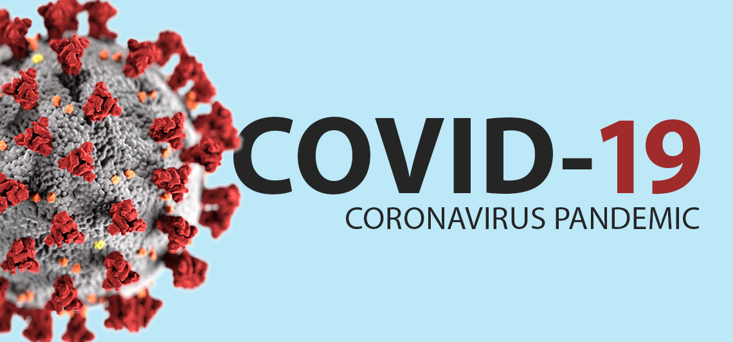
This Photo by Unknown Author is licensed under CC BY-ND

3-5 July 2018 Attended the Cancer Research In Action Conference organized by the Cancer Association of South Africa and the University of Pretoria.

19-22 January 2017 Poster presentation. AACR International conference on New Frontiers in Cancer Research.

14-16 July 2015: Attended the CANSA conference entitled “Cancer research in action”, STIAS Centre, Stellenbosch University, South Africa.

13-16 April 2014 :
S Abdul-Rasool. Keeping abreast of breast cancer: Genomic instability in breast cancer.
Oral Presentation at the “Cultivated Anatomy” 42nd Annual Conference of the Anatomical Society of Southern Africa (ASSA). STIAS Centre, Stellenbosch University, South Africa.

23-27 September 2013: Invited Speaker at the World Conference of Biological and Biomedical Sciences 2013, Dares Salaam, Tanzania. Presentation title: Keeping abreast of breast cancer: Attempts to improve survival.

20-24 April 2013: S Abdul-Rasool, Z Magwebu, Y Seir and C Chauke. Strategies to identify congenital cataract genes in Captive-bred Vervet Monkeys, Oral presentation at the 41st Annual Conference of the Anatomical Society of Southern Africa, Durban, South Africa. (A manuscript has been published in 2018)

14-18 April 2012: B Langa, S Abdul-Rasool, L Cavalli, D Govender and E Panieri, Loss of heterozygosity at the interferon regulatory factor-1 gene in South African breast cancer patients, Poster presentation at the 40th Annual Conference of the Anatomical Society of Southern Africa, Windhoek, Namibia.

14-16 June 2012: Langa B, Oliveira MMC, Abdul-Rasool S, Cavalli LR, Govender D and Panieri E.. Breast Cancer Patients with Triple Negative Phenotype: Attempts to improve survival. Poster presentation at the 6th Biennial Cancer Survivorship Research Conference held in Arlington, VA.

14-16 April 2011: S Abdul-Rasool, Temporomandibular joint disorders: Does the Old dogma stand? Oral presentation Sixth World Conference of the International Iraqi Medical Association held in United Arab Emirates, Sharjah

2-5 November 2010: S Abdul-Rasool and M Afifi. Temporomandibular Joint Disorder: A morphological misplay or a psychological dilemma? An Oral presentation at the 17th Alexandria International Dental Congress, Alexandria, Egypt.

21 November 2008: S Abdul- Rasool, RNA isolation from sperm: Challenges and preliminary results. Joint Seminar between Germplasm Conservation and Reproduction Biotechnologies, ARC- Animal Production Institute, Irene, Pretoria and “Comparative Sperm Biology Group” of Medical Biosciences, UWC

