HAYDER ALAREER 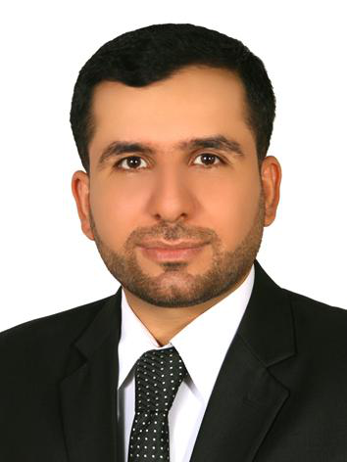

RADIOLOGY TECHNOLOGIST

* Name: Hayder Suhail Najm   
  sex: Male  
  Birthday: 9/12 /1985   
  Nationality: Iraqi   
  Address: Thi Qar/ Alnasriyah   
  Marital state: married   
  Occupation: Radiology Technologist   
  Tel.: (+964)7831918526  
   Email: [hayder.suhail85.hs@gmail.com](mailto:hayder.suhail85.hs@gmail.com)

**ACADEMIC**

_College of Health and Medical Technology / Baghdad 2007/2008

Bachelor of radiological Techniques.

_Tehran University of Medical Sciences /Iran 2017-2018

Master of Radiology Technology.

- Tehran University of Medical Sciences /Iran 2018-2021

PhD student research stage.

**LANGUAGE**

Arabic (Native)

English (Good)

Persian (Good)

Training courses and certificates   
1- MRI training course medical city / Baghdad – SIEMENS company   
2- workshop training in LIBANON.  
3- European Congress Radiology (ECR) workshop / Vienne – Austria 2013.  
4- IRANIAN congress for Radiology / 2016   
5- Certification of MRI training course for 6 months at IMAM KHUMAINI Hospital / Tehran University for medical sciences.   
6- Certification of Ultrasonography training course for 15 hours at IMAM KHUMAINI Hospital / Tehran University for medical sciences.

Skills

1- computer skills (Microsoft office )   
2- Good People communication   
3- Pharmaceutical Marketing  
4- Working on CT scan & MRI devices for different companies .   
5- Ability to give lectures in radiology (CT-MRI).

6-Supervising research projects that are specialized in the field of medical imaging.