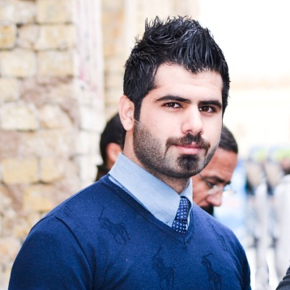

Curriculum Vitae

Personal information:

Name: Hussain Kazim Naif
Nationality: Iraqi
Date of Birth: 05/12/1992
Marital status: Married
Mobile No: 00964 7710303516
Email: sarhang.kazim@gmail.com

Education:

2013-2014 Business Administration institute / accountant Department
Mustansiriya University - college of Literature Department of Media

PROFESSIONAL ACCOMPLISHMENTS:

A graphic designer profession

- professional business card design
- office design templates for companies
- Design Photographic
- logo design for companies
- Advertising design
- Design banner
- Design Styles sites
- 3D design
- Design Flsh

Worked on Swift 3d / Soney Vegas / Swishmax / After Effect / Premiere / Photoshop / Lightroom

- Profession programmer and developer of Web sites
- HTML language
- PHP language
- Javascript

- Maintenance and programming networks

- Maintenance and programming computers

- Digital Imaging
- Nikon D810
- Nikon D7100
- 24 – 120 mm VR
- 18 – 105 mm VR
- OSMO+
- Mavic pro

Basely my job description:

- Thinking creatively to produce new ideas and concepts.
- Estimating the time required to complete the work and providing quotes for clients.
- Developing design briefs by gathering information and data through research.
- Presenting finalized ideas and concepts to clients or account managers.
- Developing interactive design.
- working as part of a team with printers, copywriters, photographers, stylists, illustrators other designers, account executives, web developers and marketing specialists

