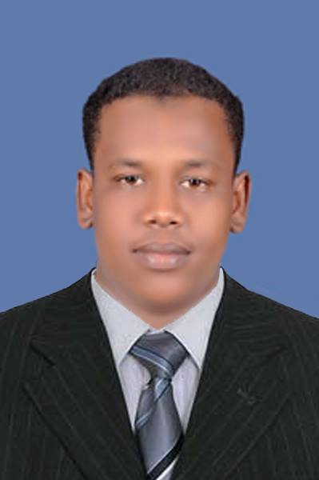
Mr. Ammar Mohamed Hamdnaalla

LinkedIn: amar hamednalla
Email: amarhamednalla@hotmail.com
Tel: 006017-616 46 09
Address: Software Engineering Lab, Block A, FCSIT,
University Malaya, Kuala Lumpur - 50603- Malaysia
Nationality: Sudanese

Objective:
To obtain a full time Software Engineer position, this offers a professional career environment and enables me as a graduate student to grow while meeting the Corporation’s goals.

Education:
Master of Software Engineering (Mix Mode), University of Malaya,
Kuala Lumpur, Malaysia
May 2016

Bachelor of Computer Science and Information Technology, Wadmedani Ahlia
University, Wadmedani, Sudan
January 2013

Professional Interests:
• Software Development Management.
• Object Oriented Technique.
• Software Reusability.
• Software Architecture.
• System Analysis.

Personal Skills:
- Good sense of synthesis and analysis.
- Proactivity, strong initiative and autonomy.
- Change management and adaptability.
- Strong motivation skills and a self-starter, capable of working independently and driving projects through to completion.
- Fantastic communication skills and ability to build relationships with the global team and external clients.

Technical Expertise:
- Tools/Software proficiency:
.NET, Eclipse, UML paradigm, SQL server, MySQL, Microsoft Office 2013 applications, Oracle platform.
- Programming Languages:
Intermediate [C++, Java, SQL, HTML, PHP, CSS, Java Script, C#, ASP.NET].

Projects:
- A Web Forms Generator Based on Database-Schema (Master dissertation University of Malaya)
  - To analyse and identify the limitations of existing techniques or approaches used in generating web forms from database schema.
  - To propose a technique or an approach to generate web forms from database schema that reduces the downtime of web forms.
  - To design and implement a web form generator that incorporates the proposed technique or approach.

- Research Monitoring Seminar (REMOS2014) (During Software Development Master Course)

➢ Position: Head of IT unit
An event aimed to provide a platform for the department of software engineering to evaluate the research progress of MSE students. In addition a registration system and Website have been developed. This seminar enables the supervisors to monitor the progress of their students.

- Web Publishing System (During OOT Master Course)
    - To analyse the given case study to capture the requirements.
    - To design all the UML Diagrams and produce the possible solution.

- Budget finalizing- Ministry of Finance & Economy-SUDAN (base on web application) (Final Year Project).
  - To create a database with a high storage capacity to save the data and reduce manual labor.
  - To facilitate and speed up the search process in the system in several different ways.
  - To establish a security system to determine the users.
Other Activities:
- PYCON Malaysia 2015 (Volunteer Student’s)
Role: Registration, Transportation, Arrangement and other issues during the conference days'
(University of Malaya – FSKTM – Software Engineering Department 2015).
- The First International Workshop on Soft Set-based Decision Making
(University of Malaya – FSKTM - SSDM 2015).
- Global Peace Foundation (Malaysia)
Volunteer at Global Peace Volunteer Malaysia GPV6 Leaderships program (2014).

Experiences:
- Wadmedani Ahlia University (SUDAN)
    - Position: Teacher Assistant
    - Duration: January 2013 – April 2013
    - Role: Teaching Software courses to students.
        - Basic in Computer Science.
        - Object Oriented Techniques.
  - Gezira Hospital For Renal (SUDAN)
      - Position: IT Trainee
      - Duration: May 2012 – September 2012
      - Role:
▪ Computer Networks.
          - Follow-up Program.
Languages:
Arabic, English.

References:
Name: Prof. Dr. Lee Sai Peck
Designation: Professor
Department: Department of Software Engineering
Faculty: Faculty of Computer Science & Information Technology
Tel. No. (Office): 03-79676361 Fax No: 03-79579249
E-mail Address: saipeck@um.edu.my

Name: Dr. Su Moon Ting
Designation: Senior Lecturer
Department: Department of Software Engineering
Faculty: Faculty of Computer Science & Information Technology
Tel. No. (Office): 03-79676369
E-mail Address: smting@um.edu.my
I am writing to apply for the position of Software Engineer at your company. I have graduated from the University of Malaya with a master’s degree in Software Engineering, with a CGPA 3.26. I am keen to apply my knowledge at your company. I believe that my experience, education will make me an excellent candidate for this position.
Education experience and strong technical background as reflected in my course of study (Computer Science(Bsc), Software Engineering (MSE)) affords me the opportunity to be able to analyze problems, work with different kinds of problem solving technology/software, and implement solutions using the various platforms or technologies available. An example is my sound ability to appropriately use Eclipse, Oracle, Paradigm, .NET and Microsoft SQL Server platforms.
Furthermore, practical skills in ‘Software Development Management and Object Oriented Technique’ modules at the university has equipped me for working within project teams in making an immediate contribution to an organization whether in a Business IT role or as a Systems Analyst or tailoring common business applications to suit the needs of the organization, using advance CASE such as OOT, UML and Software Component Reuse made me always enthusiastic to work in a more challenging environment. I have a believe that my programming skills and team management skills that I was partook during my Master’s courses has also helped me in boosting my career confidence.
Apart from academic, I also been actively involved in Volunteer Programs, I had the opportunity to join Global Peace Volunteer Malaysia Camp #6 which is aimed to build a leadership skill and it had a real impact on me, also I joined Python Conference Malaysia (PYCON MY2015) I had a good experience as a Volunteer Student which I had to help out in Registration, Transportation, Arrangement and other issues during the conference days'. The key strengths that I possess for the success in my life so far, I believe, will aid the success in this position as well. I am focused and I strive for continued excellence. I am a self-starter, which means I am pro-active to initiate plans and I participate actively in decision-making. I become a valued member of a team very quickly, but I am also confident in assuming responsibility for tasks autonomously.
In addition, I have had considerable research experience during my master’s degree and my analytic skills are excellent. I believe my enclosed resume outlines an education history and achievements that are relevant to your company. I am interested in being a part of the company and contribute to its success.
I am available for an interview at your earliest convenience. Thank you for your time and consideration. I look forward to a favorable reply from you.

Yours sincerely,
Ammar Mohamed
+60176164609
Amarhamednalla@hotmail.com .

