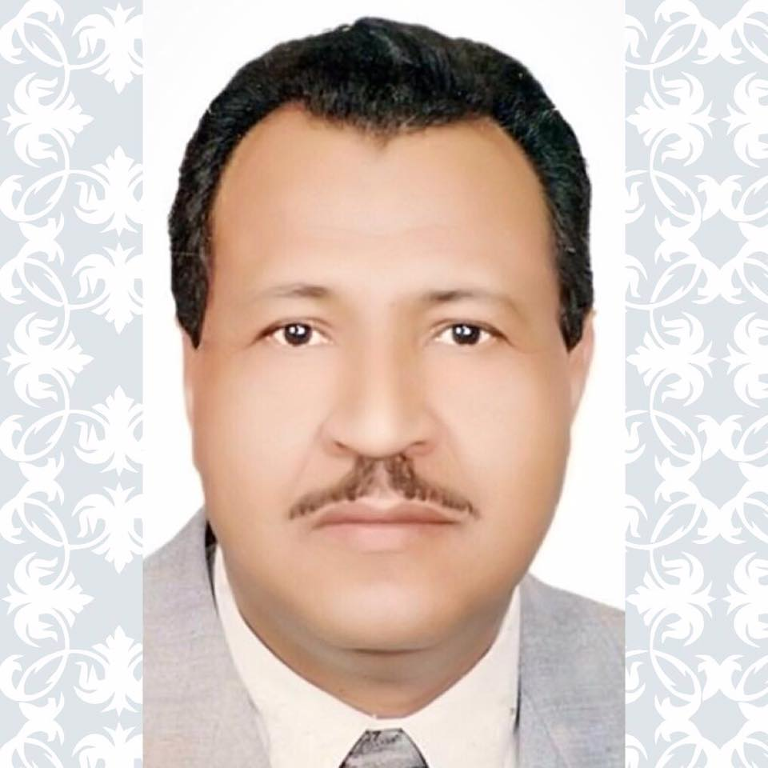

Curriculum Vitae Form (C.V)

For

A Faculty Member

First: Personal Information:

Name: Hassan Khidery Ahmad Hassan

Nationality: Egyptian Date of Birth: 20/12/1946 Place of Birth: Sohag
Current Title: Professor of Islamic History and Islamic Civilization
Place of Work: College of Arts for Girls in Dammam
Governorate: Dammam
Department: History
Currently-Engaged Position: Professor of Islamic History and Islamic Civilization
Date of Commencement of Service of Current Position: 16/9/1425
Marital Status: Married Number of Family Members: 3

Secondly: Scientific Qualifications:

Scientific Qualification | Date of Graduation | Graduation College | University Name | General Specialty | Major
Bachelor | 1985AD | Faculty of Arts | Cairo | History | History
Master | 1989AD | Faculty of Arts | Cairo | History | Islamic History & Civilization
Doctorate | 1993AD | Faculty of Arts | Cairo | History | Islamic History & Civilization

Master Thesis’s Title: The Rise of Zaydia State in Yemen (280-298H)
Doctorate Dissertation’s Title Relations between Fatimids in Egypt and Maghreb States (362-567H/ 973-1171AD)
Having good command of: Arabic-English- Spanish Languages
Thirdly: Training History:
S/N | Course Title | Conducted by | Duration | Notes
1 | Attending courses on marks inserting (Banner) | College of Arts in Dammam | Three days
2 | Attending a lecture on Basics of Academic Assessment and Accreditation | Office of Planning and Development | One day
3 | Course on Program Specifications | Office of Planning and Development | One day
4 | Attending a lecture on Analysis of Quantitative Data Using Statistics of Social Sciences | Deanship of Scientific Research | One day
Fourthly: Career Hierarchy:

S/N | Job Title | Univ./College./Dept. of Position | Period of Service
 |  |  | From | To
 | Assistant Professor of Islamic History& Civilization | History Dept./ Faculty of Arts in Qena, South Valley University | 1994AD | 1999AD
 | Associate Professor of Islamic History & Civilization | History Dept./ Faculty of Arts in Qena, South Valley University | 1999AD | 2004AD
 | Visiting Professor at Univ. of Pittsburg & Ohio Univ. at USA | Univ. of Pittsburg & Ohio State Univ. | 1999AD | 2001AD
 | Professor of Islamic History and Islamic Civilization and Head of History Dept. and Deputy-Dean for Higher Studies and Researches at Faculty of Arts in Qena (formerly) | Faculty of Arts in Qena, South Valley University | 1998AD | 1999AD

Fifthly: Courses Taught by Faculty Member:

S/N | Undergraduate | Postgraduate
 | Bachelor | MA Orientation | Ph.D. Orientation
1 | History of Islamic Maghreb | Course in field of specialization (1) | Historical Topics and Instruments
2 | Islamic History of Andalusia | Course in field of specialization (2) | Course in field of specialization
3 | History of the Prophet’s Biography | Schools of Historical Thought | Optional course in Islamic History
4 | History for Muslims | Documentary Study | Examining Manuscripts
5 | Islamic Civilization
6 | History of Abbasid Dynasty
7 | Islamic World At Present
8 | Historical Methodology
9 | History of Umayyad Dynasty
10 | History of Fatimid Dynasty
11 | History of the Orthodox Caliphs

Sixthly: Scientific Researches That Faculty Member Supervised & Supervising:
Researches Supervised and Approved by Committee of Examiners |  |  |  | Researches Still Under the Faculty Member’s Supervision
MA Theses |  | Ph.D. Theses |  | MA Theses |  | Ph.D. Theses
Research Title | Date of Approval | Research Title | Date of Approval | Research Title | Date of Registration | Research Title
Political and Cultural Relations Between Arabs and China During the Period of Abbasid Dynasty | 24/4/2000AD | Political and Cultural Dimensions of Hij and Jihad Religious Duties at Morocco and Andalusia Since the Period of Almoravids Till Fall of Bani Alahmar Dynasty 440-898H/1096-1492AD | 7/10/2002AD
Rabi’a Arabstan Tribe’s Impact During the 1st, 2nd Centuries H | 3/3/2002AD | Ismailiyah Dynasty in the Islamic East 447-656H/1055-1258AD | 26/7/2004AD
Political Relations Between Fez and Ghernata During 604-826H/1217-1458AD | 28/5/2001AD | Trade Activity in the Red Sea During the Reign of Mamelukes Jarkas 784-922H/1382-1516AD | 26/7/2009AD
Malik Jurists (Faqih) in Andalusia During the Period of Almoravids and Their Impact on Political Life 479-541H/1086-1147AD | 9/3/2002AD
Bani Merdas Emirate in Aleppo 400-475H/1010-1183AD | 20/7/2005AD
Zabid City’s Political and Cultural State of Affairs 204-554H/815-1159AD | 18/8/2006AD
Mosul City During the 1st, 2nd Centuries H/ 7th, 8th Centuries AD | 25/7/2007AD
 |  | The Common People in Fares During the Seljuk Period | 14/2/1431H |  | 1429H
 |  | Perfumes Trade and Industry for Arab Muslims During 3th, 4th Centuries H/ 9th, 10th Centuries AD | 17/2/1431H
 |  | Political Affinities and Their Impact on the Abbasid Caliphate During 2nd Abbasid Era (232-656H/846-1256AD) | 9/1/1432H
Trade Activity in Eden (696-858H) | 15/1/1433H | Yemeni Society During the Rasulid Dynasty (626-858H) | 14/4/1433H
Research Title | Date of Approval | Research Title | Date of Approval | Research Title | Date of Registration | Research Title
l | 5/7/1437H | Care for needy groups in Iraq And its impact on puplic life in the Abbasid era (447-656H/1255- 1258 AD) | 5/7/1437H
Care for needy groups in Yemen during the era of Rasulids State (626-858H / 1229-1454AD) |  | Minister of State in the Yemen and Rasulid its impact on public life (626-858H) 1229-1454AD)

Seventhly: (A) Scientific Researches Published in Refereed Periodicals:

Research Title | Research Status |  |  | Publisher
 | Single | Dual | Peer
- Ceuta City and Its Plans During the 7th Century H/13th Century AD | Single | - | - | 1- Egyptian Historian Magazine, 14th Issue, January 1995AD, Faculty of Arts, Cairo Univ.
- Qift City and Its Political Evolution Since Arabian Conquest till the Middle of 4th Century H | ‘’ | - | - | 2- Faculty of Arts Magazine in Qina- South Valley Univ., 6th Issue 1996AD.
- Zaidya Sect in Egypt from the Middle of 2nd Century H/8th Century AD to the Middle of 3rd Century H/ 9th Century AD | ‘’ | - | - | 3- Arab Historian Magazine, 4th Issue, 1st Vol., March 1996AD, Arab Historians Union at Cairo
- Al-Ahwaz in the First Three Hijri Centuries, Faculty of Arts Magazine- Qina, 6th issue 1996AD |  |  |  | 4 Faculty of Arts Magazine- Qina- South Valley Univ., 6th issue 1996AD
- Political Relations Between Fez and Granada in the 1st Half of the 8th Century AH/ 14th Century AD |  |  |  | 5 Faculty of Arts Magazine, Assiout, 1st issue, 1997AD
- Palermo City and Its Intellectual Life During the Domination of Fatemiyeh Dynasty |  |  |  | 6 Egyptian Historian Magazine, 18th Issue, Faculty of Arts, Cairo Univ., 2001AD
- Arabic Civilization in Andalusia and its impact on the West in the 4th century AH/10th century A.D )  A research delivered in the Conference of Middle-East Cultures |  |  |  | The Middle East Studies Centre (6-9 March 2001AD- Ohio State Univ.- USA
- The impact of Globalization of African American and Egyptian women : (A Historical Study )
A research delivered in the Institute of International Education of Univ. of Pittsburg, USA 10 Jan. 2001AD
- Trade Centers in the Moroccan Sahara and Their Role in Establishing Polities During the 4th, 5th Centuries H/10th, 11th Centuries AD, the International Conference (Morocco and the African Issues), Universite Hassan I, Faculty of Arts & Humanities- Casablanca- Morocco (14-15 Oct. 2002AD)
- Al-Hamadani and his Method in Writing History (4th Century H/10th Century AD) at Cairo
- Aspects of Scientific and Religious Activity in Zabid in the Period of the Rasulid Dynasty (526-858H/1229-1454AD) |  |  |  | Arab Historian Magazine, 10th Issue, 1st Vol., March 2002AD, Arab Historians Union
- Bnu Zuhr and Their Role in Prosperity of Medicine in Andalusia in the 5th, 6th Centuries H/ 11th, 12th Centuries AD |  |  |  | Arab Historian Magazine, 11th Issue, 1st Vol., March 2003AD, Arab Historians Union at Cairo
- Women's activism in Egypt” research project 2004 – 2005 Fulbright new century scholars program .  Fulbright, Cairo 2005 |  |  |  | Magazine of the Egyptian Society for Historical Studies, 42 issue, Jan. 2004AD
- Scientific and cultural aspects in the Mecca of the mission until the conquest |  |  |  | Encyclopedia of the history of Mecca, King Abdulaziz, Riyadh circuit (1436- 1437H)
(B): Scientific Production Publishable in Refereed Periodicals:

Research Title | Research Status |  |  | Publisher
 | Single | Dual | Peer

C: The Scientific Activity (Refereeing Master and Doctorate Theses; Participating in Compiling and Developing Scientific Curricula………..)

S/N | Scientific Activity | Date
1 | Examining MA Thesis- Faculty of Arts- Minia Univ. | 1999AD
2 | Examining MA Thesis- Faculty of Arts- South Valley Univ. | 1999AD
3 | Examining MA Thesis- Faculty of Dar Al Uloom, Minia Univ. | 2002AD
4 | Examining PhD Thesis, Faculty of Arts, Zagazig Univ. | 2002AD
5 | Examining PhD Thesis, Faculty of Arts, Banha Univ. | 2008AD
6 | Examining PhD Thesis, Faculty of Arts, Banha Univ. | 2009AD
7 | Examining MA Thesis- Faculty of Arts- Banha Univ. | 2010AD
8 | Refereeing scientific researches- Faculty of Arts’ Magazine at Qina | 2002, 2003AD
9 | Refereeing scientific researches- Al-Mostaqbal Magazine, Minia Univ. | 2002AD
1 | Examining MA Thesis- College of Arts for Girls- Dammam | 1426H
2 | Examining MA Thesis- College of Arts for Girls- Dammam | 1427H
3 | Participating in refereeing a research project- Taif Univ. | 1430H
4 | Examining PhD Thesis, Princess Nora Univ.- Riyadh | 1431H
5 | Participating in examining scientific product of an Associate Professor to be promoted to a Professor at College of Social Sciences- Imam Muhammad Bin Saud Univ. in Riyadh | 1431H
6 | Examining PhD Thesis- College of Arts- Univ. of Dammam | 1432H
7 | Examining MA Thesis- Qassim Univ. | 1432H
8 | Examining MA Thesis- College of Arts for Girls in Dammam | 1432H
9 | Participating in laying down the study plan for Females’ Colleges, King Faisal Univ. | 1430H
10 | Participating in examining scientific product of an Assistant Professor to be promoted to an Associate Professor at College of Arts- Princess Nora Univ.- Riyadh | 1432H
11 | Refereeing scientific researches of the Magazine of College of Arabic Language & Social Sciences- Qassim Univ. | 1432/1433H
12 | Participating in laying down the study plan for developing post-graduate studies at Univ. of Dammam | 1432/1433H
13 | Participating in examining scientific product of an Assistant Professor to be promoted to a Professor at Faculty of Education- Eden Univ./ Yemen | 1433/1434H
14 | Participating in examining scientific product of an Assistant Professor to be promoted to a Professor at College of Arts- Princess Nora Univ. | 1433/1434H
15 | Refereeing scientific researches in the Conference of Woman in Islam- Qassim Univ. | 1433/1434H

Eighthly: Refereed Books:

Book Title | Publishing House | Date of Publication | Notes
The Rise of Zaidiya State in Yemen | Madbouly book store/Cairo | 1996AD | Notes
Relations between Fatimid in Egypt and Maghreb States | Madbouly book store/Cairo | 1996AD | Notes
Studies in History of Islamic Cities | Dar algharb alislami, Beirut | 2003AD | Notes
Pages from History of the Islamic Maghreb | almotanabi bookshop/ Dammam | 1426H | Notes
Pages from History of Islamic Andalusia | almotanabi bookshop/ Dammam | 1426H | Notes
Pages from History of Abbasid Dynasty in Its golden Period | Dar alghad/ Cairo | 2007AD | Notes
Pages from History of the Fatimids Dynasty | Alzahra bookstore/ Cairo | 2007 AD | Notes
Studies and Researches in Islamic History | Darelfikrelarabi/ Cairo | 1428H/2007AD | Notes
Pages from History of Abbasid Dynasty in Its 2nd Period | Dar alghad/ Cairo | 2007AD | Notes
The Most Important Modern Studies in History of Islamic Yemen (Critical Study) | Darelfikrelarabi/ Cairo | 1429H/2008AD | Notes
How to Write a Research in History? | almotanabi bookshop/ Dammam | 1429H/2008AD | Notes
Studies and Researches in History of Morocco and Andalusia | Dar Elfikr Elarabi/ Cairo | 1431H/2010AD | Notes
“FeZilal Alsirrah” (the Prophet’s Biography) (a new reading) | almotanabi bookshop/ Dammam |  | Under publication
Conquest and Fall of Andalusia (new reading) in Ignasio Oligos’s thought | Alzahra bookstore/ Cairo | 1434H/2013AD
Science of history when Muslims  (Issues and reviews) | almotanabi bookshop  Dammam | 1436H/2015AD

Ninthly: Participation in Conferences & Scientific Symposiums:
S/N | Conference or Symposium Title | Organized by | Organizing Agency Address | Participation Type |  | Research Presented by the Member
 |  |  |  | Attendance Only | Attendance and Participation with a Research
1- | Historical Frame of the Crusade Movement (28-30 Nov. 1995AD) | Arab Historians Union | Cairo | Only attendance
2- | The Gulf Territory Over Times (23-25 Nov. 1996AD) | Arab Historians Union | Cairo | Only attendance
3- | Al-Maghreb Countries and Their Relations With the East (25-26 Nov. 1997AD) | Arab Historians Union | Cairo | Only attendance
4- | History of Al-Quds Over Times (19-20 Dec. 1997AD) | South Valley Univ. | Qina | Only attendance
5- | New Lights on Sources of History of the Arabs (24-26 Nov. 1998AD) | Arab Historians Union | Cairo | Only attendance
6- | International Conference of Islamic Economy (1998AD) | Al-Azhar Univ. in collaboration with Sheikh Saleh Al-Kamel Centre | Cairo | Only attendance
7 | Conference of Middle-East Cultures (1-3 March 2000AD) | The Middle East Studies Centre Ohio State Univ. | Ohio, USA |  | Attending and participating with a research | Arabic Civilization in Andalusia and its impact on the West in the 4th century AH/10th century A.D )
8- | International Conference (Al-Maghreb and the African Issues) 14-15 Oct. 2002AD | Universite Hassan II, Casablanca | Casablanca- Morocco |  | Attending and participating with a research | Trade Centers in the Moroccan Sahara and Their Role in Establishing Polities During the 4th, 5th Centuries H/10th, 11th Centuries AD
9- | Seminar on Islamic and Mediaeval History | Egyptian Society for Historical Studies | Cairo |  | Attending and participating with a research | Sijilmasa City and Its Economic Role in the 5th Century H/ 11th Century AD
10- | International Conference on the Egyptian-Moroccan Relations Over History, Feb. 2002AD | Faculty of Arts- Hilwan Univ. in cooperation with Faculty of Arts and Human Sciences at Casablanca, Morocco | Cairo | Only attendance
11- | 2nd International Conference of Dialogue Among Civilizations About Russia and the Arab and Islamic World 2003AD | Faculty of Arts- Hilwan Univ. in cooperation with Faculty of Arts and Human and Social Sciences, Moscow Univ. | Cairo | Only attendance
12- | International Symposium on the Economic History of the Arabian Maghreb | Faculty of Arts and human Sciences- Cadi Ayyad University- Marrakech | Marrakech, Morocco | Only attendance
13- | 11th Scientific forum (Madina Monawara Over Times) 1428H | Saudi Historical Society | Madina Monawara | Only attendance
14- | The Grand Hajj Conference, 1432H | Ministry of Hajj | Makkah Al-Mukarramah | Only attendance
15- | Conference of Islam and Peace | Islamic Studies Dept. | Univ. of Dammam | Only attendance

Tenthly: Membership of Formed Committees:

S/N | Committee Title | Committee’s Tasks | Committee’s Period of Work
 |  |  | From | To
1 | The Scientific Committee | Reviewing courses and specifications | 1431H | Till now
2 | Islamic History Committee | Reviewing specifications | 1431H | Till now
3 | Committee of developing higher studies | Master of economic and social history | 1433H | Till now

Eleventh: Membership of Scientific Associations:

S/N | Association Name | Association Reporting To | Association Location
1 | Member of Egyptian Society for Historical Studies | Egyptian Society for Historical Studies | Cairo
2 | Member of Arab Historians Union | Arab Historians Union | Cairo
3 | Member of Egyptian Teachers Syndicate | Ministry of Education | Cairo
4 | Member of Moroccan Association for Scientific Research | Scientific Research | Rabat
5 | Member of Saudi Historical Society | Saudi Historical Society | Riyadh
6 | Member of Muslim World League (electronic) | Muslim World League | Makkah Al-Mukarramah
7 | Arab Organization for Public Relations & Public Diplomacy (AOPRPD) | AOPRPD | Cairo
8 | Egypt Scholars Society | Egypt Scholar League | Cairo

Twelfth: The Member’s Activities:
First: Activities Within he College:
- Religious and Cultural Activities:

Description | Activity | Lecture Title | Date
History Department Seminar | Cultural | Al-Hamadani and his Method in Writing History | 1428H
1st Scientific Forum under auspices of Deanship of Scientific Research | Cultural | Ibn Khaldoun’s Thought Between the Scientific Approach and the Critical Vision | 1429H
History Department Seminar | Cultural | Conquest and Fall of Andalusia (new reading) in Ognasio Oligos’s thought | 1432H

- Community Activities:
S/N | Activity | Date of Activity | notes
 | --------- | ----------- | ----------

- Artistic Activities:
S/N | Activity | Date of Activity | notes
 | --------- | ----------- | ----------

Secondly: The Member’s Activities Outside The College:
- Religious and Cultural Activities:

Description | Activity | Lecture Title | Date
The Grand Hajj Conference | Preaching | Awareness in Hajj | 1431H

- Community Activities:
S/N | Activity | Date of Activity | Notes
- Artistic Activities:
S/N | Activity | Date of Activity | notes
 | --------- | ----------- | ----------

Incentive Awards for Scientific Achievements:
- Scientific Excellence Award in Science Day 1968AD
- The Ideal Teacher nation-wide in Egypt for 1994AD
- Appreciation Certificate from University of Pittsburg – USA in field of human sciences for 2000AD
- Appreciation Certificate from the Middle-East Studies Centre, Ohio University for 2001AD
- The Excellent Faculty Member at College of Arts for Girls in Dammam (the Network) 1428/1429H
- Appreciation Certificate from His Excellency the President of King Faisal University 1429/1430H
- Appreciation Certificate from Princess Nora University 1430/1431H
- Appreciation Certificate from College of Education, University of Dammam 1431/1432H
- Appreciation Certificate from Qassim University 1432/1433H

