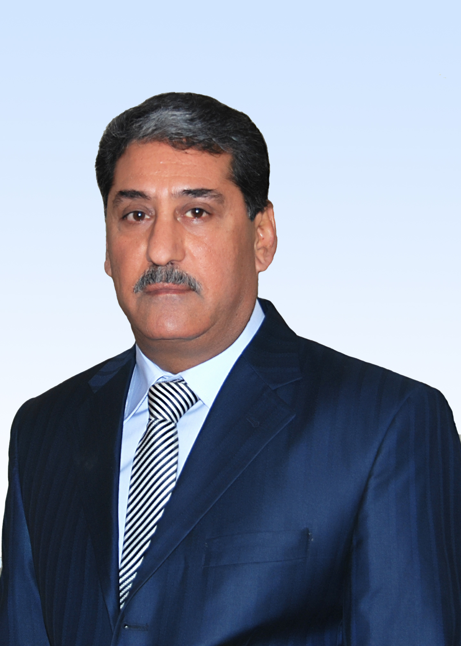 CV
ASSISTANT PROF. : DR. ABDUL QADER DAWOOD
FAISAL (A.Q.D.Faisal)

Name: Abdul Qader Dawood Faisal,
Degree: Ph.D. (Physics / Material Science)
Birth Date: 13th December 1952 / Baghdad -Iraq
Material Status: Married.
Address: University of Technology,
Applied Science Department,
Applied Science Research Unit
Home Address: Dr. Abdul Qader Dawood. Faisal Zayoona, Hay-Almuthana / Mahalla 714 / Zuqaq 55 / House number (1/27) / Baghdad / Iraq
Mobile: (00964-7901821658) ; E -mail: abdulf330@gmail.com
First Occupation Date: 14/5/ 1980 : Ministry of Scientific Research and Higher Education, as a Lecturer Assistant at the University of Al- sulaymania / Iraq.
Education:

1977 :B.SC. in Physics , College of Science , Almustansyria Univ.
1980 :M.SC. in Solid State Physics , College of Science , Baghdad University [Magnetic Electron Lenses Design and Optical Properties Studies].
14/5/1980 : Lecture Assist. / Physics Department /College of Education/ Al-Sulaimanya University.
1981 : Lecturer Assistant, College of Education, Salah Al deen Univ. Erbil, Iraq.
1981 : Lecture Assist./ Physics Dept./ College of Education/ Salah Al-deen Univ.-Erbil.
1982-1987: Scholarship for Ph.D. Study / University of Sussex / Brighton / England.
1987 :Ph.D. in Physics at Sussex University, Brighton, England. [Transmission Electron Diffraction Studies of Xenon Adsorbed on Graphite]
1987: Awarded Ph. D in physics from Sussex University / England.
1987: Lecturer/ Physics Department / College of Education /
Salah Al-Deen University / Erbil.
1988 : Lecturer at College of Education in Salah Al deen University- Erbil- Iraq.
1988-1996: Governmental official / Baghdad / Iraq
1996-1998 : Broadcasting tube workshop / High Power Broadcasting Electronic Valves- R and D Workshop / Baghdad. This workshop was transformed to Broadcasting Tube Project.
1998: 2003 Al-Salam Co. /broadcasting tube Project / Research and Development.
3003-2006: Ministry of Reconstruction and Housing.
2006- 2009: Lecturer at the Laser Branch, Dept. of Applied Sci. Univ. of Technology, Baghdad, Iraq. [(1) 1st class – measurements. (2) 4th class solid state physics. (3) Post graduate student –M.Sc. - sandwich course: my lectures on carbon nanotubes synthesis and characterization.
4-5-2009 : Assistant Prof. Awarded / University of Technology/Applied Science Department/ Laser branch.
2009-2010: An active member of the new established Nanotechnology and Advanced Material Researches Center at UOT which is directed by UOT president and vice-president.
2010 : Directory of the first established Nanotechnology and Advanced Material Researches Center at UOT.
2010-2014: Researcher in the field of nanotechnology materials synthesis by many techniques and applications.
2014-2016 : Researcher and Lecturer at Applied Science Department / Applied Science Research Unit.

Instruments Qualifications:

Experience in installation and maintenance of the following instruments:
1. Different kinds of vacuum evaporation systems.
2. Ion Beam Thinning Machine.
3. Transmission Electron Microscope (TEM).
4. Scanning Electron Microscope (SEM Probe analyzer) equipped with Energy Dispersive Spectrometer (EDS) and Wavelength Dispersive spectrometer (WDS).
5. Scanning Transmission Electron Microscope (STEM), equipped with EDS for Elemental Analysis.
6. Optical Microscopes and Microstructure Preparation Machines.

Training Courses:

- 1989 : Training course in Tokyo : JEOL Co.
Two weeks training course on Scanning Transmission Electron Microscope (STEM).
- 1989 : Training course in London : Link Analytical system Co.
Five days training course on Energy Dispersive Spectrometer EDS System.

Computer skills:
Using PC | Browsing | Typing
Good | Very good | Very Good

English Skills:

Speaking | Reading | Writhing
Very Good | Excellent | Very Good

Books Translation:

Surface Physics
Author M. Brutton, 135 pages
England.
Translator's team: Dr. Mohamed Saleh Ahmed and Dr. Abdul Qader Dawood Faisal
University of technology 2011.

التكريمات :
حاصل على تكريم بيوم العلم حسب الكتاب المرقم ب ت / 2923 بتاريخ2 / 4 / 2011 مع كتاب شكر وشهادة تقديرية من السيد وزير التعليم العالي والبحث العلمي.

التفرغ العلمي : Scientific Research Scholarship

مدة التفرغ : ستة اشهر للفترة من 15-6-2013 والى 30-11-2013

الدولة : الولايات المتحدة الامريكية

حاصل على تفرغ علمي بزمالة بحثية الى جا معة New Orleans في الولايات المتحدة الامريكية
برنامج ISFP للبحث في مجال النانوتكنولوجي وتطبيقاته
15th June 2013 to 30th November 2013
Iraq Science Fellowship Program (ISFP) / CRDF
Associated Prof. Dr. W. Zhou Group / Material science
USA/ Lousiana / University of New Orleans / College of Science /
Advance Material Research Institute (AMRI)

النشاط البحثي العلمي خلال فترة التفرغ :

Conducting research on synthesis and applications (gas sensors and solar cells) of metal oxide nanostructure materials (NWs, NRDs, Nanocomb, etc.) such as : ZnO, SnO₂, CuO, TiO₂, via various techniques like CVD, HT, etc..
قائمة بالبحوث المنشورة والبحوث قيد النشر

ت | عنوان المجلة | حالة النشر | عنوان البحث | مكان النشر- التصنيف العالمي
البحث الاول | J.of Mat. Sci. Electron 2015 USA | Published  منشور | Synthesis and characteristics study of TiO₂ nanowires and nanoflowers on FTO/glass and glass substrates via hydrothermal technique | Springer (Thomson Reuters)  IF :1.569 For (2013-2014)
البحث الثاني | مجلة علوم المستنصرية – المجلد 27 و العدد 3 الجامعة المستنصرية2016 | حاصل على قبول نشر 2016 | Influence of seed layer on morphology of ZnO nanostructures synthesized on silicon (100) via hydrothermal method | 2016
البحث الثالث | لدى المجلة / Bulletin of Material Science | حاصل على قبول نشر 2016 | Optimization of CVD Parameters For Long ZnO NWs Grown on ITO / Glass Substrate | Springer (Thomson Reuters)  IF : 1.07 For (2014-2015)
البحث الرابع | Bulletin of Material Science | قيد االتقييم | Synthesis of ZnO Comb-like Nanostructure for High Sensivity H₂S Gas Sensor fabrication at Room Temperature | 2016

Postgraduate Student's Supervision 2003-2015

ت | اسم الطالب | عنوان الرسالة | الدرجة العلمية وتاريخها
1 | ميثم حسن رشيد | دراسة الصفات الفيزيائية للكاربون الحراري المرسب بطريفة CVD  Study the Physical Properties of Pyrolytic Carbon Deposited by CVD. | ماجستير  2003 / الجامعة التكنولوجية / علوم تطبيقية / فرع الفيزياء
2 | رغدان محسن ناموس | Coating of CNT produced by CVD to increase wetting for nanocomposite | ماجستير  4/10/2012
3 | محمد عودة داود | Design and construction of CVD system for synthesis carbon nanotubes for gas sensing | دكتوراه  31/10/2013
4 | ابرهيم جليل ابراهيم | استخدام عوامل مساعدة وعوامل مساعدة نانوية لانتاج الوقود والكاربون المكلسن من الفضلات البلاستيكة | دكتوراه  22/1/2014
5 | مروة عبدالكريم مسعود | Preparation of copper oxide nanowires for gas sensors | ماجستير  4/6/2014
6 | فهد زاهر كمال | Synthesis of ZnO nanostructures on silicon using hydrothermal method for gas sensor application. | ماجستير/ مستمر  2014-2015 / العلوم التطبيقية / التكنولوجية

PUBLICATIONS : 1981-2016 [Updated on 10/7/2016]

Assist. Prof. Dr. Abdulqader Dawood Faisal
(Internet Browser with Keywords: A.Q.D.Faisal )

[1] S.M. Juma and A.Q.D.Faisal; (Properties of axial flux density distribution of magnetic electron lenses with a single cylindrical pole piece ), J. Physics E, 1981 vol. 14.
[2]A.Q.D.Faisal , M. Hamichi , , and J.A.Venables: Low Temperature Structure of Xenon on Graphite , Physical Rev B34 ,V 34 , N 10 , P7440-7443(1986).
[3] A.Q.D. Faisal , M. Hamichi, R.Kariotis, J.A.Venables : Solid State Phys. Meeting ( IOP Dec. 1986 poster)
[4] R. Kariotis , J.A. Venables . M.Hamichi, A.Q.D.Faisal : Xenon-Graphite interaction near the C-IC transition , J. Phys. C 19, 1987, PP. 5717-26 .
[5] M. Hamichi ,A.Q.D.Faisal , J. A. Venables , R. Kariotis : Lattice parameter and orientation of Xe on Graphite at low pressure, Phys. Rev. B, March , pp 415-425, 1989.
[6] J.A.Venables , A.Q.D.Faisal ,M.Hamachi, R. Kariotis, and G. Raynard : THEED Studies of Xenon on graphite , Ultra Microscopy . , 26 (1988) pp169-176.
[7] Dr. Sabah S. Abdul Noor, Dr. Abdulqader D.Faisal ( Physical and mechanical studies of a deposited pyrolytic carbon using CVD) . journal of College of Education , Univ. of Al- Mustasyria , Vol. 55, No. 3,pp.832-851,2009.
[8] Dr. AbdulqaderD.Faisal , Fadhil A. Hashim and Waddah J. Raouf , Journal of Um Sallama for Sci. ( Carbonization and treatment of high temperature distortion of thoriated tungsten cathode for high power electronic tubes ) , Bahdad Science Journal , Vol. 6 ( 4) ,pp.763-769 ,2009 .
[9] Dr. AbdulqaderD.Faisal , (Preparation of pyrolytic graphite (PG)shell using CVD technique ), Engineering and Technology Journal, Vol. 27, No. 5, p 868-878 ,2009.
[10] Dr. Dhia H. Hussain , Abdul Jabar I. Rasheed, Dr. Abdulqader D. Faisal ,AL-MustansiryaJ.Sci. , (Synthesis of carbon nanotubes by electrochemical deposition using Al substrate), Vol. 21, No. 5, pp168-174, 2010.
[11] Dr. Abdulqader D.Faisal,Dr. Ahmed A. Mossa, and Zeinab A. Jawad, ( Asandwich porous alumina Nanostructures Based on Anodic Alumina) ,Eng. and Tech. Journal Vol.28 , No. 11, pp.2091-2102, 2010.
[12]Dr.AbduaderD. Faisal , Ahmed Ali Mossa , and ZeinabAbassJawad , (Preparation Studies of ZnONanomaterials Using Chemical Method), The 2nd Conference of Nanotechnology and Advanced Materials , UOT, 3-4-Nov., pp. 241-251, 2011.
[13]Dr. Abduqader D. Faisal ,Aysar S. Keiteb , Dr. Mufeed A. L. Jaleel , (Synthesis of Carbon Nanomaterials in Deionized Water with and without Catalyst Using Arc Discharge Technique.) . Eng. and Tech. Journal Vol.29 , No. 2, pp240-252, 2011.
[14]Dr.Abdulqader D. Faisal , Dr. Raid A. Ismail , Dr. Ahmed A. Mossa., Dr.Khaleel I. Hassoon
"Synthesis and characterization of nanostructured SnO₂ film" ;J. Mater Sci: Mater Electron , 22:pp.1681-1684
2011. Springer; IF: 1.076 (2011)
[15] Dr.Abdulqader D. Faisal , Zainab N. Jameel, ( Catalytic Growth of Carbon Nanotubes on Ni Nanoparticles prepared Using Nd-YAG Pulse Lazer Technique ):J. of Basic Education/college of Basic Education /Al-Mustansirya University : الصفحة 53-61 ,المجلد 18, ملحق العدد 732012 مجلة كلية التربية الاساسية-
[16] Dr.Abdulqader D. Faisal , Dr Ahmed Ali Mossa, Zenab A. Jawad ( Carbon Nanotubes Growth Studies with FeCl₃ and Ethanol Catalyst using CVD Method ) Eng. and Tech. Journal ,V30,No.8,pp.1374-1380. 2012.
[17]Dr.Abdulqader D. Faisal , Zainab N. Jameel , Raid A. Ismail," Synthesis of colloidal copper oxide nanoparticles using pulsed Nd:YAG laser ablation in liquid. Eng. and Tech. Journal,Vol. 31, No. 1 , 2013.
[18]Dr.Abdulqader D. Faisal, Dr. Kadum Hassan Hassain and Mohamed AudaDawood, "Synthesis of MWCNTs using CVD on Fe catalyst prepare in D.C. diode sputtering", International journal of application in engineering and management (IJAIEM), Vol.2, Issue 9,pp.97-100, 2013.
[19]Dr.Tariq A. Mandeel, Dr.Abdulqader D. Faisal, and Ibraheem J. Ibraheem,
"Degradation of Plastic Wastes (PP, PET, and LDPE) for Liquid Fuel Production as alternative energy by Using Vacuum Pyrolysis Method". J. of university of Anbar for pure science: Vol.7:No.2, 2013
2nd Conference for Pure Science - university of Anbar 20-22/11/2012.
[20]Dr.Abdulqader D. Faisal, SadekH.Lafta, "Investigation of gold nanostructures on silicon using electrochemical deposition method", Journal of Al-NahrainUniversity, Vol. 16, No.4, 2013.
[21]Dr.Abdulqader D.Faisal,Ahmed Flaih Hussian, Sadek Hani Laftta , 'Morphology investigation of carbon nanostructures synthesized with gold catalytic chemical vapor deposition (CCVD), Journal of Kufa Physics Vol.5, No.1 ,2013.
[22]Dr.Abdulqader D. Faisal, Dr. Faeq H. Anter , and Marwa A. Masood, " Structural and morphological study of CuO nanostructures synthesized by chemical route ", J. of university of Anbar for pure science : Vol.7,No.3,2013.
[23]Ibraheem J. Ibraheem, Dr. Tareq Mandeel, Dr.Abdulqader D. Faisal, Y.Aldouri, "Thermal degradation of plastic wastes (PP,LDPE) using metal particales ,metal oxides and metal nanoparticles as acatalyst" , Advanced Materials Research Vol. 925 ,pp.359-363, Trans. Tech. Publications, Switzerland ,2014.
[24]Dr.Abdulqader D. Faisal , Zainab N. Jameel, Dr. Ahmed Ali Mossa, " Preparation of silver and gold nanoparticles by using Nd - YAG pulse laser ablation", Eng. and Tech. Journal , UOT,Vol.32, No.1, Part (B) ,2014 .
[25]Dr.Abdulqader D. Faisal and Mohamed AudaDawood," Design and construction of argon D.C glow discharge plasma using Al target ", Journal of Kufa Physics ,Vol.7, No.1 ,2014.
[26]Dr.Abdulqader D. Faisal and Mohamed AudaDawood, "Measurements of the breakdown voltages for different cathode materials: Al, Ni, Fe and Cu", مجلة كلية التربية / الجامعة المستنصرية العدد الأول 2014
[27]Dr.Ahmed Ali Moosa, Dr. Abdulqader D. Faisal, Ragdan N. ??? "Surface Modification of Multiwall Carbon Nanotubes for Metal Matrix Nanocomposite Applications", Eng. and Tech. Journal, UOT, Vol.32, No.7, Part (A),2014.
[28]Dr.Abdulqader D. Faisal, "Synthesis and characteristics study of TiO₂ nanowires and nanoflowers on FTO/glass and glass substrates via hydrothermal technique", J. Mater Sci: Mater Electron V26, pp.317-321(2015).
[29] Dr.Abdulqader D. Faisal , “Influence of seed layer on morphology of ZnO nanostructures synthesized on silicon (100) via hydrothermal method “ , مجلة علوم المستنصرية : المجلد 27: العدد 3 ك 2016
[30] CVD ZNO 2016.

Note: More planned projects under research and articles are prepared for next publications.
THANKS

