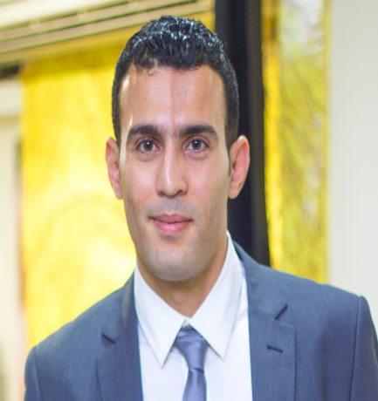
احمد محمد عز الدين عثمان
09/1983
الجنسية :مصري
العنوان :المملكة العربية السعودية . أبو عريش -جازان
00966532519016محمول :
Ahmedezz3@gmail.comالايميل :

EMPLOYMENT EXPERIENCE

Mud Logger/Geologist with a good record of academic and employment achievement. Key areas of expertise include core analysis special core analysis, well log analysis, formation damage and Petro physics (Sedimentary Basin Analysis)

Equipped with excellent scientific and technical skills, good observational skills, Capable of working with statistic and graphical information to deliver evaluations
Currently seeking a career enhancing position where skill set can be used to make a valuable contribution for both of us .because I believe in this aphorism ( Be wise enough to know that you do not know everything ) for that I am searching for new experience and new skills and improving skills I already have

Pre-Master’s Degree in Geology 2005 – 2006
with grade Very-Good

Core Analyst - Corex Service Company Ltd Mar. 2007 - JUN. 2009

- Conducted Conventional Core Analysis, including Core Gamma (total and spectral), Slabbing (radial, bandsaw) and Porosity and Permeability tests.
- Led on review of profile permeability, full diameter core analysis, whole core analysis, plug acquisition, fluid saturation and special core analysis.
- Reviewed formation factor, compressibility, relative permeability, Oil & Brine permeability and capillary pressure saturation.
- Compiled statistical data and prepared associated reports.

Mud Logger - ECS Service Company Jul. 2009 – May. 2013

- Worked at rig sites as part of a team and conducted formation evaluation.
- Logged cuttings and performed site supervision.
- Compiled comprehensive reports for senior management.
- Monitored drilling parameters and geological parameters on CDT 200 server.
- Monitored drilling steps from spudding to TD.
- Demonstrated strong health and safety leadership through implementation of formal

Abo Hawe Office For Geological Consulting And Materials & Soil Tests In Jizan and Khamis Mishit Jul. 2014 – Till now

Responsible for ensuring the smooth running of the quality department, whilst ensuring that departmental targets and its proparties
- soil Tests (Sand-Cone , Sieve Analysis , C.B.R , Proctor , Sand Equivalent ,Atterberg-limits )
- Concrete Tests (Load Tests , Coring and its test , Cylinders making and curing in Location , in Field concrete test )
- Asphalt Tests (Marshal method , Bitumen content and Gradation of particles in Asphalt , Total Specific weight of Asphalt , Maximum Specific Density of Asphalt

EDUCATION & Qualifications
- Pre-Master’s Degree in Geophysics, 2005 - 2006 with grade Very-Good
- Modules: Petro physics, seismic interpretation, well logging, structure, tectonic movement and soil mechanics
- BSc Geology, Al Azhar University, Cairo, Egypt, May 2005 with grade Good
- Graduation Project: Well-Log Data analysis using manual interpretation and
- comparison with computerized interpretations

KEY ACHIEVEMENTS
- Participated in field trips in Egypt, including trips to the Western Desert
- Abo Rowash, Eastern Desert, (Kashm Al Galala ) and Al Osier (Red Sea coastal) and Gulf of Suez

Computer SKILLS
- Microsoft Windows and its Office Package
- AutoCAD

TRAINING
- Safety courses of land and offshore fields (full details available on request)
- H2S and CO2 Safety courses in Egypt

PERSONAL
- Languages: Arabic (Mother tongue)
- English & Italian (Very. Good)
- References available on request
- Driving license( Egyptian, Saudi , Italian )
- saudi Arabia work permit Valid
- Italy Work permit Valid

