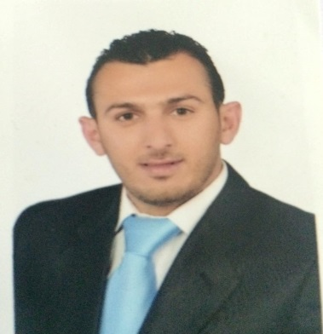
Khaled,Yousef Issa
To obtain a teaching and research position in the field of computer science, where my education and experience are fully harnessed.
Contact Details

- Address : 337-A, TKT 2, JLN TENAGA 20, TAMAN TENAGA, 43000 KAJANG, SELANGOR.

- Mobile No. : +60183850062.

- Email : khaledalshboul@yahoo.com
Personal Particulars

- NAME : Khaled Yousef Issa.

- Age : 27 years.

- Date of Birth : 10 JUL 1987.

- Nationality : Jordanian.

- Gender : Male.

- Marital Status : single.

Education and Qualification

- Qualification : Master's Degree.
- Field of Study : Master of Muamalat Administration.
- Major : Muamalat Administration.
- Institute/University: USIM UNIVERSITY, Malaysia.
- Grade : GPA 3.19 (good).
- Graduation Date : 2015.

- Qualification : Bachelor Degree.
- Field of Study : FINANCIAL&BANKING SCIENCE.
- Major : FINANCIAL&BANKING SCIENCE.
- Institute/University : IRBAD NATIONAL UNVERSITY
- Duration : 2005- 2009.

Skills

- Computer driving License (ICDL) (Microsoft Word, Microsoft power point, Microsoft Excel, Microsoft FrontPage).
- Excellent research skills.
- Translation skills from Arabic to English language.
- Hardworking, reliable, team player
- Successful in building long-term relationships.
- Flexible under pressure.
- Very interested in programming language & teaching styles computer field.

Languages

Language Spoken Written
----------------------------------------------------------------------------------
Arabic 10 10
English 8 8
BM 5 4

