Curriculum Vitae
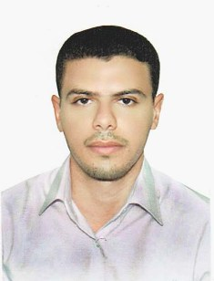

Name : Hayder Khudhair Abdullah Fatlawi
Birth (date – place ) : Najaf – 1986
Address : Najaf – Kufa – near Imam Ali Bridge
Contact info. : 07707105002
hayder.alnajfi@gmail.com
hayder_alnajfi2@uokufa.edu.iq
hayder_alnajfi@yahoo.com
Education
- Bsc. in computer science – University of Babylon with ( Very Good ) Graduated degree ( 84.66% ) .
- Msc. Student in computer science – University of Babylon – Information Technology college .
Training
- Information Technology Program – University of Technology – Berlin – Germany , Seven months in IT Administration on Linux, 2011.
Work
- Programmer , IT center – University of Kufa , 2008 – Now .
- Linux Server Administrator , Data Center of IT center – University of Kufa , 2011 – Now .
- Programmer – Morabaa Company , 2009 -2011 .
- Programmer – Smartiq Company , 2014 -2016 .

Skills
- Visual Basic.Net & Asp.Net & MsSql .
- Linux Administration .
- Web Server Administration .
- Data Mining & Analytics .
- DNS configurations management .
- Email Server Administration .
- PHP & MySql .

Projects
- 8 Programs for different departments and colleges in University of Kufa , (Visual Basic.Net & Asp.Net & MsSql & Mysql ).
- 3 Programs for different costumers with Morabaa company , (Visual Basic.Net & Asp.Net & MsSql ).
- Linux Web Server http://elearning.uokufa.edu.iq in University of Kufa Data center .
- Google Apps for University of Kufa Administration .
Positions
- Manger of programming department in IT center – University of Kufa , 2012 .
- Administrator of Linux Servers in Data center – University of Kufa , 2011 – Now .
- Responsible of Email Service of Google Apps - University of Kufa .

