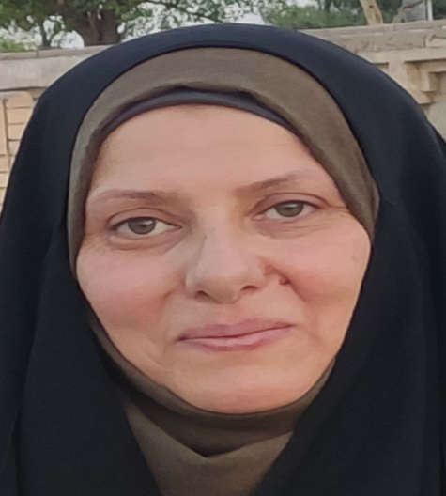

Contact

**Address:**

Najaf province

**Phone:**

07808468170

**Email:**: [rabab.ali@utq.edu.iq](mailto:rabab.ali@utq.edu.iq)

or

[almosawimo2@gmail.com](mailto:almosawimo2@gmail.com)

languages

Arabic

English

Rabab Ali

Al-Mosawi

Summary

I hope to be an editor of your discreet journal" Science and Technology Studies" and I can participate in the team for four years who will edit the journal with the editorial team

Skill Highlights

|  |  |
| --- | --- |
| * Physiology * Hematology * molecuar | * Reviewer * Teacher |

Experience

**Lecture(parasites) in science college of Thi-Qar university 2016.**

**Lecture in National University of Science and Technology 2020**

**Lecture in Open Educational College in Dhi Qar 2021.**

**https://www.researchgate.net/profile/Rabab-Ali-5**

**https://www.webofscience.com/wos/author/record/ABH-3178-2022**

**https://scholar.google.com/citations?user=KlkqnmEAAAAJ&hl=en&authuser=2**

Education

2020 Ph.D. of Biology /physiology /science college/ Thi-qar university

2015 MSC. of Biology /parasitology /science college/ Thi-qar university

1994 B.Sc. of Biology/College of Education Ibn Al-Haytham/ Baghdad university