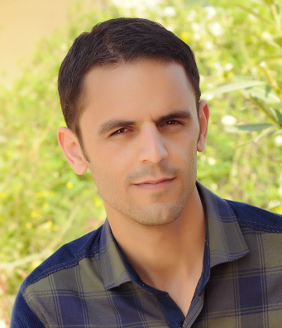
c.v
Name: - Hussien Ali Rashed
Address: - Iraq – Kurdistan - Duhok-Faide
Email: - H30077@yahoo.com
Mobile:- +964 7503496549
Date of Birth: - 07-11-1988
Sex: - Male
Marital status:- Single
Nationality: - Iraqi- Kurdish

Qualifications
Graduatedfrom of the College of Education / Department of geographical / University of Mosul / 2009-2010

Language skills
- Kurdish (mother tongue)
- Arabic excellently
- English

Computer Skills
- Ability to use all of Office range (97-2000 - 2007 - 2010)Microsoft office collection
- TheAbility to use of the programs(Word , Excel, PowerPoint and access lists)
Ability of computers formats, re-installed and computer programming

Work which views
- The Ministry of Displacement and Migration (as a temporary contract) the distribution of relief + million grant from the date of 21.08.2014 to 15/11/2014

Courses and certifications
- Bachelor's degree from the Department of Geography at the University of Mosul
- Cuarse (TOEFL) to build English language skills at the University of Dohuk

