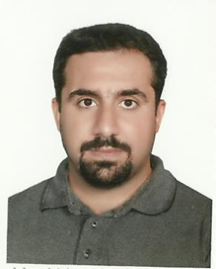

Iam (Alaa Mohammed Hussein Wais )born in Hilla 1979and received BSC in material engineering in Babylon university in 2002.I complete M.Sc. in material engineering in the field of **Effect Of Friction Stir Processing On Mechanical Properties of The Cast *Aluminum-Silicon Alloys*** in 2013.I complete ***PhD .in material engineering /metals engineering in the Wear and Corrosion behavior of Ni-B-CNTs on 4340 Steel Coated by Plasma Nitriding*** in 2020.I had more 14 papers .Now more attention in the surface engineering field to enhance surface properties against wear and corrosion effects. I am studying in Al-Mustaqbal University College, Babylon, Iraq since 2014.

E:alaa.mohammed@mustaqbal-college.edu.iq