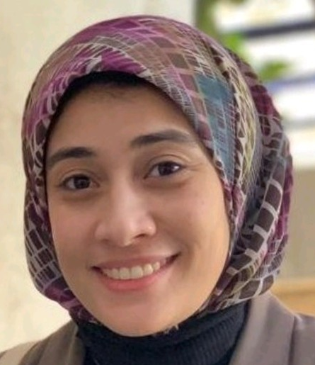
Name: Aya Elshafay Saad
Address: Egypt- El Minia
Tel: 01286595697 -01032604827
E-mail: ayaasaad259@yahoo.com
LinkedIn: https://www.linkedin.com/in/aya-el-shafay-saad-191b1a18b/
Languages:
- Arabic: Mother tongue
- English: Very Good
Specialization: Chemistry and zoology &Material Science & Nanotechnology
Affiliation: Faculty of Postgraduate Studies for Advanced Sciences (PSAS), Beni-Suef University.

Education:
- Per-master in Material Science & Nanotechnology, Faculty of Postgraduate Studies for Advanced Sciences (PSAS), Beni-Suef University with a very good grade (2018)
- Postgraduate diploma in Material Science & Nanotechnology, Faculty of Postgraduate Studies for Advanced Sciences (PSAS), Beni-Suef University with a very good grade and Excellent in the project under the title: Facile Synthesis of Osage Orange TiO₂ from Titanium Nanotubes (2017)
- B. SC of Science Chemistry and Zoology Assuit University “2014”

Interests:
- Production of Nanomaterials from different precursors,nature-inspired and biomimicry by physical and chemical methods
- Characterization of Nanomaterials by different tools of analysis.
- Photocatalysis
Projects:
- Morphology transformation from Titanate nanotubes to TiO₂ microspheres.
(2 Publication )
preparation of different nanomaterials from natural resources for different applications (1 Publication+ 2 Publishing in progress(
Publication:
1) Innovative templates for the synthesis of ZnO nanoparticles with versatile morphologies
(DOI: 10.1007/s10971-021-05546-6)

Lab work, Writing – review & editing, Writing – original draft, Visualization Methodology, Investigation, Formal analysis, Data curation, and Conceptualization.

2) Acceleration of ammonium phosphate hydrolysis using TiO2 microspheres as a catalyst for hydrogen production
(DOI: 10.1039/D0NA00204F)
Lab work, Visualization Methodology, Investigation, Formal analysis, Data curation, and Conceptualization.
3) Morphology transformation from Titanate nanotubes to TiO2 microspheres
(DOI: 10.1016/J. mss.2017.09.030)
Lab work, Writing – review & editing, Writing – original draft, Visualization Methodology, Investigation, Formal analysis, Data curation, and Conceptualization

Teaching experience:
- Make presentations in PSAS.
- I led a group of students in the laboratory, and we worked on research number 2 mentioned above.
Conferences, Workshops, and Training Courses:
- Attending the 4th International conference of advanced sciences (ICAS4), Hurghada, 7-10 Nov 2017
- Training program at a molecular biology research center at Assuit University.
- Training program at the unit of the electron microscope at Assuit university.
- Training program at the unit of clinical pharmacy at (south cancer institute).
- Training Course on Plagiarism and Scientific Writing, 26-27 Sep. 2018, held at Scientific Research Developing Unit, Beni-Suef University.
- Attending the workshop on (Recent advances in renewable energy technologies), held at PSAS, Beni-Suef University.
- Attending the Clarivate-Web of Science- JCR workshop organized by Clarivate Analytics cooperating with EKB, on 21 April 2019 held at the Faculty of Medicine, Beni-Suef University.
- Attending the international publication workshop with chief editors of Nature Nanotechnology and Nature Materials, 9 Oct. 2019,), held at PSAS, Beni-Suef University.
- Development of thinking and management skills “management approach”
- PCR Principles, Applications, DNA Extraction Gene and Protein Regulation.
Professional skills:
- Dealing with various office programs.
- Managerial and teamwork skills.
- Communication skills.
- Social Media Marketing.
- Fundamentals of Pricing.
- Problem-solving and Decision making.
- Complementary general knowledge.

