Curriculum Vitae
Salih Abbas Habeeb
Contact & Address :
Cell No: +9647811877380
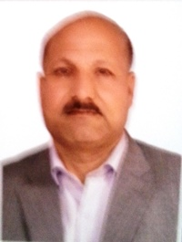
E-mail salihabbas61@yahoo.com
Date of birth: 1-7-1967
Adress : Babylon University
Materials Engineering College
Hilla, Iraq

Education

Exam : B. Sc . In chemical Engineering
Session : 1986- 1990
Institution : University of Technology, Baghdad
Status : Iraq
Exam : Engineering designer
Session : 1990- 2005
Board : Ministry of Industry and Minerals, Babylon
Exam : University of Babylon (Chemical Engineer)
Session : 2005- 2007
Exam : Master degree in materials engineering – polymers technology
Session : 2007-2009
Institution : University of Babylon, Hilla
Status : Iraq
Exam : lecturer in university of Babylon, materials engineering college, polymers and petrochemical industries department
Session : 2009-2013
Exam : PhD in chemical engineering – polymer nanotechnology
Session : 2013 -2018
Institution : Razi university, Bage apresham , Kermanshah
Status : Iran
Chemical engineering skills

Material Characterization , Materials Nanomaterials ,Mechanical Properties , Mechanical Behavior of Materials ,Thin Films Nanotechnology ,Microstructure ,X-ray Diffraction
Language Proficiency
Good command over English and Persian languages

