Curriculum Vitae
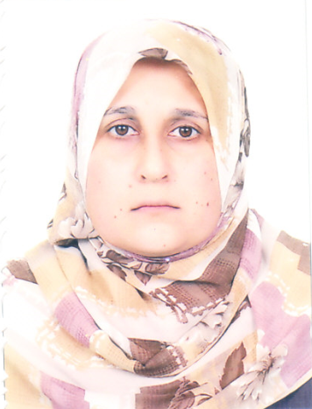
Personal information
Name: Awham Jumah Salman
Date of bearth: 2/7/1980
Gender: Female
Home Adress: Babylon/ Alexandria
Mobile: 07803823581
E-mail: awghamjumah@yahoo.com
Academic achievement
Bachelor's degree:
Country: Iraq
University: Babylon University College: Engineering
specialist: Materials Engineering
Date: 16/8/2003

Master's degree:
Country: Iraq
University: Babylon University College: Engineering
General specialist: Materials Engineering Specialization: Metals Engineering
Date: 2/4/2009
Ph.D degree:
Country: Iraq
University: University of Technology College: Department of Materials Engineering
General specialist: Materials Engineering Specialization: Materials Engineering
Date: 22/7/2018
Academic work:
Department: Building & Construction Technology Engineering
Date of employment in the government:21/12/2016
Date of employment in the foundation:21/12/2016
Scientific title: Lecturer
Date of obtaining the Scientific title: 2/8/2018
Headlines:
Account name :( Awham Salman)
Email : (inb.awh@atu.edu.iq)

1 – Research gate:
https://www.researchgate.net/profile/Awham_Salman
2 - Scopus id:
https://www.scopus.com/sources?zone=&origin=NO%20ORIGIN%20DEFINED
3 – Research ID : T-3438-2017
http://www.researcherid.com/rid/T-3438-2017
4 – ORCID:
https://orcid.org/0000-0003-3486-3616
ORCID ID : 0000-0003-3486-3616
5 – Google Scholar:
https://myaccount.google.com/personal-info?hl=en

