CURRICULUM VITAE
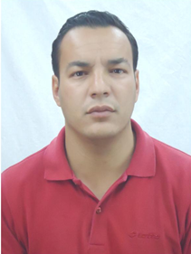
Name Billal NIA
Address 107 building n° 84, Fesdis 05078 Batna, ALGERIA
Telephone +213 664 540 676
E-mail billal.nia@univ-biskra.dz / bnagro@yahoo.fr
Date of birth 21 Juine 1984
Nationality Algerian
Sex Male
Marital status Single

Education/Qualifications
2012-2016 Mohamed Khider University of Biskra, forth inscription in Doctorat
2009-2011 Mohamed Khider University of Biskra, Magister in Agricultural Sciences obtained in 2012.
2002-2007 Hadj Lakhdar University of Batna, Graduate Engineer of Agronomy obtained in 2008

Employment to Date/Work Experience
2013-present Centre for Scientific and Technical Research on Arid Regions (C.R.S.T.R.A), Biskra, Algeria.
Post: Researcher.

Languages Arabic: native speaker; English: fair; French: good.

Interests Travelling, reading, practicing sport.

Publications

Frah N., Nia B. and Medjdoub Bensaad F. 2013. Comparative effect of Flavonoids extracted from the leaves of the bean (ViciafabaL. var. Headquarters) and acetamiprid on the second trophic level Aphis craccivora Koch (Homoptera: Aphididae) and the third trophic level Coccinella septempunctata L. (Coleoptera: Coccinellidae). Agricultural Science Research Journal 3(7) : 199- 203.

Billal NIA, Naama FRAH and Imane AZOUI. 2015. Insecticidal activity of three plants extracts against Myzus persicae (Sulzer, 1776) and their phytochemical screening. Acta agriculturae Slovenica 105 – 2 : 261 – 267.

Imane AZOUI, Naama FRAH, Waffa HABBACHI, Mohamed Laid OUAKID, Billal NIA. 2016. Biodiversity and population dynamics of litter-dwelling cockroaches in Belezma National Park (Algeria). Turk J Zool 40: 231-240.

