- 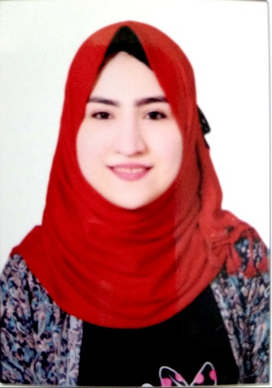

Heba Ebrahim Mahsoub Abo-Elanen
E-mail: hebaa.ebraheem1998@gmail.com
Mobile: +21018735127

Objectives

Seeking a challenging position in reputable organization where my work background and interpersonal skills are well developed and utilized in order to improve my communication skills. To utilize international exposure within an innovative organization with prides itself in its high standard and encourages both company and employee growth.

Highest Education

(2016-2020)
Bachelor Degree in Science
Excellent with honors

Majoring in special Microbiology
Tanta University-Egypt

Graduation project 2020

Role of Bacteria in Plastic Degradation
Excellent degree

Courses and Training

Scientific research center and measurement
2019
Medical Chemical Analysis
Attended the following
Animal Models for studying Human Diseases obesity, Metabolism and cardiovascular diseases
At faculty of veterinary Medicine, Suez canal university on Tuesday 13th October 2020
Presented by Prof.Dr Amal El-Nahla professor of physiology faculty of veterinary medicine

Computer& IT
Microsoft Office™ (Word™, Excel™, PowerPoint™)
Windows™
Language
English: Excellent
Arabic: Native
German: basic
Skill

- Ability to stay calm under pressure.
- Computer literacy.
- Able to work flexible schedule.
- Strong interpersonal skills.
- Organized and detail oriented.
- Time Management Skills.
- Communication Skills.

Personal Background

Nationality: Egyptian
Date of Birth: January 17, 1998
Marital Status: single
Gender: female
Address: Al-Galaa street,treaty road
Al-santa ,Al-Gharbia Governorate

Subject
Microbiology specialist

