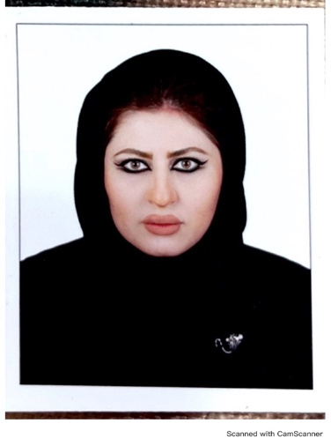

|  |  |  |
| --- | --- | --- |
| Practitioner Name  Dr. Rand Salwan Kamal Abbood  Family medicine specialist (Omar Bin Al Khattab Health center )  Member of Qatari associated of family and community physicians 2023  **Focal person for mental health in OBK health center 2024** | | |
| [Phone:] **33165255**  [E-mail: ]  [violet_rose6@yahoo.com](mailto:violet_rose6@yahoo.com)  [raabbood@phcc.gov.qa](mailto:raabbood@phcc.gov.qa)  Nationality : Iraqi  Lagunage : Arabic , English  [Street Address], [City, ST Zip Code] | |  |
| Street : 125,Doha/ Qatar | | |
|  |  | |
| Educational Qualifications | **Degree 1**  Sanaa University , Yemen  (2008 - 2013)  Degree 2 :  Family medicine specialist/ HMC residency program / Arab board / ACGM Accredited | |
|  |  | |
| Internship | ( 1st January 2015 to 31 dec 2015 -) – HMC – Medical Intern | |
|  |  | |
| Clinical Experience  (including training) written from Current | HMC /PHCC/Qatar  Family medicine resident  (20 August 2017 to 21 July 2022 – )  As resident in different specialties e.g , family medicine clinics , general medicine, COVID19 frontline fighters , endocrine, nephrology, cardiology ,rheumatology , surgery, pediatric , gynecology , psychiatry , dermatology , ophthalmology , ENT , radiology, orthopedic , sport medicine , emergency department. Extra…)  family medicine specialist PHCC Augst 2022- up to today..  Click here to enter a date. | |
|  |  | |
| License | **License Title : medical license /QCHP/PHCC**  **Expiratory date 10 December 2024** | |

|  |  |
| --- | --- |
| * Training Courses | * PLS course 2023 PHCC * BLSO course 2023 PHCC * ILS course 2024 PHCC * BLS Course 2023 PHCC * Medication misuse workshop 2023 PHCC * Qatar mental health conference 2023 * Presentation about COVID 19 impact on family 2020 * Passed IFOM Medical exam 2017. * First Aid Training Course at AL-Kuwait Hospital in collaboration with Yemen Red Crescent, Sanaa Yemen from 15th July to 15th August 2008. * Microsoft Office Application Course Ms Word, Ms Excel, Ms Power Point, Internet course Yemen. 2007 * PHCC surgical workshop 2018 * Conference family medicine department: Journal club participation * Community participation in Autism activity 2018 * HMC communication skills training .. * HMC 5th medical conference Nov /2018 * HMC 3rd endocrine conference Dec/2018 * HMC first Cardiometabolic Symposium Dec 2018 * HMC Osteoporosis day 3rd, November 2018 * Orthopedic research day 31/October /2019 * Rheumatology symposium 2019 * CUSPS Congress November 2019 * PHCC conference 2020 Doha Qatar * Endocrine conference Feb. 2020 Doha Qatar * Casting workshop, Doha Qatar 2020 PHCC * Urinary catheterization course 2018 HMC |