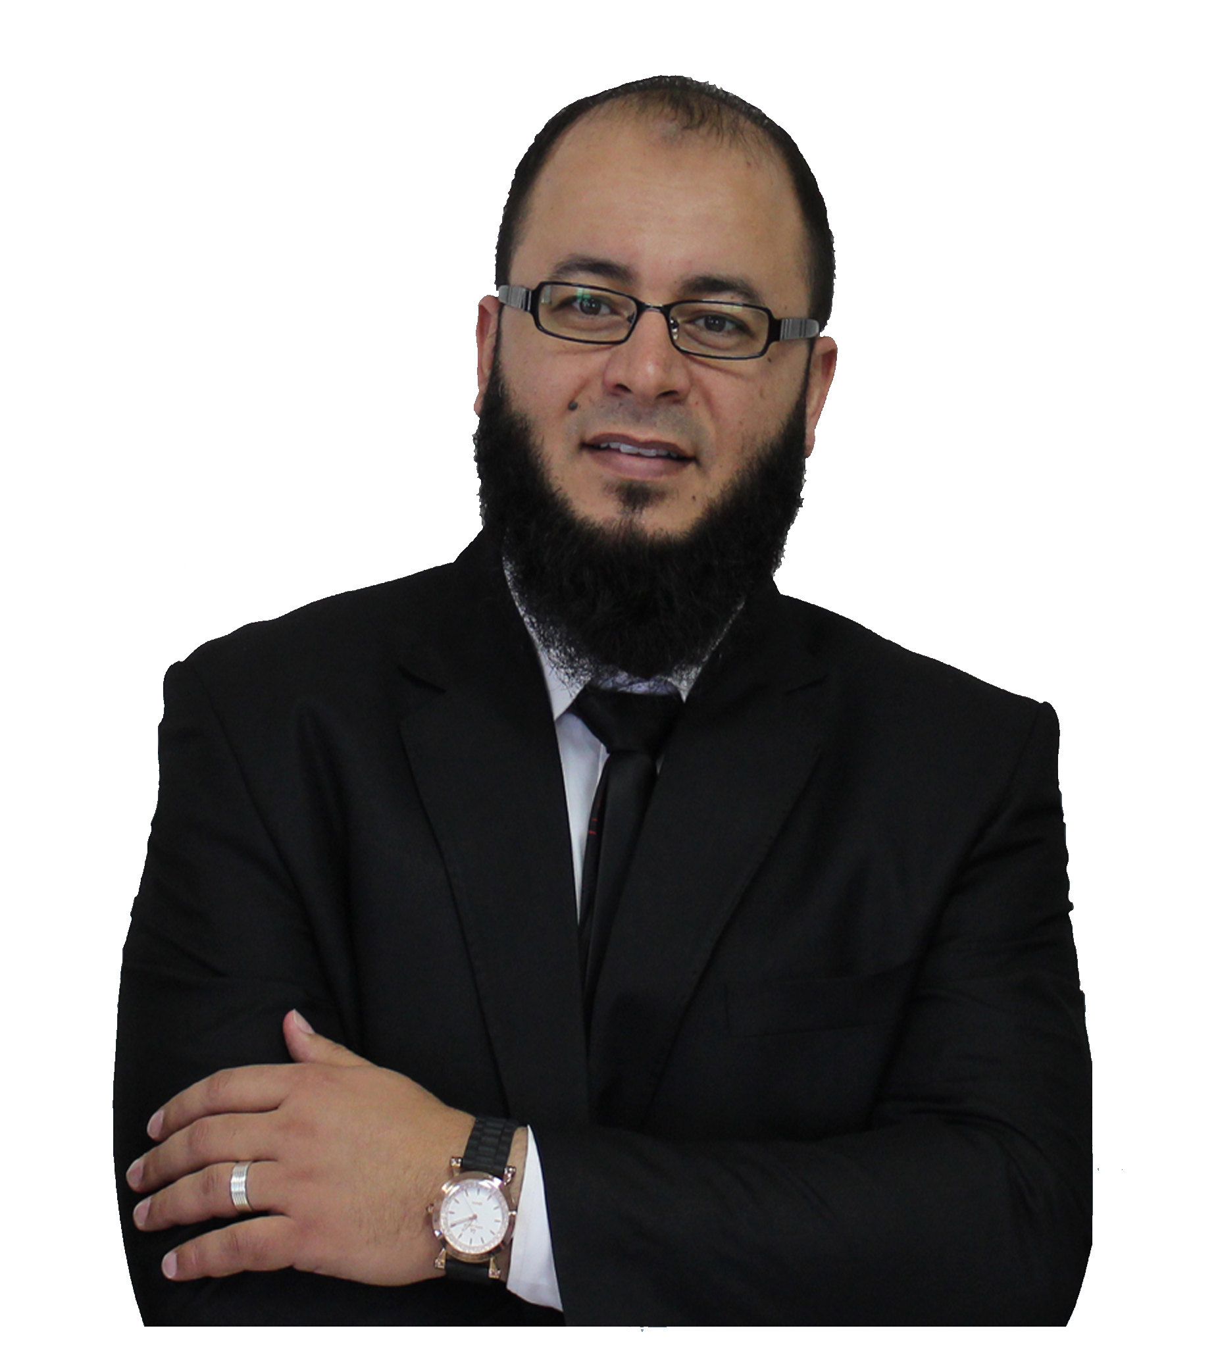
PHOTO

Curriculum Vitae

Contacts:
Name: Muhammad Samir El-Khouly
Phone: 0020 46 494 66 46 – 0020 12 22 90 6505
E-mail: avantposte@yahoo.com

Qualifications:
B.Sc. of Commerce, Alexandria University, 2002
Faculty of Arts – French dept. (Undergraduate), Cairo University, recent.
EMBA, Alexandria University .
Highly Effective Leadership Diploma, School of continuing education, Oxford University.
(Training Licensed Instructor) by Tony Buzan, U.K.
A member of Human Development School, Wales University.
Certified Training in Human Development, Cairo University.
Certified Training in Human Development, Canadian Center, Montreal, Canada.

Training & Skills:
"VQL (Visual quantum Learning)", FACT for human performance technology, improvement, & assessment.
"Creativity and innovation" (Tony Buzan, U.K).
Memory and Speed reading and mind-mapping (Tony Buzan, U.K).
T.O.T. from (IODTC – HCWW – Wales University).
"Situational Leadership", "Methodology of educational leadership" Dr. Tariq Swaidan.
"Soft skills program", New horizons training center.
"Administrative duties using IT", Manpower ministry.
Experience:
2011-Recent.
- Training General Manager at MCWW. http://www.iao.org/IAO/MemberArea/Accreditation-Profile.aspx?ec=89148
- Certified Trainer in these areas:
- Human development and administrative science trainer.
- T.O.T.
- Memory and mind mapping.
- Vision, mission, and objective.
- B.M.I.
- Innovative thinking.
- Modern methods in management.
- Soft Skills (time management, problem solving, etc)
2008-2011
Financial Auditor.
Conferences, Editions, and participations:

"Ship of success" book, Muhammad Samir El-Khouly, Dar-El-Masry press, 2014
"Power of mind" book, Muhammad s. El-Khouly, Dar El-Masry press, under publication.
Regular Radio talks program named "Self-development", at Matruh National Radio. (each 2 weeks)
2nd Water International Conference, Cairo
The first International Conference on Management and Training and Human Development Malaysia
To share research paper at the Second International Conference on Management, training and human development in Malaysia

Cambridge IT Skills Diploma
(The Cambridge IT Skills Diploma is a certificate that is based on the Microsoft Office software)
Iso internal auditor
Icdl Arabian

