Curriculum Vitae
- Personal/Contact Information
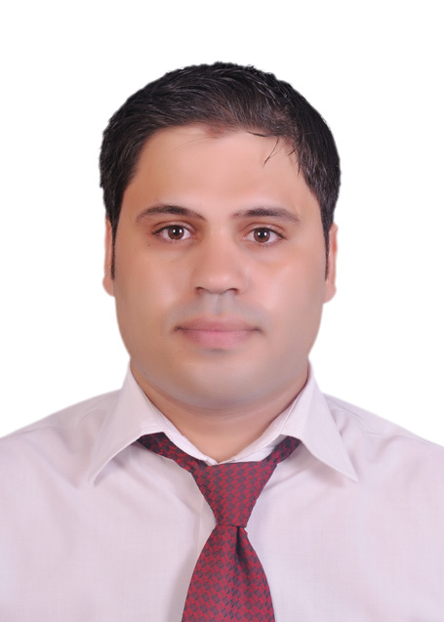

Name: Ahmed Mohammed Yaseen Qaid Alqutaibi
Phone number(s): 00201144772955
Email: am01012002@yahoo.com , am01012002@gmail.com

- Professional Licenses/Certifications
- Ph.D. (prosthodontics), (96.1%) Faculty of Oral and Dental Medicine, Cairo University, Egypt, march 2016.

- Master degree of Dental science (prosthodontics), Faculty of Oral and Dental Medicine, Cairo University, Egypt, 2012.

- License for dentistry practitioners from Yemen Dental Association 2006.

- Intern in Faculty Dentistry, Ibb University, Ibb,Yemen 2006.

- Bachelor degree in Dental science (88.71% with degree of honor) Faculty Dentistry, Ibb University, Ibb, Yemen 2005.
- Educational attainments/Certificates
- Exams and Standards Evaluation Systems, Faculty and leadership Development Center, Cairo University, Cairo, Egypt.
- Quality Standards in the Education Process, Faculty and leadership Development Center, Cairo University, Cairo, Egypt.
- The Credit Hour Systems, Faculty and leadership Development Center, Cairo University, Cairo, Egypt.
- Effective Presentation Skills, Faculty and leadership Development Center, Cairo University, Cairo, Egypt.
- Managing research team, Faculty and leadership Development Center, Cairo University, Cairo, Egypt.
- Use of Technology in Teaching, Faculty and leadership Development Center, Cairo University, Cairo, Egypt.
- Academic/Teaching Experience
- 2006-2009: Demonstrator in prosthodontic Department, Faculty of Dentistry, Ibb University, Yemen.
- 1/10-2016 till now: director of evidence based prosthodontics for Ph.D program, prosthodontic Department, Faculty of Dentistry, Cairo University, Egypt.
- 1/12/2016 till now : lecturer of prosthodontics, Ahram Candian University , Cairo, Egypt

- Related/Other Experience
Full time clinical training in outpatient's clinics with full prosthodontic treatment of variety of cases using different treatment modalities including removable, fixed teeth and implant supported prosthesis as well as maxillofacial prosthesis for intra and extra-oral defect and multidisciplinary treatment. Faculty of Oral and Dental Medicine, Cairo University, Egypt, 2009-2016.

- Technical and Specialized Skills
- Evidenced based practice (critical appraisal of published articles)
- Virtual implant planning: Very good using mimics®, bluesky® and other third party softwares.
- Computer skills: Word, Excel, PowerPoint, Photoshop.
- Windows, Operating Systems maintenance
- Statistical analysis using SPSS® application (statistical package for scientific studies.)
- Professional/Academic Honors and Awards Journal
- Publications Journal Publications
- Alqutaibi AY; M.F. Abdullah and A.F. Kaddah: comparison of two attachment retaining mandibular immediately loaded two implants overdenture: Cairo Dental Journal 1:7 (28) 2012

- Ahmed Alqutaibi, Iman Radi, Ahmed Fayad, khaled zekry: Immediate Implant Placement with a Novel Approach to get Adequate Soft Tissue Coverage: A Case Report. the journal of implant & advanced clinical dentistry.2015. 8(7)

- Ahmed Yaseen Alqutaibi, Mohammed Farouk: Solving the Problem of Misangulated Implant Retained Overdenture with Bar Attachment: A Case Report. the journal of implant & advanced clinical dentistry2015. 10(7)

- Ahmed Alqutaibi: No Reliable Evidence Regarding the Most Effective Interventions for the Treatment of Peri-implantitis. International Journal of Evidence-Based Practice for the Dental Hygienist, 2015. 1(1)

- Ahmed Yaseen Al-Qutaibi, Radhwan saleh Algabri: Limited Evidence Suggests High Risk of Implant Failure Rates Among People With Generalized Aggressive Periodontitis. Journal of Evidence Based Dental Practice 12/2015; 15(4). DOI:10.1016/j.jebdp.2015.10.006

- Ahmed Yaseen Alqutaibi: There is No Evidence on the Effect of the Attachment System on Implant Survival Rate, Overdenture Maintenance, or Patient Satisfaction. Journal of Evidence Based Dental Practice 12/2015; 15(4). DOI:10.1016/j.jebdp.2015.10.005

- Ahmed Yaseen Al-Qutaib: There is No Clear Evidence of Superiority Concerning the Platform-switching in the Preservation of the Marginal Bone Level. The journal of evidence-based dental practice 09/2015; 15(3):118-20. DOI:10.1016/j.jebdp.2015.07.015

- Adnan Abdullah, Naji Al-Fahd, Ail Alsourori, Ahmed Yaseen Al-Qutabi, Mohamed Farouk, Nadia Abbas: Impact of screw retained versus cement retained implant-supported prosthesis on peri-implantitis: A systematic review and meta-analysis.

- Alqutaibi, A.Y., Limited Evidence Suggests Prophylactic Antibiotic Regimen May Reduce Dental Implant Failure. International Journal of Evidence-Based Practice for the Dental Hygienist, 2015. 2(1): p. 40-43.

- Alqutaibi, A.Y., Air Polishing Is a Promising Nonsurgical Treatment Modality for Peri-implant Disease. International Journal of Evidence-Based Practice for the Dental Hygienist, 2015. 1(2): p. 57-60.

- Alqutaibi AY, Aboalrejal AN (2015) Types of Occlusal Splint in Management of Temporomandibular Disorders (TMD). J Arthritis 4:176. doi:10.4172/2167-7921.1000176

- Alqutaibi, A.Y., Limited evidence suggests a single implant overdenture as an alternative to two-implant− supported mandibular overdentures. Journal of Evidence Based Dental Practice, 2016.

- Alqutaibi, A.Y.and Altaib F Short dental implant is considered as a reliable treatment option for patients with atrophic posterior maxilla. Journal of Evidence Based Dental Practice, 2016.

- Alqutaibi, A.Y.,and Aboalrejal A. There is no evidence recommends a specific optimum number of implants for an overdenture. Journal of Evidence Based Dental Practice, 2016.

- poster presentation in 9th international implantology conference, , Egyptian Scientific Society for Dental Implantologist, Cairo , Egypt, 2015

- Editorial board member and reviewer in the following journals

  - ARC Journal of Dental Science from 2015 till now
  - Mathews dentistry Journal from 2015 till now
  - International journal of evidence based practice for dental hygienist, from 5/ 2016 till now.

- Professional Development (conferences/workshops attended, other activities: names and dates)

- Dental clinic practical training , Tishreen University, Lattakia , Syria. 2004

- Course title: Radiation protection in hospitals and medical centers in filed of x- ray, public health office Ibb, Yemen,2004

- The 12th Scientific dental meeting YEMENI DENTAL ASSOCIATION, Sana’a, Yemen2007

- UAE International Dental Conference & Dental Exhibition (AEEDC Dubai) DUBAI HEALTH AUTHORITY,Dubai, UAE, 2009
.
- The 2nd International Dental Congress, Cairo, Egypt, 2013

- 9th international implantology conference, Egyptian Scientific Society for Dental Implantologist Cairo , Egypt, 2015

- Workshop title Systematic Reviews of Interventions Egyptian Center for Evidence Based Medicine, Cairo , Egypt, 2015

- Course title: dental esthetic symposium, British University in Egypt 2015

- The third FUE-IDC, Future University in collaboration with Case Western Reserve University, Cairo, Egypt, 2016.

- Workshop title: The current trends in osseointegeration and implant prosthesis, Future University in collaboration with Case Western Reserve University, Cairo, Egypt, 2016.

- Workshop title how to publish scientific research. Egyptian Center for Evidence Based Medicine, Cairo , Egypt, 2016

- Workshop title Fundamentals of Clinical Research. Egyptian Center for Evidence Based Medicine, Cairo , Egypt, 2016

- The third Egyptian Dental Syndicate International Conference, Egyptian dental syndicate in collaboration Future University, Cairo, Egypt, 31 AUG to 2 SEP 2016.

- Foreign Language Abilities/Skills
English Language.
- References
- Amal Kaddah, Professor and head of prosthodontic, Department of prosthodontic, Faculty of Oral & Dental Medicine, Cairo University, Cairo, Egypt.
Email: amalkaddah@yahoo.com
- Khaled Zekry, Professor of implant prosthodontic, Department of prosthodontic, Faculty of Oral & Dental Medicine, Cairo University, Cairo, Egypt.
Email: kzekry@hotmail.com

