CURRICULUM VITAE

Personals
Name |  | Lubna Ali | 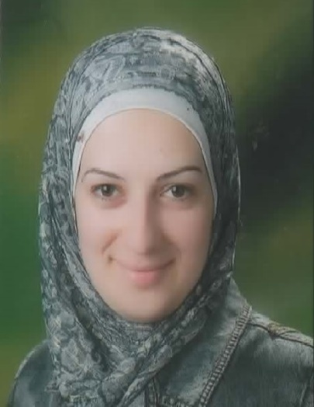
Date of Birth |  | 20.09.1981
Place of Birth |  | Zarqa, Jordan
Marital Status |  | Married, three children
Nationality |  | Jordanian

Education
2004 - 2007 |  | Master of Science in Software Systems Engineering with overall mark of 1,7; RWTH Aachen University- Germany.  Master Thesis: “Minimum Interference Channel Assignment  for Wireless Mesh Networks“.
2003 - 2004 |  | Test of English as Foreign Language (TOEFL), Graduate Record Examination (GRE), Zertifikat Deutsch als Zweitsprache (DaZ), International Computer Driving License (ICDL)
1999 - 2003 |  | Bachelor of Science in Computer Science with a grade of Excellence; Jordan-Yarmouk University

Work Experience
3.2016 - |  | Contractor consultant at Nuance Communication GmbH Company  - Tickets synchronization  - Reviewing batched files design  - Target testing  - Reviewing and modifying already translated or localized texts
8.2015 – 12.2015 |  | Voluntary Works  - Helping the refugees and supporting Aachen Municipality  - Translating Arabic/German  - Accompanying the patients to the doctors and hospitals  - Helping in organizing German lessons
01.2014 |  | Internship at the Deutsche Welle/ Bonn  - Being involved in the daily editorial activities  - Research, writing and translating online articles
11.2010 - 10.2012 |  | Contractor consultant at Nuance Communication GmbH Company for the Arabic projects  - Annotations, prompt tuning and localization  - Evaluating design and quality of pronunciation dictionaries  - Reviewing and modifying already translated or localized texts  - Evaluating and correcting dictionary entries  - Working on several internally developed tools and Software

Professional Development Courses
04.2105 - 07.2105 |  | Project Management Professional Development Course/ Contact GmbH  - The course addresses the Contextual competences, Technical competences and Behavioral competences related to project management.  - Quality Management for Project Mangers Certificate  - Individual Project “Gründung einer Ganztagschule in Jordanien”  - Certified Project Management Associate (IPMA Level D) Certificate
02.2015 - 03.2015 |  | “English for Business” Course  - Review the grammatical expressions related to economics and management  - Improvement of business communication  - LCCI English for Business Certificate; Level 3/C1
10.2011 - 03.2012 |  | DSH German Language Proficiency Course for the Admission to Higher Education  - Understand and analyse scientific texts  - Understand and summarize written texts  - DSH Test  - DSH Certificate with „Note 2“/ Very good

Additional Qualifications
Computer-Skills
Programming |  | C++, Pascal, Visual Basic, Assembly, Oracle
Others |  | MS Office, CorelDraw, MS Project
Languages
German |  | Very good in spoken and written
English |  | Very good in spoken and written
Arabic |  | Fluent in spoken and written

Interpersonal Skills
- Ability to manage multiple tasks.
- Excellent communication skills
- Great time management and self-organization.
- Ability to be team leader/player.

Hobbys
Reading, Swimming, Gymnastic, Travelling, Writing

Lubna Ali
Herzogenrath,23.09.2016

