CURRICULUM VITAE

Personal Info
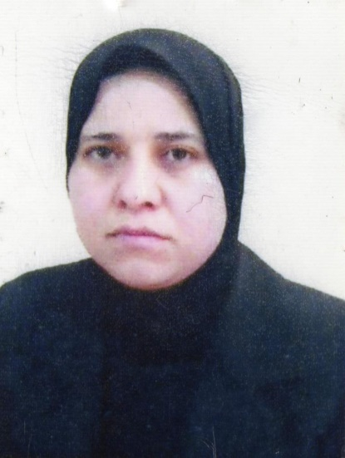
Full Name: Hala mohammed majeed
Nationality: maslam
Place of Birth: kurkuk
Birth Date: 08/10/1980
Public Major: veterinary surgical medicine
Special Major: microbiology
Academic rank: Assistant professor
Marital Status: Single
E-Mail: halamicro@tu.edu.iq

ACADEMIC QUALIFICATIONS (Certificates)
Qualification | Grade | Country | Major | Institution | Date obtained
B. A. | Good | iraq | Baghdad university | veterinary surgical medicine | 07/07/2004
M. A. | Excellence | iraq | baghdad | microbiology | 08/20/2008
Ph. D. | Excellence | iraq | university tikrut | microbiology | 05/01/2015

Academic rank
Rank | Date obtained
professor
Assistant professor | 11/16/2016
Lecturer | 10/12/2011
Assistant lecturer | 08/20/2008

Course Taught
Undergraduate | Postgraduate
microbiology
parasitology
virology
immunology
clinical pathologyical
Hygiene practical
bacteriology

Publications
Published researches / Article | Published Date | Journal book
Isolation and identification of causative agent bacteria aerobic Cause Clinical Mastitis From Cows and The role Lactobacillus | 06/01/2009 | Journal Tikrit Univ. For Agri. Sci.
Study on Prevalence of Bovine Mastitis and Its Major Causative Agents in Salahadin City, Iraq. | 06/06/2016 | Journal Tikrit Univ. For Agri. Sci
Isolation and identification of causative bacteria Cause chronic sinusitis | 08/09/2011 | Journal Tikrit Univ. For Sci
Isolation and identification of fungi Cause inflammation chronic sinusitis | 04/07/2011 | Journal Tikrit Univ. For Sci
ASSOCIATION BETWEEN HERPES SIMPLEX VIRUS TYPE 2 (HSV 2) AND BAD OBSTETRIC OUTCOMES | 05/07/2014 | Our Dermatol Online
Association Between Cytomegalovirus Infection and Bad Obstetric Outcomes in Women from Kirkuk. | 11/04/2014 | Int J Public Health Sci
Rubella Seroprevalence in Women with Bad Obstetric History | 11/02/2016 | Journal of Immuno Virology
Isolation of diverse bacterial species associated with sheep diseases in salah - Din City, Iraq. | 11/05/2016 | المؤتمر الطب البيطري الثالث
Autoantibodies In Women With Bad Obstetric History | 11/03/2016 | ournal-of-Immunology-and-Cellular-Microbiologyj
Autoantibodies In Women With Bad Obstetric History | 11/03/2016 | ournal-of-Immunology-and-Cellular-Microbiologyj

Academic Conference Attended
Conference Title | Conference Date | Conference Place
3rd scientific conference of veterinary medicine | 05/02/2016 | Tikrit university-college of veterinary medicine

Awards & certificates or letters of appreciation
Institution Awarded | Date obtained | Reasons for Awarding | Institutes of Appreciation
ministerial | 06/06/2013 | Efforts at the university service | letters of appreciation
academic | 01/08/2004 | Efforts at the university service | letters of appreciation
academic | 04/16/2012 | Efforts at the university service | letters of appreciation
administrative | 01/20/2010 | Efforts at the university service | letters of appreciation
administrative | 12/10/2009 | Efforts at the university service | letters of appreciation
administrative | 11/05/2008 | Efforts at the university service | letters of appreciation
administrative | 04/07/2010 | university day | letters of appreciation
administrative | 11/06/2011 | Efforts at the university service | letters of appreciation
administrative | 01/19/2016 | Efforts at the university service | letters of appreciation
administrative | 12/25/2011 | academic rank | letters of appreciation

ADMINISTRATIVE posts
Major | Institution | Date held
determinant | college of veterinary medicine | 04/07/2009

Signature Signature
Dean of College President of University

