C.V
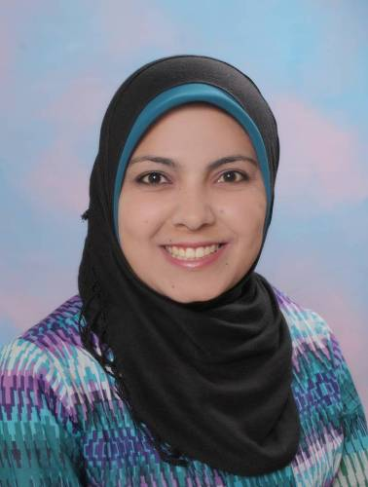
Personal Information
- Name : Fida,a as,ad mustafa mustafa
- Marital Status: Single
- Data of birth 13th of April 1981
- Gender: Female
- Nationality: Jordanian
- Address: Al-muqabalain ,Amman,Jordan
- Mobile : 00962-776492008 / 00962788789960
- E-mail : fida-81@hotmail.com
Education
- 2004 BSC. Libraries and information management (Al-Balqa Applied University ,Jordan).
- 2001 Diploma of instruction technology and libraries (alia queen college,amman,jordan).
- 1999 tawjihi 79.3 (zain alsharaf school, aqaba, Jordan).
Work Experience
- Oug 2009 – now - I have worked librarian in MOE.
- May 2008 – Oct 2008 - archiving , montaging and data entry in the library at saudi comedy channel using "Avid liquid" and "Access" software.
- Dec 2006 – dec 2007 - a programmer, data entry, montaging, musical list, archiving in the musical library at sawtalmadena (JBC) radio station using "Netia"software.
- Jan 2005 – Nov 2005 - Librarian and typing in The Association of Banks in Jordan.
- Sep2006 – nov 2006 - Data Entry in internet in global star trading investment.
- Sep2004 – Oct 2004 – Population &housing census to 2004.
Courses
- Apr 2018 – course in a supportive learning environment at queen rania academy.
- Nov 2018 - Attendance of the eighth conference under the title: Information institutions in the Kingdom of Saudi Arabia and its role in supporting the economy and the knowledge society at Saudi Libraries and Information Society.
- June 2011 - Course in english language at jordan library &information association.
- Apr 2011 - Course in ICDL at ministry of education.
- I had training while I was studying in the university for 8 month in sections of clasification, cataloging, Acquistion, loaning, referenses and data bases& internet.
- Oct 2003 – Feb 2004 - Hashemite university library.
- Feb2001 - June2001 - Amman training college library.
- Aug 2007 - Course in marketing at sawtalmadena radio station.

Personal Skills
- I have a very good experience in Microsoft office applications (word, excel, access, CDs/Isis, winisis, web Design"html", visual basic , Netia and Avid liquid)
- Arabic and English typing by computer and scanning.
- I have a very good experience in surfing internet & databases.
- Excellent coordination and communications skills.
- Ability and willingness to learn.
- Work excellently in team-built environments.
- Leading personality.
- Ability to work under pressure.
Other: -
- Reading a new informations and search at internet.
- driver's license private.

