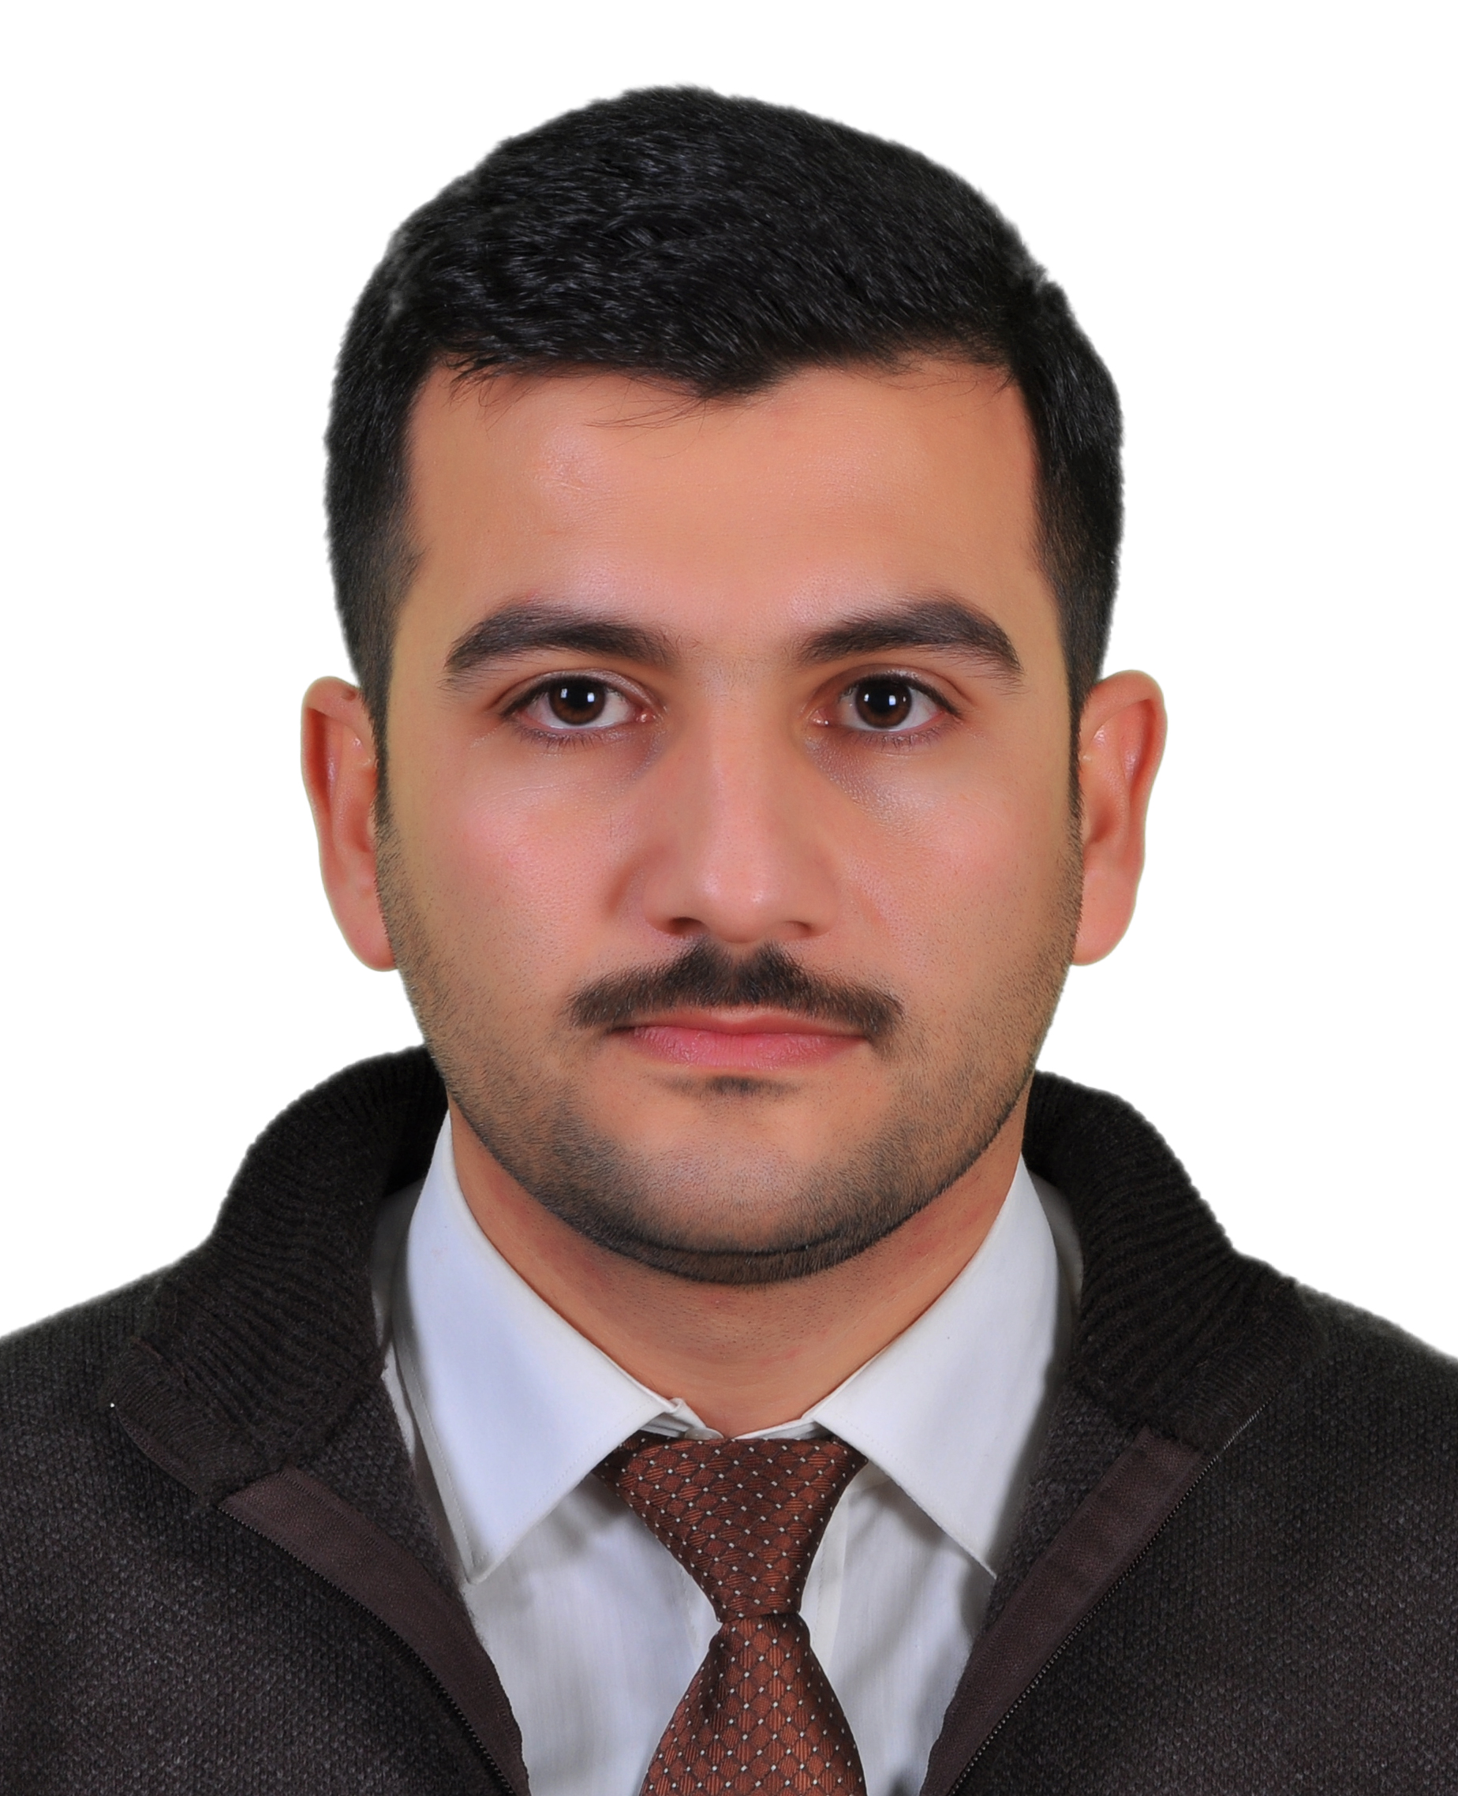
CV

Mohammed Assim Mohammed Al
Primary Email Address: mohammed.asum@yahoo.com
Permanent Address : University of Mosul, Kirkuk city, Iraq.
City, State, Zip Code: 009647512736484
Telephone Number: 009647703850347
EDUCATION (List Most Recent First)

Date Received | Name of Institution and Address | Area of Study | Degree Received
Dec-2010 | University of Mosul  Mosul - Iraq | Management Information System | Master degree
June-2007 | University of Mosul  Mosul - Iraq | Management Information System | Bachelor degree  (I'm Ranked First of 160 student )
Master-Thesis:
-Title: Design Data Warehouse to Support Customer Relationship Management : Case Study in ready mode wear factory/Mosul.
I got excellent grade (average mark is 90%) in discussing Masters' thesis.
Bachelor- Final project
-Title: The role of ICT in the enhancement of quality assurance requirements in institutions of higher education in Iraq.
I got excellent grade in discussing Bachelor- Final project.

HONORS/AWARDS/RECOGNITION (List Most Recent First)
Date Received | Name of Institution or Organization and Address | HONORS/AWARDS/RECOGNITION
1/4/2008 | University of Mosul  Mosul - Iraq | Award for first ranked student
1/4/2008 | Iraq Red Crescent Organization Nineveh Branch | Award for first ranked student
Work Experience
Name of Institution or Organization and Address |  |  | Begin and End Date
Academic
Assistant Lecture, Department of Management Information systems, University of Mosul. |  |  | 2011- now
Instructor, Alhoda Institute for computer, Mosul, Iraq. |  |  | 2010 - 2011
Coordinator of management information system Dept. University of Mosul. |  |  | 2014-now
Assistant Lecture, College of Administration and Financial , University of Cihan |  |  | 2015-2016
Other Experience
Database Developer, Alhoda Institute for computer, Mosul, Iraq. |  |  | 2011 – 2012

PUBLICATION: Articles and conferences
Journal and Conferences | Name of Article
Strategic vision of the reality of service in Iraq and their impact on investment: Annual Scientific Conference of the Faculty of Business and Economics - University of Mosul, 2011 | Information Technology Governance to enhancing strategic performance of service organization focus on balance scorecard – a case study the Directorate of Telecommunications and post in Nineveh.(A joint research)
Administrative Arab journal,2012 | Design Data Warehouse and the use of on-line analytical processing to support customer relationship management: a case study in ready mode wear factory/Mosul.(A joint research)
The use of logic of scientific and historical for economic drive traffic, National Scientific Conference , College of Administration and Economics and the Higher Institute of Accounting and Financial Studies, University of Baghdad, 3-4-2003 | Proposed model for the application of E-learning In Iraqi universities(Arabic version) (A joint research)
Towards a better investment environment: Reality - Challenges - Prospects  : The first global scientific conference of the faculties of Computer and Business, university of Duhok, 11-13-5-2013 | Using data analysis techniques to improve customer satisfaction: a case study. (Arabic version) (A joint research)
Second International Scientific Conference of the Faculty of Business and Finance : The role of excellence and leadership in the superiority of business organizations , International Islamic University of Science, Amman, Jordan, 21-22-5-2013 | Using Information System to improve Small Organization's performance in retail sector: case study. (Arabic version)(A joint research)
journal of education and science, 2013 University of Mosul | FP Growth Algorithm for market basket analysis. (Arabic version)(A joint research)
International Journal Of Advanced Research in Engineering & Management (IJAREM) | Factors Affecting Customer Loyalty Towards Yes Company in Malaysia Factors Affecting Customer Loyalty Towards Yes Company in Malaysia Media (English version)(A joint research)
In the process of completion | E-Marketing by using Social Media (English version)
In the process of completion | Critical Factors in the Adoption and  Diffusion of E-government Initiatives in  Iraq (English version)
PRESENTATION
Name of Conference or meeting and Location | Title and Data of presentation
Third scientific conference at Department of management information systems . | Electronic archive as a part of Electronic Government  Date : 2011
Strategic vision of the reality of service in Iraq and their impact on investment: Annual Scientific Conference of the Faculty of Business and Economics - University of Mosul, 2011 | Information Technology Governance to enhancing strategic performance of service organization focus on balance scorecard – a case study the Directorate of Telecommunications and post in Nineveh.  Date : 2011
Courses Taught
Department of Management Information Systems, University of Mosul.
- Database (Oracle) : 2012
- Visual Basic Essentials 2013.
- Human Resource management: 2013.
- Information Technology 2014
- Concept of Database : 2015
- Business application of internet
- Essential of Management information systems.
Department Of Accounting, University of Mosul
- Essential of Computer: 2012.
- Essential of Computer: 2013.
Alhoda Institute for computer
- Database: 2011.
College of Administration and Financial , University of Cihan
- Leadership Effectiveness 2015.
- Human Resources Management I 2015.
- Project Management 2016.
- Human Resources Management II 2016.

Skills and Interests
Interests | Skills
Research Interest :  My research interest cover :  Information Technology, Information system, Project Management, Data management , data base, Data Warehouse, Data Mining ,OLAP, Business Intelligence , Planning ,leadership, | Technical Skills:  Programming Languages :  Visual Basic, Essential C++.  Computer Application:  MS Office, SPSS, SPSS.  Operation System:  MS Windows 2000/XP/ Vista, win 7.  Data Base System:  MY SQL, Oracle 10g, Fox pro, MS Access.  Internet Technologies:  HTML, Php , Dreamweaver, Wampserver
Committees
Committees :
- Member of Information Technology Team in Management information system Dept. , University of Mosul (2012).
- Member of Higher education quality Committee in Management information system Dept. , University of Mosul (2011- now).
- Member of training students Committee in Management information system Dept. , University of Mosul (2011-2012).
- Member of committee of Examination students in Management information system Dept., University of Mosul (2011-now).
- Member of organization structure committee for Nineveh University (2013).

Training courses
Training Center | Courses Name
HP LIFE e-Learning | Selling online Certification
HP LIFE e-Learning | Social media marketing Certification
HP LIFE e-Learning | Effective business websites Certification
Prospects Center for Human Development, creativity and development | Leadership Certification
Al Rowad instate for science | Leadership (Leader Making) Certification
Center for developing teaching methods & staff training, University of Mosul. | Teaching methods certification
Center of computer , University of Mosul | Computer essential Certification
Certiport | IC3 GS3 Internet and Computing Core Certification (Windows 7, Office 2010 , Computing Fundamental )
In the process of completion | OCA & OCP

PROFISIONAL MEMBERSHIP
- Member : Project Management Institute (Iraq) (Director)(2010-2013)
- Internet society (2012- now).
- Iraqi students and youth society – Nineveh branch since (2003-2008).

REFERENCES (Include the Names of at Least Three Professors or Instructors)
Telephone Number and Address | How this person know you | Name of Reference
Iraq, Duhok ,University of duhok .  Drakela08@yahoo.com  009647701735244 | Chairperson of the Committee of my Master thesis and I work with her in the field of scientific research | Akela Mustafa AL-Atroshi  (Professor)
Iraq, Mosul, university of Mosul.  sadallahlayth@yahoo.com  009647701616345 | Supervisor of the master's thesis,  Currently I'm working with him i n the same academic department. | Layth Sadalla Hussein  Assistant Professor))

