Curriculum Vitae
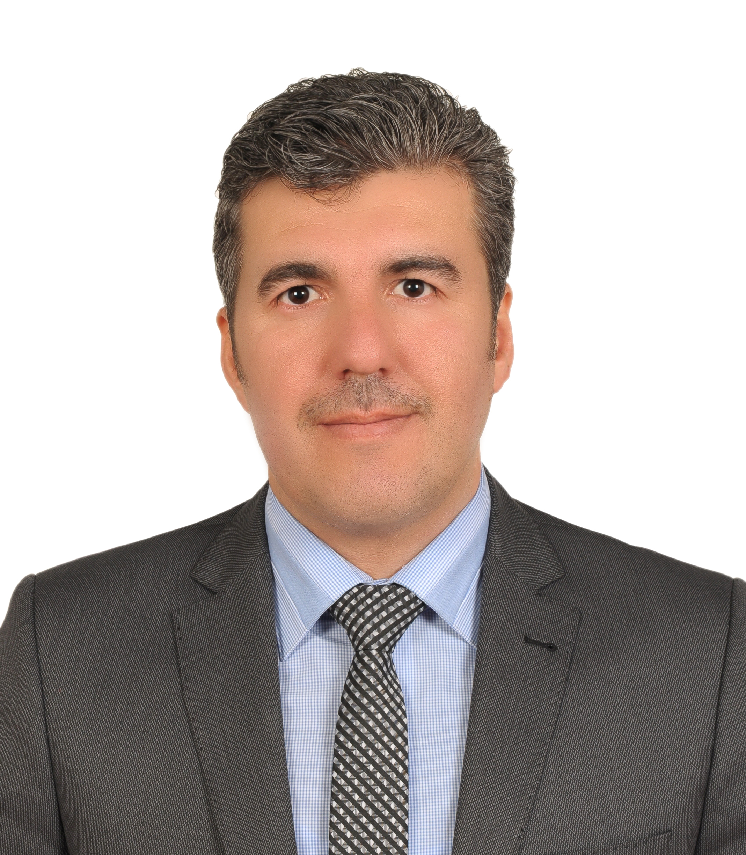

Personal Information:

    - Name: Ahmed Burhan Mohammed
    - BOD: 25/04/1979 Kirkuk, IRAQ.
    - Nationality: IRAQI.
    - Languages Influent and Spoken: Arabic, English, and Turkish.
    - Address: Al_Asra Reg, KIRKUK, IRAQ.
- Mobile: +964 770 -1331591
- E-mail: ahmedlogic79@yahoo.com

Educational Terms:

- 1985 - 1998: Primary and Secondary Schools (Kirkuk).
- 1999 - 2003: Technical College Kirkuk / Software Engineering.
- 2003 : B. Sc. Software Engineering.
- 2015 : M. Sc. Computer Engineering.

Technical Experience:
- 2003 – 2004:
  - Computer Maintenance in Logic Computer Center and Teaching C++ Programming language and Assembly 8085 language for science college students.
- 2005 – 2006: Computer Maintenance / Kirkuk University.
- 2006 – 2007: Database programming, Web Site Design Networking, Practical Teaching in Medicine College/ Kirkuk University.
- 2007 – 2008:
  - Design and Print Kirkuk University Journal for Human Studies / Education College / Kirkuk University.
  - Design and Print Journal of The First Scientific Conference For Agricultural Researches / Kirkuk University.

- 2008 – 2009:
  - Teaching Office Programs and computer maintenance courses in computer center in Kirkuk University.
  - Teaching CCNA1 Course in Cisco Academy – Kirkuk University.
  - Design and Print Journal of The First Symposium of The Reconstruction of Kirkuk University 2009.

- 2009 – 2010:
  - Teaching CCNA1 Course in Cisco Academy – Kirkuk University.
  - Teaching IT Essential Course in Cisco Academy – Kirkuk University.
  - Teaching CCNA2 Course in Cisco Academy – Kirkuk University.

- 2010 – 2011:
  - Teaching CCNA1 Course in Cisco Academy – Kirkuk University.
  - Teaching IT Essential Course in Cisco Academy – Kirkuk University.
  - Teaching CCNA2 Course in Cisco Academy – Kirkuk University.
  - Teaching IC³ Course in Computer Center – Kirkuk University.
  - Video Conference Coordinator in computer center in Kirkuk University.
  - Network Managing and Teaching.

- 2015-2017
  - Principle of Computer Fundamental in college of arts.
  - Principle of Digital Technologies for media department second class students.

Programming:
- Microsoft Office (Word, Excel, Access, PowerPoint, Front Page).
- Visual Basic Programming.
- Programming Languages (Basic, Pascal, C, C++, Java etc).
- Adobe Photoshop, and other Photo Applications.
- Many Other Programs.
- Working on WEKA with Machine Learning algorithms.
- Simple work on Apache Spark.
- Work on Joomla web site management platform.
- Working on map reduce data mining applications.
- Working on Mikro Tik network management devices.

Courses:
- Course of CompTIA A+ Essential and Elective.
- Course of Networking in Computer Center / Kirkuk University.
- Course of CCNA1 in Salahaddin University / Regional CISCO Academy as Instructor.
- Course of Web design in Computer Center / Kirkuk University.
- Course of IT Essential in Salahaddin University / Regional CISCO Academy as Instructor.
- Course of CCNA2 in Lebanon American University / Byblos Lebanon
As Instructor in CISCO academy.
- Course of CCNA in Aman Jordan by The Consultants For Managerial & Technical Consultation 2010.
- Course of Video Conference Managing using Moodel System in Bilkent University Ankara Turkey 2011.
- Course of the website management for Kirkuk university faculties in the Computer Center 2017.

Publishing:
- Book: Anomalous Network Packet Detection Using stream mining and clustering algorithms by LAP LAMBERT Academic Publishing 2017.
- Paper: Decision Tree, Naïve Bayes and Support Vector Machine Applying on Social Media Usage in NYC / Comparative Analysis.
- Paper: Using Data Mining Techniques to Predict University Students Hookah Smoking.
- Participation in the First Scientific Conference of the College on AL Mustafa University in Baghdad 2017 by a Paper: using of technical methods in reducing scientific astrology.
- Certificates:
- Certificate in Test of Computer Using skill from Computer Center / Kirkuk University 2006.
- Participation Certificate of First Scientific Conference For Agricultural Researches Kirkuk University 2007.
- Certificate of CompTIA A+ from RITS 2008.
- Certificate of CCNA1 from CISCO Academy as Instructor 2008.
- Participation Certificate of First Symposium of The Reconstruction of Kirkuk University 2009.
- Certificate of IT Essential from CISCO Academy as Instructor 2009.
- Certificate of CCNA2 from CISCO Academy as Instructor 2009.
- Certificate of CCNA in Amman Jordan by The Consultants For Managerial & Technical Consultation 2010.
- Certificate of ITP TOFEL score 427 in 2011.
- Certificate of participation for the program of “Relationship Management in Business” by EDUCON Turkey in 2014.
- Certificate of participation for the program of “Successful Communication model in Business” by EDUCON Turkey in 2014.
- Certificate of of Completion course of What is open science by the Elsevier Publishing Campus 2017.

Ahmed Burhan Mohammed
Signature
2017 / /

