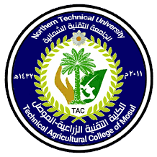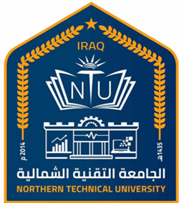

**Northern Technical University**

**Technical Agricultural College of Mosul**

**Personal Information**

|  |  |
| --- | --- |
| **Donea Abdulrazak Abdullah** | **Full name** |
| **Asso. Prof** | **Scientific Title** |
| **Head of Department** | **Position** |
| **Animals Production Techniques** | **Department/Division** |
| doneaabed@ntu.edu.iq | **E-mail** |

**Academic Certificates**

|  |  |  |  |  |
| --- | --- | --- | --- | --- |
| **Country** | **Specialization** | **Date of Certificate** | **Certificate** | **University** |
| **Iraq** | **Veterinary Medicine** | **2001** | **Bachelor** | **University of Mosul** |
| **Iraq** | **Veterinary Parasitology** | **2004** | **Master** | **University of Mosul** |
| **Malaysia** | **Veterinary Parasitology** | **2019** | **PhD** | **University of Putra Malaysia (UPM)** |

**Academic Experience**

|  |  |
| --- | --- |
| **√** | **Undergraduate Study** |
|  | **Postgraduate Study** |

**Research and Scientific Interests**

|  |
| --- |
| **Veterinary Parasitology, Molecular Parasitology** |

**Scientific Activities**

|  |  |
| --- | --- |
| **Published researches** | **28** |
| **Conferences and seminars** | **4 conf. + 6 seminars** |
| **Membership in scientific and professional societies and publishing houses** | **Journal Director in NTU journal of Agriculture and Veterinary Science** |

|  |  |
| --- | --- |
| **Profiles** | |
| <https://scholar.google.com/citations?user=-yIdvW4AAAAJ&hl=en> | **Google Scholar Profile** |
| <https://www.researchgate.net/profile/Donea_Abdullah> | **ResearchGate Profile** |
| <https://www.webofscience.com/wos/author/record/D-1134-2019> | Web of Science MyRA - Apps on Google Play  **WEB OF SCIENCE** |
| <https://orcid.org/0000-0002-6985-6611> | **ORCID** |
| <https://www.scopus.com/authid/detail.uri?authorId=57202773356> | **Scopus** |

**Honours and Awards**

|  |  |
| --- | --- |
| Issued by | Title of Achievement |
|  |  |