**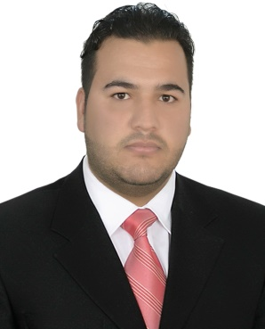 *MUSTAFA SAEED HABEEB***

**Address**

**Iraq\diyala\ALmansuriyah**

***Contact***

**E-mail: *mo4772788@gmail.com***

**Phone: *+9647706002304***

***Academic Achievement***

**Bachelor in Environmental Engineering**

**Studies Master degree in Environmental Engineering**

***Languages***

**Fluency in Arabic**

**Average English**

**Courses:**

***1- Field Survey Training***

***2- Rights and freedom of woman Training.***

***3- Modern media* *Training***

***4- WASH Training.***

***5- First aid Training***

***Skills & Interests***

**Skilled in engineering works**

**Skilled in ATUCAD**

**Skilled in Visual basic**

**Skilled in GIS**

**Good in computer--Excel-PowerPoint and Word**

**Design water treatment plants-units of air filter design**