PERSONAL INFORMATION | Islam Asem Abdelkareim Biomy
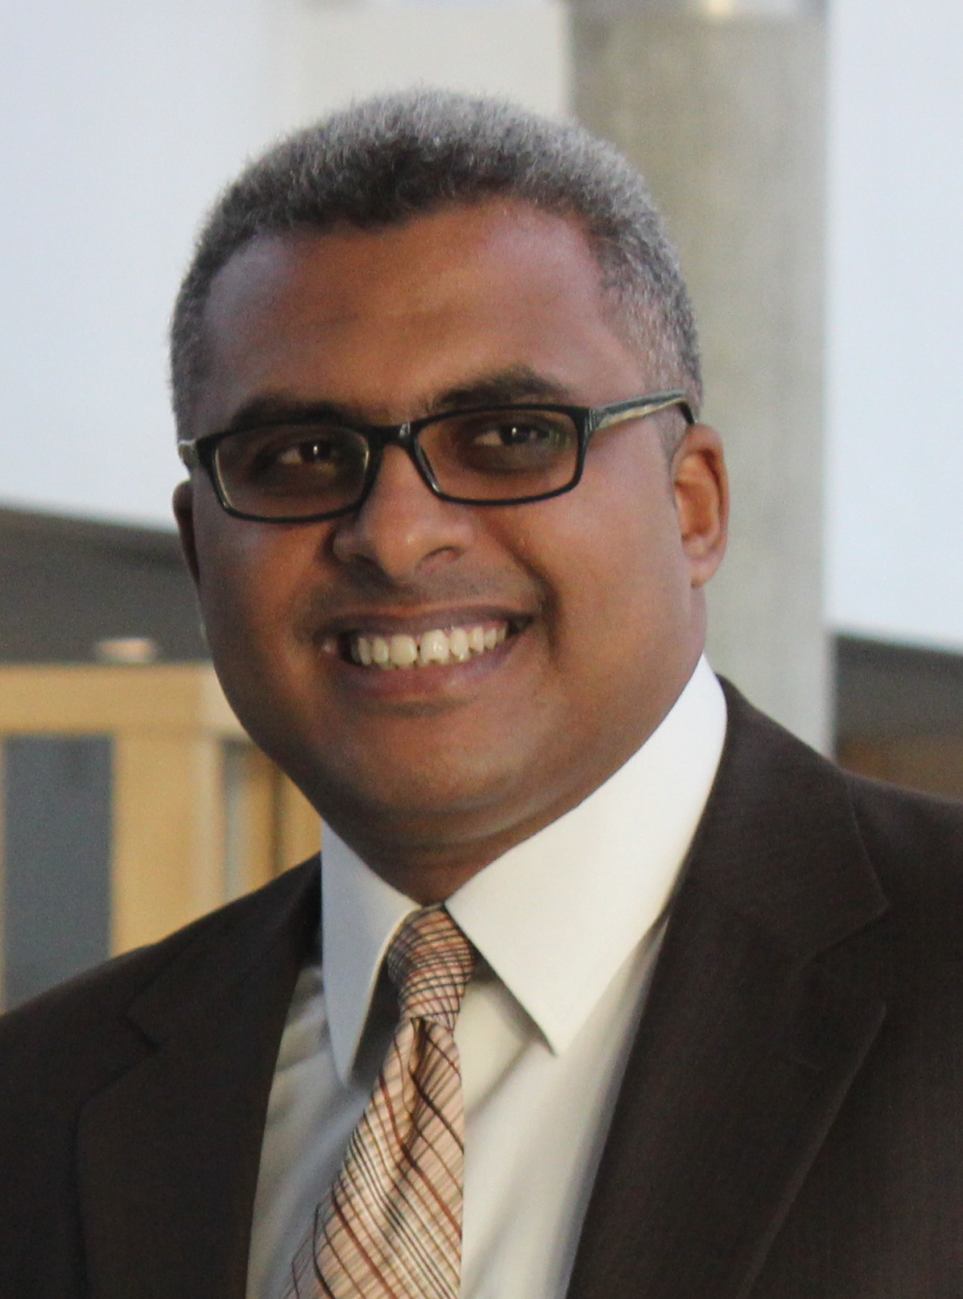
 | Alexandria (Egypt)
 | +201001860959
 | guiaegipcio@yahoo.com
 | Sex Male | Date of birth 05 August 1980 | Nationality Egyptian

WORK EXPERIENCE

Feb. 2020 -Present  Dec. 2019 – Present | Act Head of Tour-guiding Dep.  The High Institute of Tourism, Hotels and Monuments restoration of Abukir, Alexandria (Egypt)  Associate professor of Modern and Contemporary History and Tour-Guiding
 | The High Institute of Tourism, Hotels and Monuments restoration of Abukir, Alexandria (Egypt)

22 Sept. 2013 – Nov. 2019 | Lecturer of Modern and Contemporary History and Tour-Guiding
 | The High Institute of Tourism, Hotels and Monuments restoration of Abukir, Alexandria (Egypt)

September 2002–2017 | Spanish- English Tourist guide
 | Freelancer, (Egypt)

EDUCATION AND TRAINING

February 2011–30 July 2013 | PhD in Tourist guiding (Modern and contemporary history - Heritage Tourism)
 | Faculty of Tourism - Alexandria university, Alexandria (Egypt)
 | Thesis Title: “The Role of The Religious Buildings in Enriching Heritage Tourism, A Study of The Religious Islamic Buildings in Alexandria from 1882 to 1952”.

2006–18 November 2009 | (MSc) Master's degree of Tourist Guiding and Tourism and Hotels- Modern and Contemporary History
 | Faculty of Tourism &Hotel, Alexandria University, Alexandria (Egypt)
 | Thesis Title: “Egypt in the Eyes of The Travellers in The Modern Time (1517-1952), A Historical, Cultural, Tourist Study”.

September 1997–May 2001 | B.Sc. of Tourist Guiding.
 | Faculty of Tourism &Hotel, Alexandria University., Alexandria (Egypt)

PERSONAL SKILLS

Mother tongue(s) | Arabic
Other language(s) | UNDERSTANDING |  | SPEAKING |  | WRITING
 | Listening | Reading | Spoken interaction | Spoken production
Spanish | C1 | C1 | C2 | C2 | C1
 | Diploma de Español como Lengua Extranjera(DELE) B2.
 | Related document(s):
English | C1 | C1 | C1 | C1 | C1
Levels: A1/A2: Basic user - B1/B2: Independent user - C1/C2: Proficient user
Common European Framework of Reference for Languages

Communication skills | Good communication skills and excellent contact skills with all ages gained through my experience as a Tour guide and as a lecturer in the field of raising the awareness of architectural heritage in Alexandria.

Organisational / managerial skills | - Training Course on International Publishing of Research, , FLDC, Alexandria University, 10 June 2019.  - Training Course on Design and production of Digital Content, FLDC, Alexandria University, 1-2 June 2019.  - Training Course on Legal and Financial Aspects in University, FLDC, Alexandria University, 11-12 March 2019.  - Good organisational skills with quality insurance gained through holding the position of Secretary General and president of the Tourist guides syndicate in Alexandria from 2011 till 2017, and through managing the events and the activities of the Association of Heritage and traditional Arts.

Computer skills | ICDL certificate 2011 from the Ministry of Communications and Information Technology- Egypt  Skills:  Concepts of Information Technology (IT)  Using the Computer and Managing Files (Windows)  Word Processing  Spread sheets(Excel)  Database(Access)  Presentation(Power Point)  Web Browsing and Communication

ADDITIONAL INFORMATION

Conferences | - The international conference "From stone to paper, from paper to digital: what means of safeguarding heritage?" Senghor University in Alexandria, Egypt 25 to 28 February 2019 a paper entitled "The Role of Digitizing Traveller’s Books in Preserving The Intangible Heritage of Egypt".  - The 1st international conference of Faculty of Tourism and Hotel Management – Pharos University in Alexandria-Egypt, 24- 27 October, 2017. With a paper Entitled” The Collection of Carl Wilhelm von Gerber: Unknown History”.  -The international workshop of Enlargement and enrichment the Mediterranean Historic centers network, AASTMT, Alexandria, 16th Nov. 2016.  - The first international conference of Arab Tourism: Reality and Future Prospects, in Kark-Jordan, 03-06 April, 2017. With a paper Entitled "Alexandria stadium: Historical and Touristic Value"  - The seventh international conference of the Arabic Tourism, 29- 30 November, 2016. In Ismailia-Egypt, With a paper Entitled” The Anglican Patriarchate of saint Mark in Alexandria: historical, heritage, tourist Value”.  - The HU- BTU third international conference on Heritage Conservation and site Management", 08- 11 December, 2015. In Cairo-Egypt, With a paper Entitled”The First World War In Alexandria Ignored Heritage”.  - The fifth international conference of the Arabic Tourism, 02- 05 December, 2014. In Sharm El-shikh-Egypt, With a paper Entitled” The Greek Orthodox Patriarchate of Alexandria, New Tourist Destination”.  -The fifth international Forum of Calligraphy and writings in the world through the ages, 16 to 18 October 2012, In Alexandria-Egypt, a paper entitled "Inscriptions and writings on Islamic religious buildings of Mario Rossi in Cairo and Alexandria."

Publications | - Co-author in the book entitled “AL-Zamalek Island: The value and the heritage”, The National Organization for Urban Harmony‏, Egypt, 2020 (Arabic)  -"The First World War Cemeteries in Alexandria: Ignored Heritage" in the international Journal of Heritage and Museums Studies (IJHMS), Vol. 1, Oct. 2019. Faculty of Tourism and Hotels, Helwan University, Egypt. pp. 80-92. DOI: 10.21608/IJHMS.2019.118757  http://tourism.helwan.edu.eg/IJHMS/wp-content/uploads/2019/11/Volume-1.pdf  - Article. "Alexandrie durant la Première Guerre Mondiale: en feuilletant les pages du Journal Al-Ahram" In Alexandrie dans la première guerre mondiale, edit. Jean-Yves Empereur, CEALEX, 2018.  - "The land of the oasis land in the writings of the foreign Explorers and travellers during the time of Mohamed Ali Pasha" in the Journal of the Association of Arab Universities for Tourism and Hospitality, vol. 15, no.1, June 2018. pp. 1-18. Issn. 1687-1683 (Arabic)  DOI: 10.21608/JAAUTH.2018.47987  - "The Marshal's Batons in the Egyptian Museums" in Journal of the faculty of Tourism and Hotels, Mansoura University, Vol. 3, June 2018.  - "The Anglican Patriarchate of saint Mark in Alexandria: historical, heritage, tourist Value " in the Journal of the Association of Arab Universities for Tourism and Hospitality, vol. 14, no.1, June 2017, pp. 1-28. Issn. 1687-1683 (Arabic) DOI: 10.21608/JAAUTH.2017.49953  - "The Collection of Carl Wilhelm Von Gerber: Unknown Heritage", in the international Journal of Heritage, Tourism and hospitality (IJHTH), Volume 11, Issue 4 (Special Issue), October 2017, Page 199-214 DOI: 10.21608/IJHTH.2017.43098  - "Alexandria stadium: Historical and Touristic Value" in paper publication of the 1st international conference of Arab Tourism: Reality and Future Prospects, Faculty of Social science, Moatah University, Jordan, 2017. (Arabic)  - Book entitled "The Arab Gulf:a study of the Period 1900-1904" Dar Al-kotob wa Alderasat Alarabiah- study and translation-2015.(Arabic)  - Book entitled "The Cities of Arabian Gulf in the Western Traveller Writings" Dar Al-kotob wa Alderasat Alarabiah- 2015(Arabic)  - "The Greek Orthodox Patriarchate of Alexandria: New Tourist Destination"- Journal of the Association of Arab Universities for Tourism and Hospitality.- Volume 11, Issue 3, 2014, pp. 1-17 Dec. 2014 Issn. 1687-1683 (Arabic) DOI: 10.21608/JAAUTH.2014.57472  -"The Appearance of Nasrid Motto on the Doorknobs of Ahmad Salem’s Mosque known as Elsainy In Alexandria”- Abgadyat No.7, Bibliotheca Alexandrina - (Arabic)

Memberships | - Member of the committee of saving Abu Mina (World heritage site in danger) Alexandria municipality. (Jan. 2020 till present)  - Member of Alexandria visual identity Committee (Alexandria municipality) (Jan. 2020 till present).  - Board member of The High Institute of Tourism, Hotels and Monuments restoration of Abukir, Alexandria (Egypt) (2020-present)  - Board member of the Al-Horya Culture Centre, Alexandra. (ministry of culture) (2019-present)  - Member of the committee of documentation of the Fine Art museum of Alexandria. (2019-present).  - Founding member and Alexandria Branch- Director of the Association of Heritage and Traditional Arts (2014- present).  - Member of the International Committee of Museums (ICOM) (2017-2019)  - President of Tourist Guides syndicate in Alexandria (Sep.2014-Nov.2017)  - Member of the Association of Antiquities in Alexandria. (2018-present)  - Secretary General of Tourist Guides syndicate in Alexandria (July2011-Sep.2014)  - Member of the Association of the Islamic Arts and monuments. (2012 till 2014)

Projects | - Project manager of "Arab Memory" Web-site Project in Bibliotheca Alexandrina (Nov.2015 till Jan.2020)  - Co- organiser "Heritages days of Alexandria" cultural festival under the French institute of Alexandrian studies (CEAlex).since 2013 till present.  - Head of The Tour Guides Training project in Alexandria. (2018 till present)  - Participated as researcher in documentary movie entitled "Voices and Sounds of the Mediterranean" that Created by Linguamón - House of Languages, with the cooperation of the Museum of the Mediterranean in Torroella de Montgrí (Catalonia) and Televisió de Catalunya (website in Catalan), Catalonia's public television network, "Voices and Sounds of the Mediterranean" has been directed by the musicologists Jaume Ayats and Joaquim Rabaseda, and produced by the company Gen-Lock Vídeo.(2010).

