Curriculum Vitae  Abeer Salim Mohammed alnooamy  Ph.D/ Lecturer  Department of Chemistry, College of Education for Pure Sciences, University of Mosul, Mosul, IRAQ |  |  |  |  |  |  |  |  | 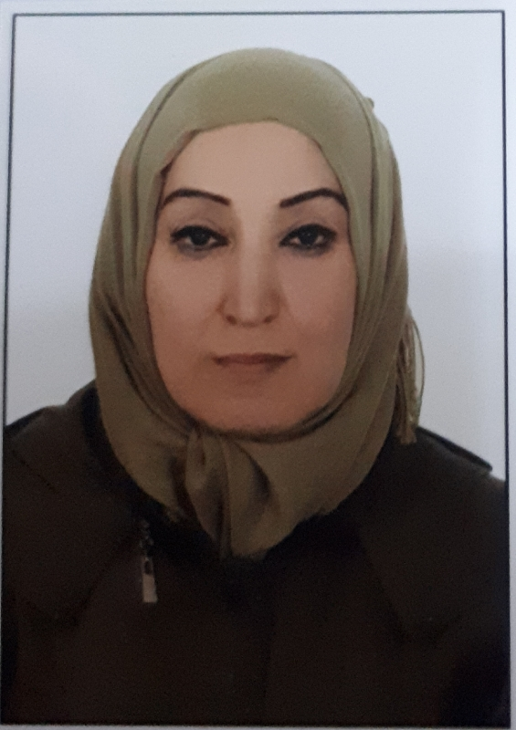
Personal Information
Name |  |  |  | Abeer Salim Mohammed alnooamy
Dare of Birth |  |  |  | 15/10/1971
Place of Birth |  |  |  | Al Mosul
Gender |  |  |  | female
Nationality |  |  |  | Iraqi
Marital Status |  |  |  | Marrid
No. of Children |  |  |  | There is no
Cell phone No. |  |  |  | 07740936567
Academic Information
Scientific Title |  |  |  |  | Lecturer
Scientific Dept. |  |  |  |  | Department of Chemistry,  College of Education for Pure Sciences, University of Mosul
General specialty |  |  |  |  | Chemistry
Specific specialty |  |  |  |  | Inorganic chemistry
Email |  |  |  |  | abeersalim1971@gmail.com  abeersalim1971@uomosul.edu.iq
Research Gate |  |  |  |  | Abeer Salim  Ph.D. inorganic chemistry
Google Scholar |  |  |  |  | Dr. abeersalim  Lecturer in university Of Mosul
ORCID |  |  |  |  | https:// orcid.org/ 0000.0002.4192.8302
Education
Degree | Year |  |  |  |  | Major |  | University
Ph.D. | 2012 |  |  |  |  | Ph.D. inorganic chemistry |  | College of Education for pure Sciences,University of Mosul,iraq .
M.Sc. | 2001 |  |  |  |  | Inorganic chemistry |  | College of Education for pure Sciences,University of Mosul,iraq .
Bachelor | 1993 |  |  |  |  | Chemistry science |  | College of Education for pure Sciences,University of Mosul,iraq .
Scientific titles
Lecturer |  | 24/6/2012
Assistant Lect. |  | 19/3/2006
Scientific and Administrative Experiences
lecturer |  |  | 2006-2020 |  |  |  | Department of Chemistry,  College of Education for Pure Sciences, University of Mosul
Teaching Activities
1-inorganic chemistry ,first stage theory
2- inorganic chemistry is practical ,third stage
Postgraduate Supervision
Master |  |  | There is no
Ph.D. |  |  | There is no
Peer-reviewed Publications
1-Preparation and Characterization of New Complexes of Mixed Ligands of Schiff bases Derived From Isatin and Amino Acid and Diamine Ligands With Fe(ıı),
2-Synthesis and characterization of Fe(ıı),Co(ıı),Ni(ıı),Cu(ıı)and Zn(ıı) complexes with mixed ligands of α- naphthyl amine di thio carbamate and 1,10-phenanthrolin
TIKRIT JOURNAL OF PURE SCIENCE,VOL.14,NO.(2)2009
3- Synthesis and characterization of Fe(ıı)Co(ıı) and Ni(ıı) Complexes With Captopril SCIENCE,VOL.14,NO.(2)2009 TIKRIT JOURNAL OF PURE

Books and Chapters
1-Preparation and Characterization of New Complexes of Mixed Ligands of Schiff bases Derived From Isatin and Amino Acid and Diamine Ligands With Fe(ıı),Co(ıı),Ni(ıı) and Cu(ıı) Ions 2012
2- Preparation and Characterization of New Complexes of Antimony(ııı) and Bismuth (ııı)Chloride With Some Xanthate Substituted Nitrones 2001
Scientific Conferences and Symposiums
1-Basic sciences and cinnamon a vision towards education and contemporary science/Faculty of Basic Education ,Duhok University/ The first international conference for the duration of 11-12/2/2019.
2-The second scientific conference of chemistry/ Department of Chemistry College of Education for Pure Sciences, University of Mosul,17-18/11/2013.
3- The first scientific conference of chemistry/ Department of Chemistry College of Education for Pure Sciences, University of Mosul,15-16-10/2008.
4-Participation in 10 seminars.
Other Scientific activities
1-She holds a certificate of injection skills.
2-She holds a first aid certificate/ T.R.Learning Center.
3- She holds a T.O.T. Iraqi chemists syndicate Chemists Training center for Scientific and laboratory techniques.
4-Participation in (14) cours ,(3) of which are incontinuing education,(3) of which are international as attends ,lecturer and trainer and coach as well as participation in many permanent commitments attiudes and cards
Associations
Not affiliated with any association
Awards and thanks
13 thanks you books (2) from the president of the university ,(1) from the director of health of Nineveh and (4) from Minister and (6) from the Dean.

