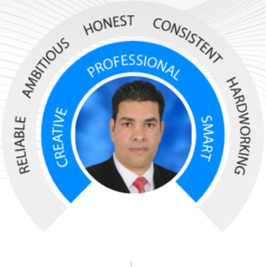
Jamal.Alawamy@Gmail.com
+601123525300
University of Omar Al-Mukhtar
El-Beida, Libya
15.09.1973
Married

Jamal.Alawamy@Gmail.com
+601123525300
Omar Al

-Mukhtar University
El-Beida, Libya
15.09.1973
Married

Jamal S. A. Belkasem
Lecture

WORK EXPERIENCE
Lecturer 2012- present
- Faculty of Natural resources University of Omar Al- Mukhtar, El-Beida, Libya
- Teaching several courses such as General Geology, Mineralogy, Soil Conservation, Land Surveying Science, Principles of cartography and aerial photographs, Computer principles, and General Statistics.

Lecturer Assistant 2006-2009
- Faculty of Agriculture, Omar Al-Mukhtar University, El-Beida, Libya.
- Thought the practical parts of Fundamental of Soil science and, Land surveying courses.

Researcher 2009-2012
- Agriculture Researches Canter (ARC), El-Beida, Libya.
- Employed as a Soil Specialist within a Water Harvesting Team in Collaborative Research Projects between Agriculture Researches Canter (ARC) Libya and International Canter for Agriculture Researches in Dry Areas (ICARDA).
Supervisor engineer 2000-2006
- General Authority of water, El-Beida, Libya.
- Worked in field of underground water exploration and supervision of the implementation of well drilling projects and the distribution of water for domestic, agricultural and industrial purposes.

Soil Specialist 1997-2000
Soil Department, Ministry of Agriculture, El-Beida, Libya.

EDUCATION
Soil and water (B. Sc) 1991-1994
- University of Omar Al-Mukhtar, El-Beida, Libya

Land Management (M. Sc) 2005-2009
- Omar Al-Mukhtar University, El-Beida, Libya

Land Management (Ph.D.) 2015- present
- Universiti Putra Malaysia (UPM), Serdang-Malaysia

Learning English language May 2014- Jan 2015
- ELS Language Canter, Serdang-Malaysia.
- British Council.

LANGUGES
- Arabic: Native
- English: Advanced
- Bahasa Malay: Low

AREAS OF EXPERTISE
- GIS and remote sensing
- Land management
- Water harvesting
- Groundwater exploration

TRAINING PROGRAMS
Specialized training course on (Design of Experiments and Statistical Data Analysis Using the Computer)
- El-Beida, Libya, 27th Feb – 04th Mar 2010
- Organized and sponsored by the Agriculture Researches Centre (ARC) Libya and International centre for Agriculture Researches in Dry Areas (ICARDA).

Specialized training course on (Rainwater Harvesting for Agriculture in Dry Areas)
- IRA Medenine, Tunisia, 17 th May– 17 th Jul. 2010
- Organized and sponsored by the (Insitiute des Régions Arides de Médenine) (IRA), Tunisia and International Centre for Agriculture Researches in Dry Areas (ICARDA).

Advanced Research Methodology Course
- Kajang, Malaysia., 22 th - 24 th May2015.
- Organized by Filspay Academy.

Application of Geographical Information Systems (GIS).
- Kuala Lumpur, Malaysia, 1 st -5 th Jan 2016
- Organized by TMC College

Workshop on A Guideline Strategies to Write the Quality Papers (ISI/Scopus)
- Kuala Lumpur, Malaysia, 9th Feb 2017.
- Organized by USIM university

Structuring Your Article Correctly
- UPM Serdang, Malaysia, 13 ^{th} Jun 2017
- Organized by ELESEVIRE.

Mitigating Chemical Risk in Laboratories and the Good Laboratory Practices.
- UPM Serdang, Malaysia, 02 nd Aug 2017
- Organized by Erlab and TMS.

Workshop on Using Soil & Water Assessment Tool.
- Bangi, Malaysia, 23th-25th Oct 2017.
Organized by the Malaysian Society of Soil Science and SWAT Network of Malaysia.

Multirotor Drone Pilot Course
- Kuala Lumpur, Malaysia, 27th -28 th Oct 2018.
- Organized by International Institute of Drones (IID)
Fundamentals of Implementation of Remote Sensing Data for Industries, Agriculture and Rational Nature Management.
- UPM Serdang, Malaysia, 20 th – 22th Nov 2018.
- Organized by Peoples’ Friendship University of Russia.

CONFERENCES
- Al-Beida, Libya, 2011, the first conference of Libyan agricultural specialists during the Libyan uprising, the slogan of the conference: the role of agriculture specialists after the political change in Libya. Hosted by Omar Al-Mukhtar University & the ministry of agriculture.

- Istanbul, Turkey, 2012, Meeting of the senior official members of the Organization of Islamic Cooperation (OIC) on the OIC water vision, held during the period from 12 to 14 January 2012.

- Al-Beida, Libya, 2012, the first international conference for water resources in Al-Jabal Al-Akhdar: Reality & Horizons. Hosted by Omar Al-Mukhtar University & the Ministry of Agriculture, Faculty of Natural Resources & Environmental Sciences.

- Bangi, Malaysia, 2017, The 5th Soil and Water Assessment Tool Conference in South East and Asia (SWAT SEEA V). Organized by the Malaysian Society of Soil Science and SWAT Network of Malaysia during the period from 23th to 25th Oct 2017.

COMPUTER SKILLS
- Operating systems (Windows)
- Office suites (Microsoft Office)
- Presentation software (PowerPoint)
- Spreadsheets (Excel, Google Spreadsheets)
- Data visualization
- Spatial analysis using Remote sensing & GIS software (ARC GIS, Q GIS, ENVI, Google Earth)
- Statistical analysis (SPSS and GenStat)

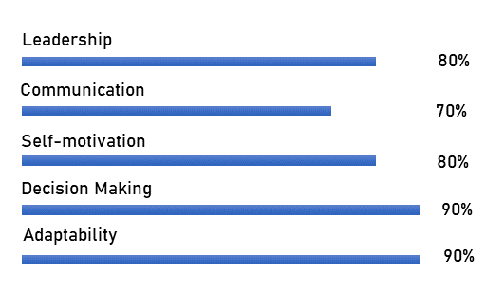
PERSONAL SKILLS

MY TIME

HOBBIES & INTERESTS
Travel Reading Photography

